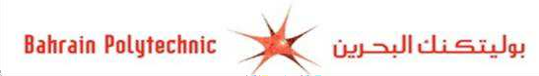

**Assessment** **Cover** **Sheet**

**Assessment**

Project(Group)

**Assessment**

Uncontrolled

Group 5

Not must-pass

**Due** **Date**

22-May 2024 by 11:55 p.m

**Course** **Code**

IT8416

**Course** **Title**

Data Mining

**Internal Moderator’s**

Dr. Shomona Jacob

**External Examiner’s**

**Instructions:** **Given** **in** **the** **Project** **description**

1. This cover sheet must be completed (section in red below) and attached to your assessment before submission in hard copy/soft copy.
2. The time allowed for this assessment is till Wednesday, 22nd May 2024 by 11:55 p.m..
3. This assessment carries 100 marks with a weightage of 35% with 6 tasks assessing LO1,2,3
4. The materials allowed for use in this assessment are Moodle, Instructor informed website resources.
5. The **use** **of** **generative** **AI** **tools** **is** **strictly** **prohibited**.
6. References consulted (if any) must be properly acknowledged and cited.
7. The assessment has a total of 5 pages.

**Students** **Name** **Students ID** **Programme**

**Lecturer’s**

BICT -Database

Sini Raj Pulari

202003580 - 202000270

Sara Albuainain – Amena Almohana

###### By submitting this assessment for marking, I affirm that this assessment is my own work.

Do not write beyond this line. For assessor use

**Assessor’s** **Name**

Sini Raj Pulari

**Marking** **Date**

**Marks** **Obtained**

**Learner**

Sini Raj Pulari

**Comments:**

**Table of Contents**

**Task One - Problem Statement Formulation and definition** 3

Motivation 3

Objectives 3

Problem Statement / Project Definition 3

Expected Result 3

**Task Two - Selection of an Appropriate Data Set (Data Collection)** 4

Source of Dataset 4

The initial data 5

Missing values and repeated values. 7

Redundant attributes 8

Visualization 9

Distribution of dataset before the data preparation 14

**Task Three - Preparation and Pre-processing of Selected Data** 17

Distribution of dataset after the data preparation 25

Inferences before and after data pre-processing 26

**Task Four - Building Data Mining Models** 28

**Task Five - Evaluating Data Mining Models** 41

**Task Six - Inferences, Recommendation and Reflection** 47

Inferences 47

Recommendation 47

Reflection 47

**Extra challenge** 48

**Log Files** 49

**GitHub Link** 50

**YouTube Link** 50

**References** 51

# 

# **Task One - Problem Statement Formulation and definition**

## Motivation

Diabetes is a common health issue worldwide that is caused by high blood sugar levels. It is a chronic illness that is difficult to diagnose and intervene early due to the complex relationships between various medical factors. Every year, diabetes death rates increase significantly. According to the World Health Organization in 2023, “In 2019, diabetes and kidney disease due to diabetes caused an estimated 2 million deaths.”. Consequently, detecting diabetes at an early stage and preventing or delaying its consequences can save millions of lives and improve their quality of life.

## Objectives

The aim is to analyze the Diabetes prediction dataset to build a model that is helpful for medical experts to detect diabetes sooner by using medical and demographic data to predict whether an individual is likely to develop diabetes based on their lifestyle changes. Moreover, writing a detailed analysis of the dataset by discovering patterns and factors relationships will assist in enhancing patients’ well-being. Furthermore, Analysis of Diabetes Risk by evaluating the factors and their contribution to the disease may increase life expectancy.

## Problem Statement / Project Definition

Motivated by the need to advance diabetes treatment and prevention, the goal is to empower doctors with useful knowledge to aid patients by designing a model with accurate diabetes prediction using people’s health history.

## Expected Result

As a result, a transparent model will be capable of predicting diabetes with high accuracy. Therefore, healthcare specialists should be able to interpret the model, so they can understand the factors that contribute to the prediction. Also, several medical and statistical variables will be examined in this project to highlight their influence on diabetes risk.

# **Task Two - Selection of an Appropriate Data Set (Data Collection)**

# Source of Dataset

The selected data set is appropriate because it is widely used in the healthcare field and the link is publicly available for research. In addition, it meets the project objectives and contains many valuable factors and details which will lead to an accurate representation of diabetes patients or likely to develop diabetes analysis as it is collected by hospitals through surveys, medical records, and lab tests as part of the daily work. Furthermore, the presence of noisy data will help in applying data mining tools effectively (Mustafa, 2023). The data includes 100000 instances and 9 features of a hybrid type that consist of both qualitative and quantitative attributes such as:

1. **Gender**

The biological sex which includes male, female, and other.

1. **Age**

The age ranges from 0 to 80, which is important since diabetes is more often diagnosed in older adults.

1. **Hypertension**

A medical condition where blood pressure in the arteries is persistently high. A 0 implies a person does not have hypertension, while a 1 implies they do.

1. **Heart disease**

An increased risk of developing diabetes as 0 means they do not have heart disease, while 1 means they have.

1. **Smoking history**

The condition increases diabetes risk and can make complications worse. It consists of five categories: not current, current, former, never and ever and No Info.

1. **BMI (Body Mass Index)**

It measures the amount of body fat depending on weight and height. Diabetes is associated with higher BMI values. BMIs in the dataset range from 10.16 to 71.55. Underweight is less than 18.5, normal is 18.5-24.9, overweight is 25-29.9, and obese is 30 or more.

1. **HbA1c (Hemoglobin A1c) level**

A test of the average blood sugar level over the last two to three months. Diabetes risk increases with higher levels. HbA1c levels over 6.5% usually point to having diabetes.

1. **Blood glucose level**

The amount of glucose in the blood at a certain period. The main symptom of diabetes is elevated blood glucose.

1. **Diabetes**

Diabetes status is either 1 that indicates the existence of diabetes or 0 that indicates the absence of diabetes.

**The initial data

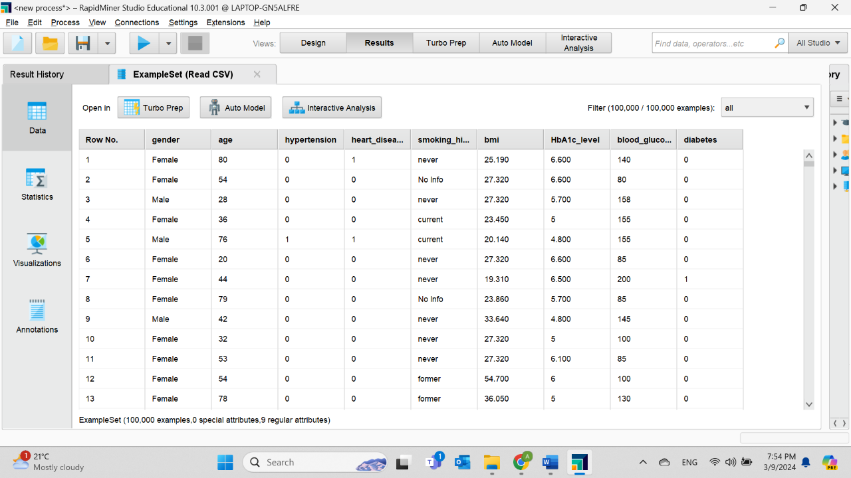**Figure 1. Reading Data from Rapid Miner Datasets.**

**Figure 2. The results are in the Results Tab.**

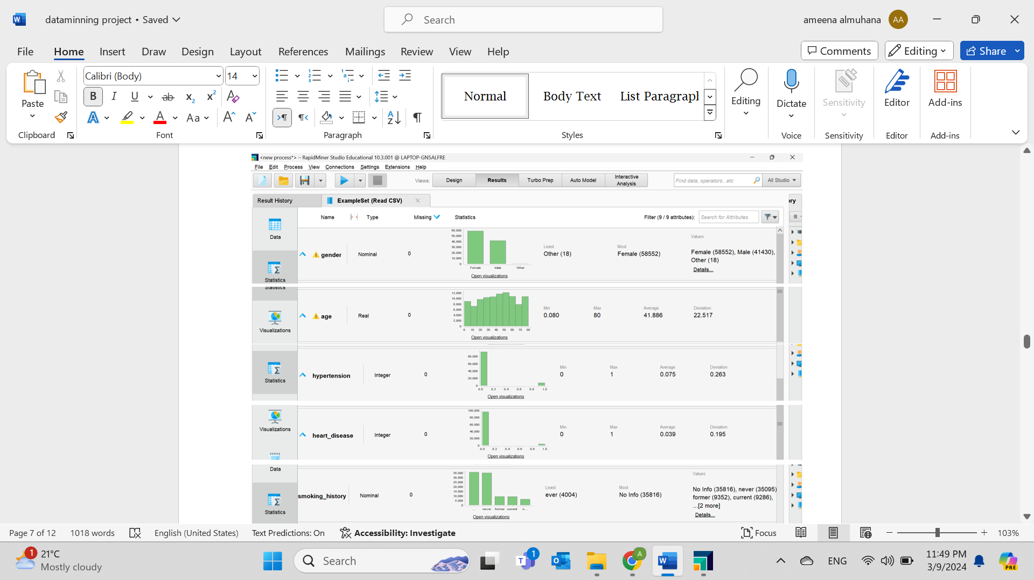

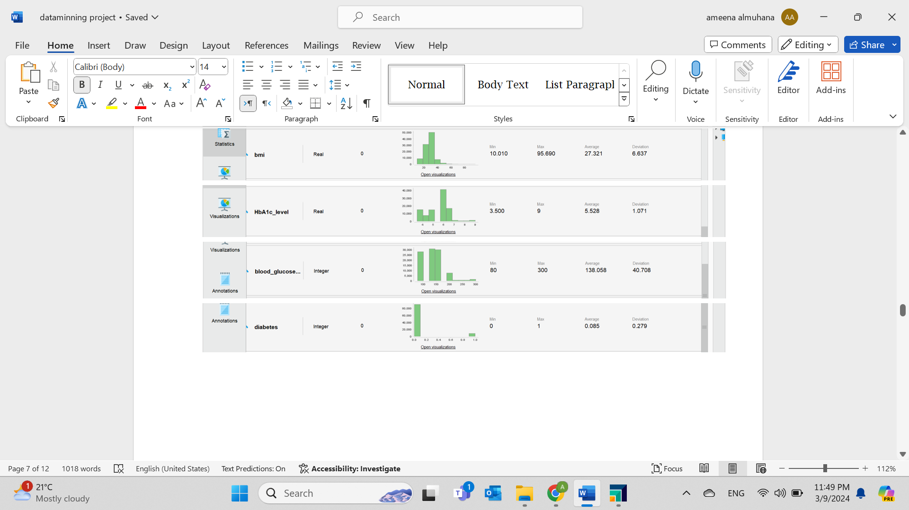

**Figure 3. The results in the Statistic Tab.**

**Missing values and repeated values.

**Figure 4. The Details of the Dataset.** The dataset includes wrong values but because the fields are not null it does not show them as a missing number.

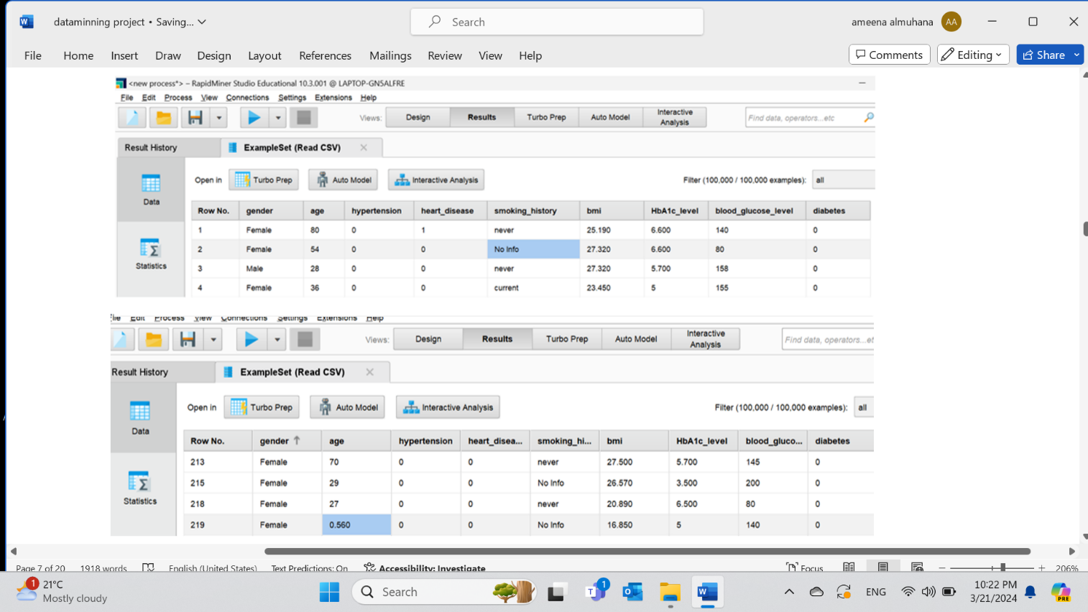

**Figure 5. Noisy information and repeated values.** As it appeared in the age attribute some values are not in integer and less than 0 which is not possible. In addition, (not current) and (former) refer to the same thing and could be used in one word. Furthermore, (ever) does not make any sense. The details are not provided or contain mistakes, but the machine is considering them as a correct value.

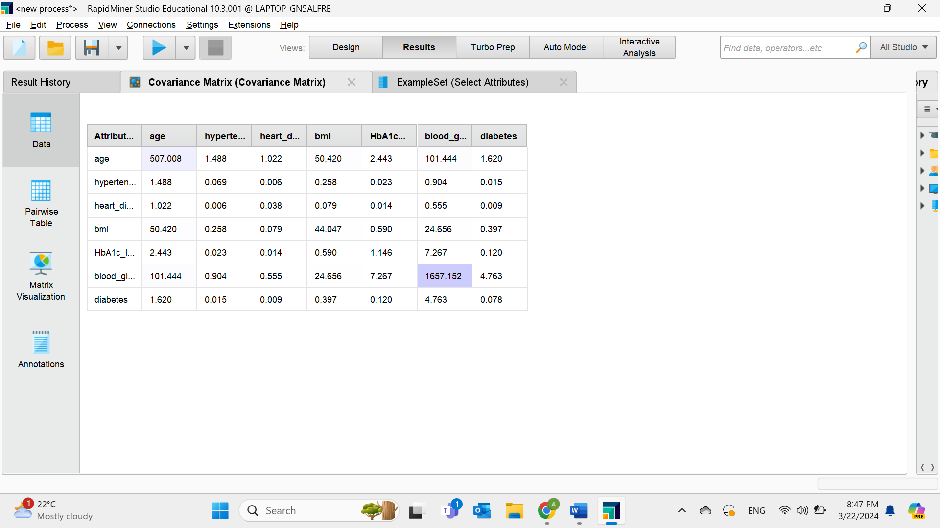**Figure 6. Covariance Matrix.** As displayed in the matrix, the attributes are certainly related because all of them have a covariance value of more than 0.

# A screenshot of a computer Description automatically generatedRedundant attributes

**Figure 7. Correlation Matrix.** The matrix shows the positive relationship between the attributes but the values are not very strong so there are no redundancies to consider as they are all under 0.5.

# Visualization

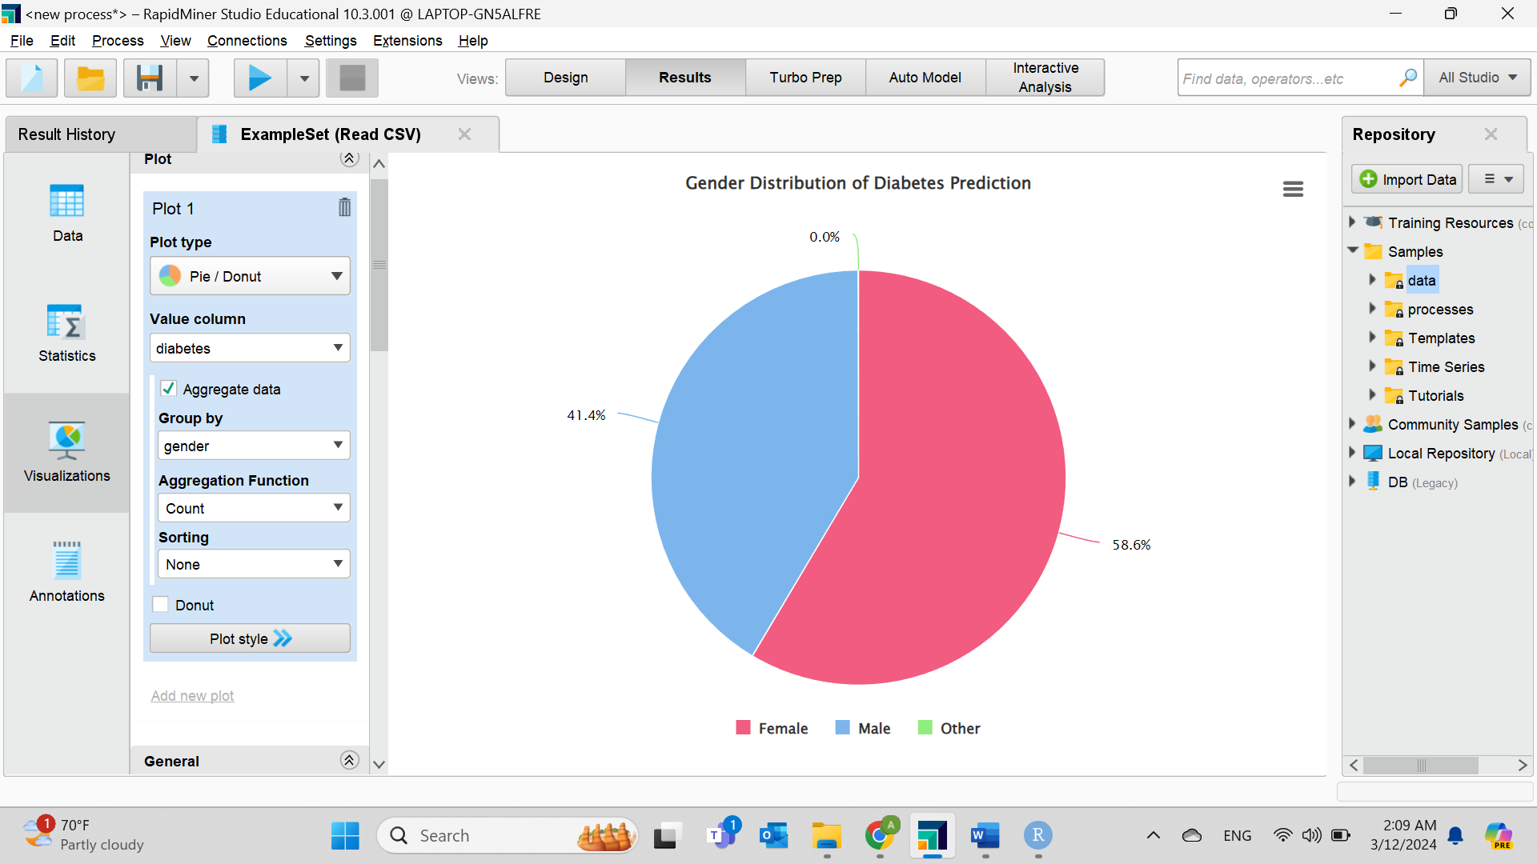

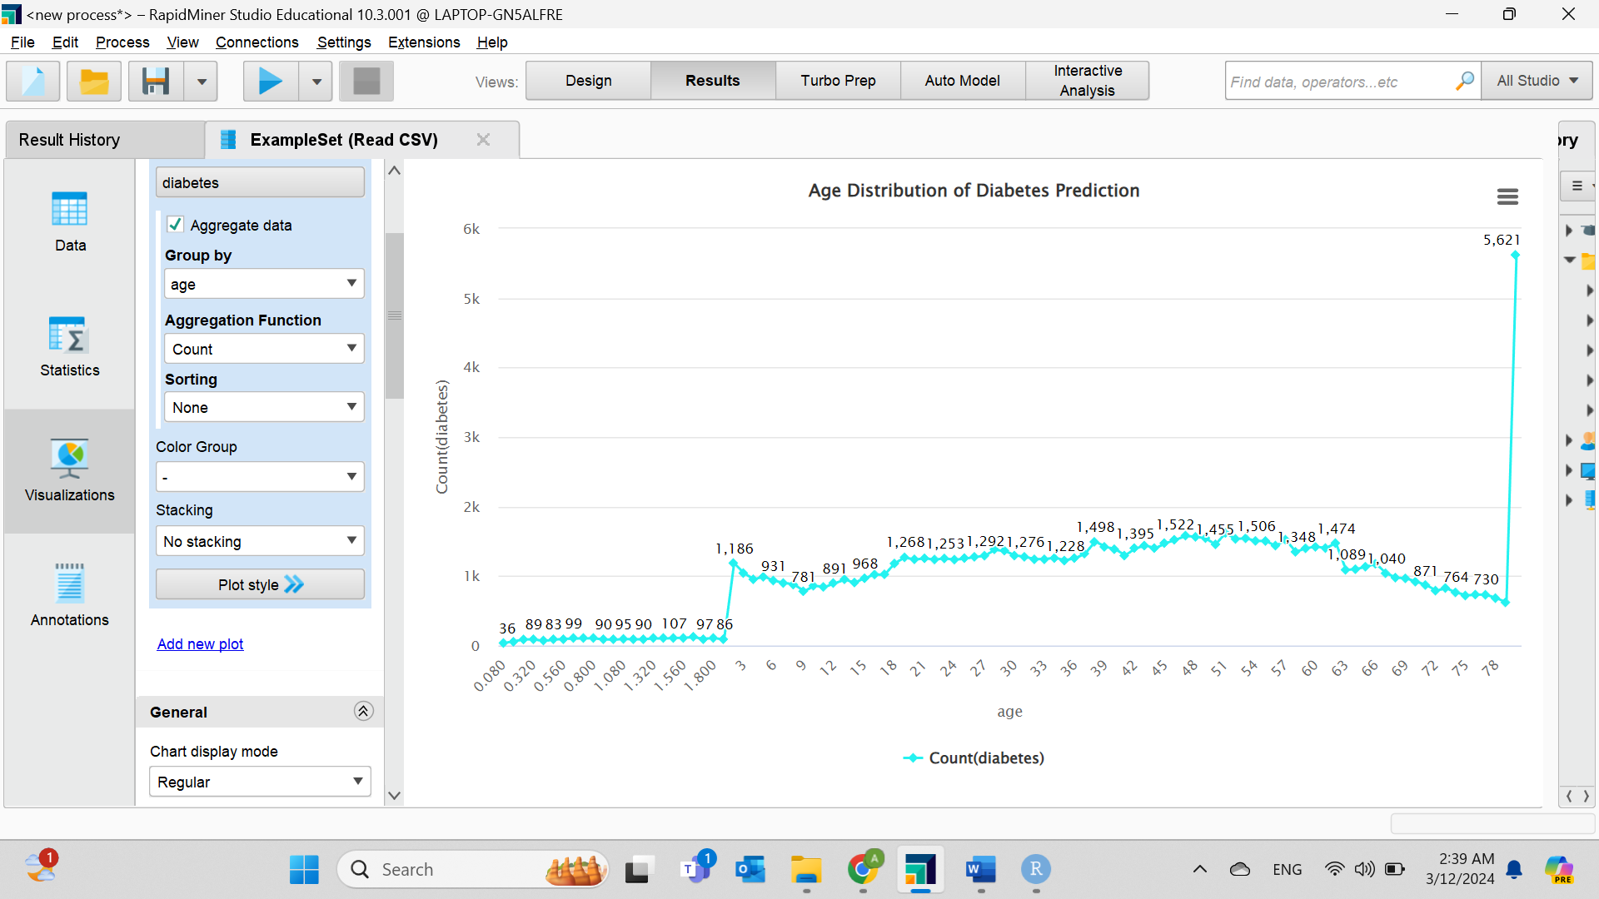**Figure 8. Diabetes pie chart by gender.** Female percentages are higher indicating that women are more likely to get diabetes compared to Males and Other, where there were only 18 people, so a zero percentage was displayed.

**Figure 9. Line chart for age.** As it shown, diabetes is more common in people aged 80, so older people are more likely to be diagnosed with it.

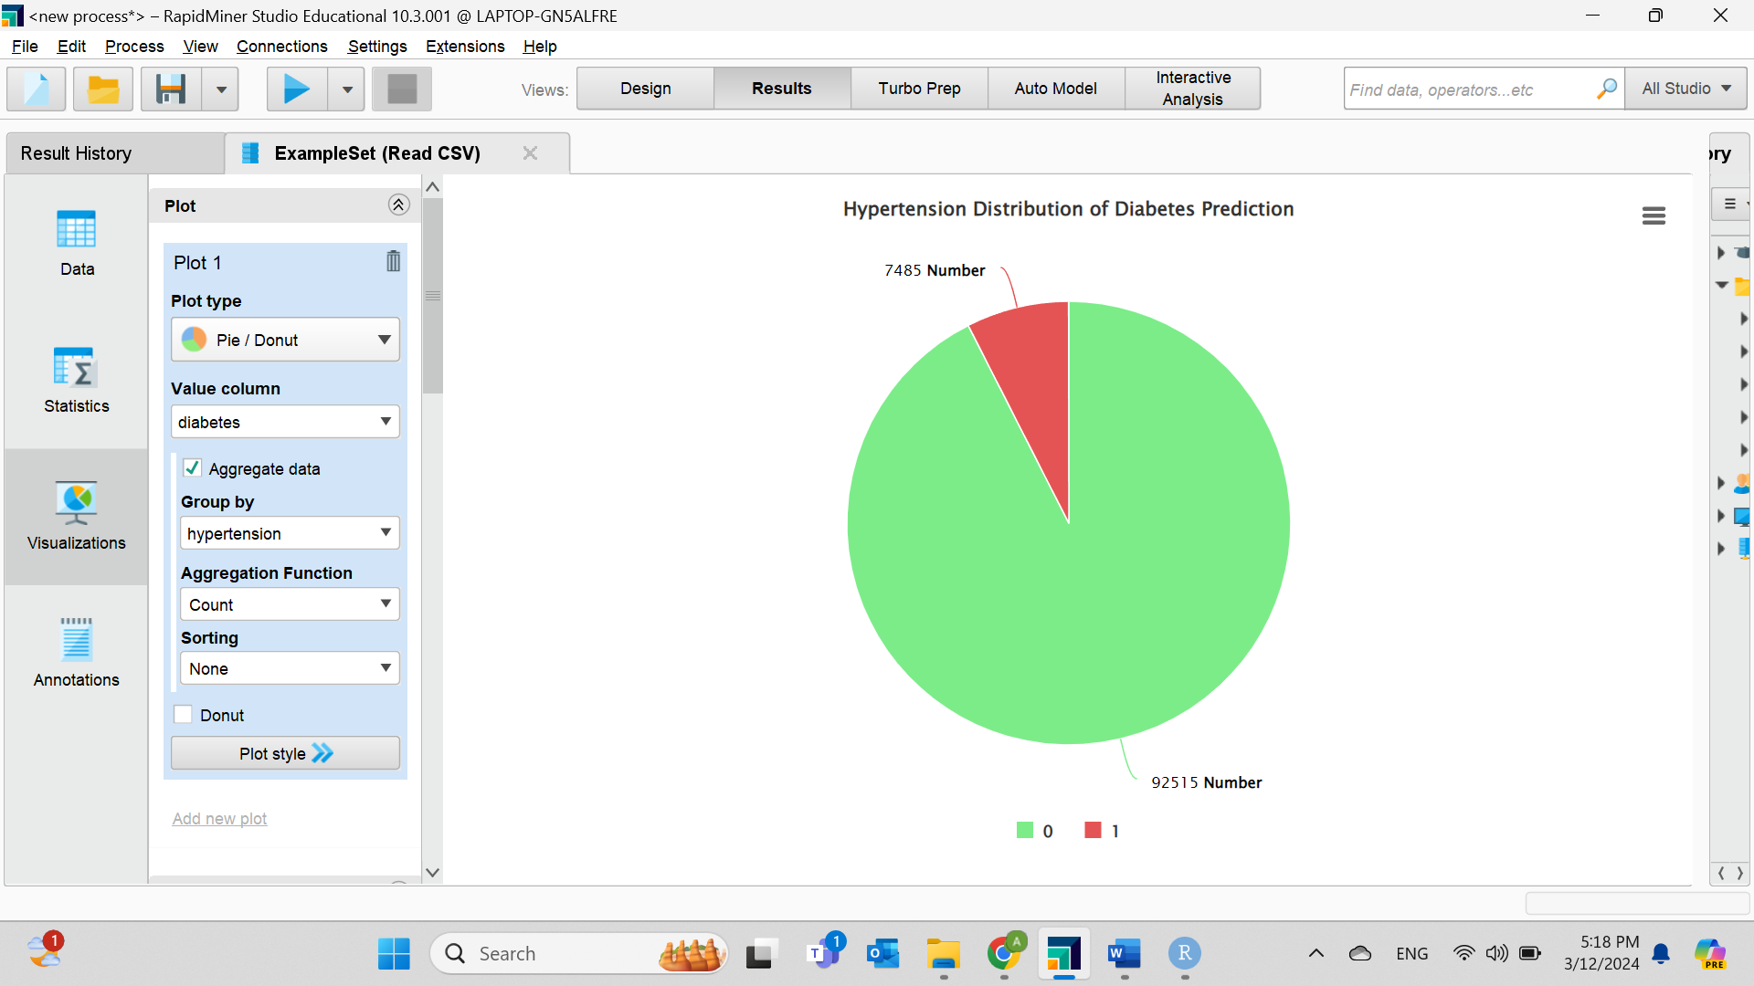

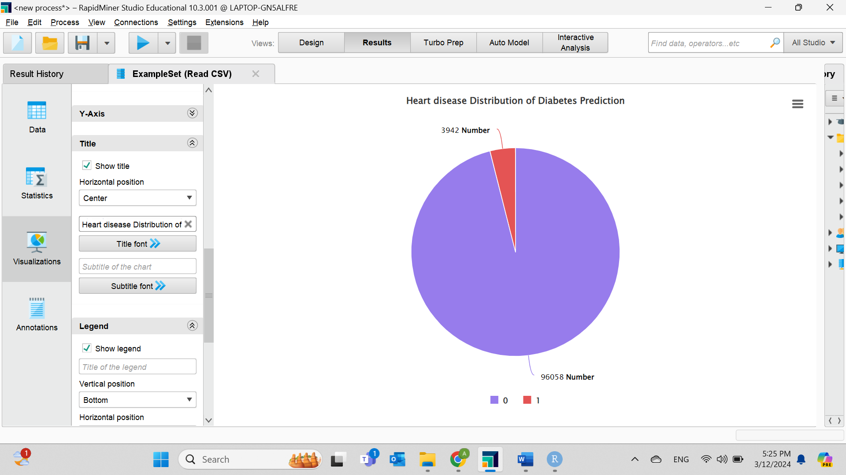**Figure 10. Pie chart for hypertension.** As exhibited in the chart, even though most people with diabetes do not have hypertension, it is counted to be one of the causes contributing to the disease.

**Figure 11. Pie chart for heart disease.** Similarly, most diabetics do not have heart disease, but it is still considered a risk factor.

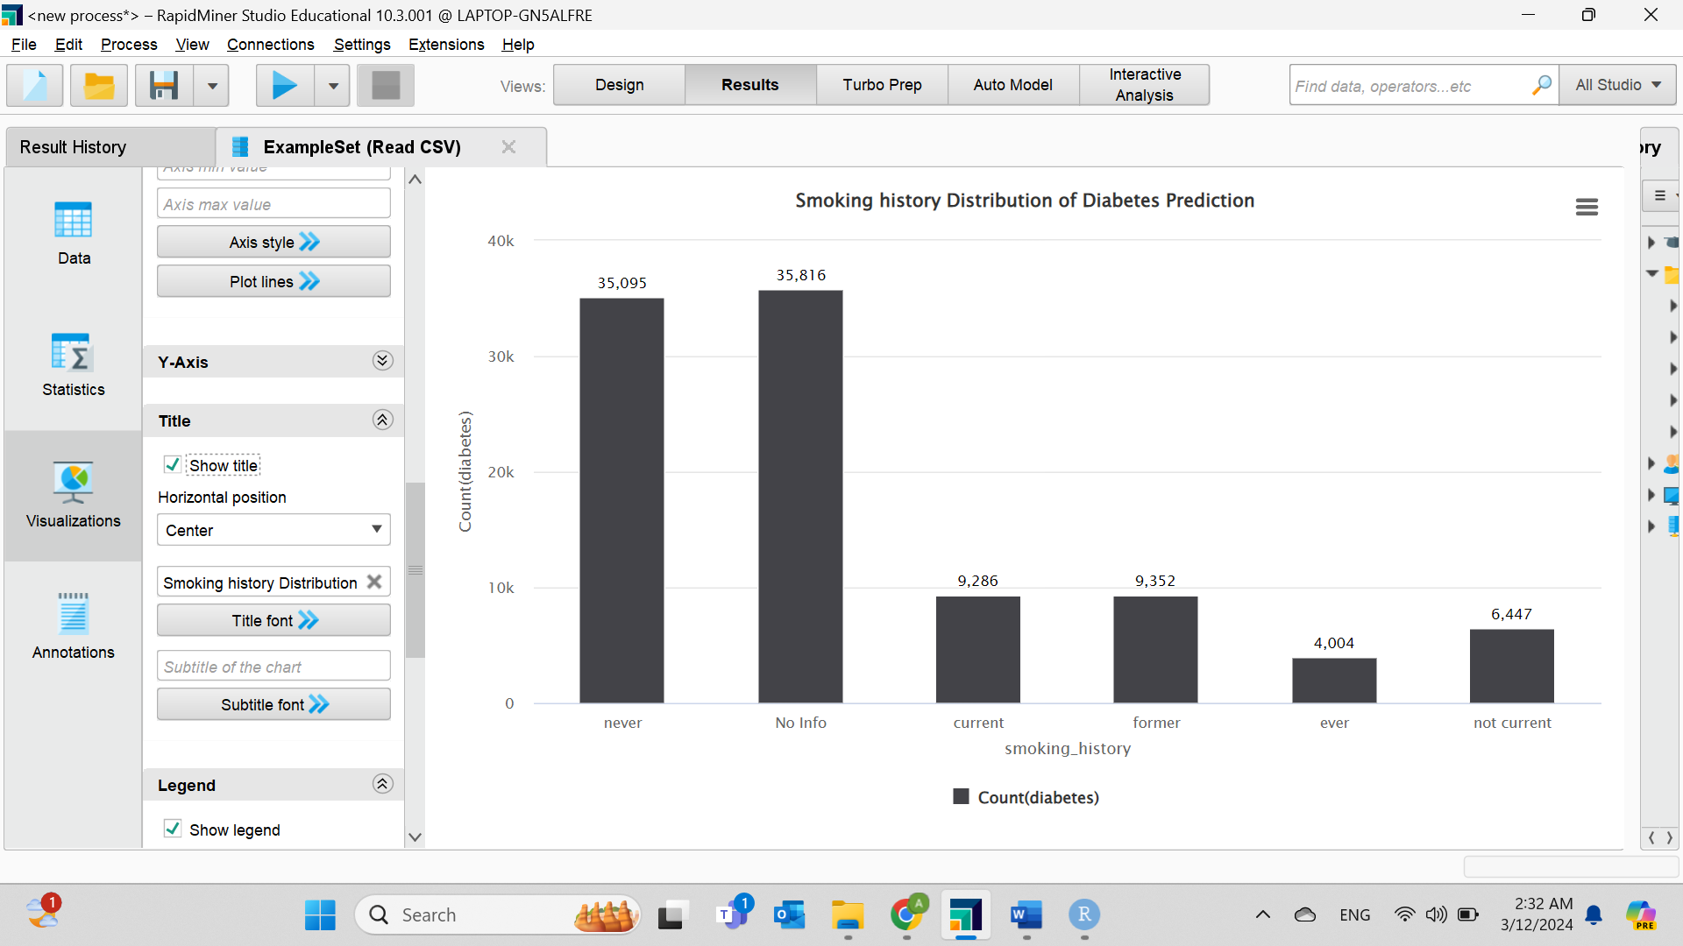

**Figure 12. bar chart for Smoking history.** There is a high percentage of patients who have never smoked or have no information about their smoking history, indicating that smoking is not a common cause of the disease.

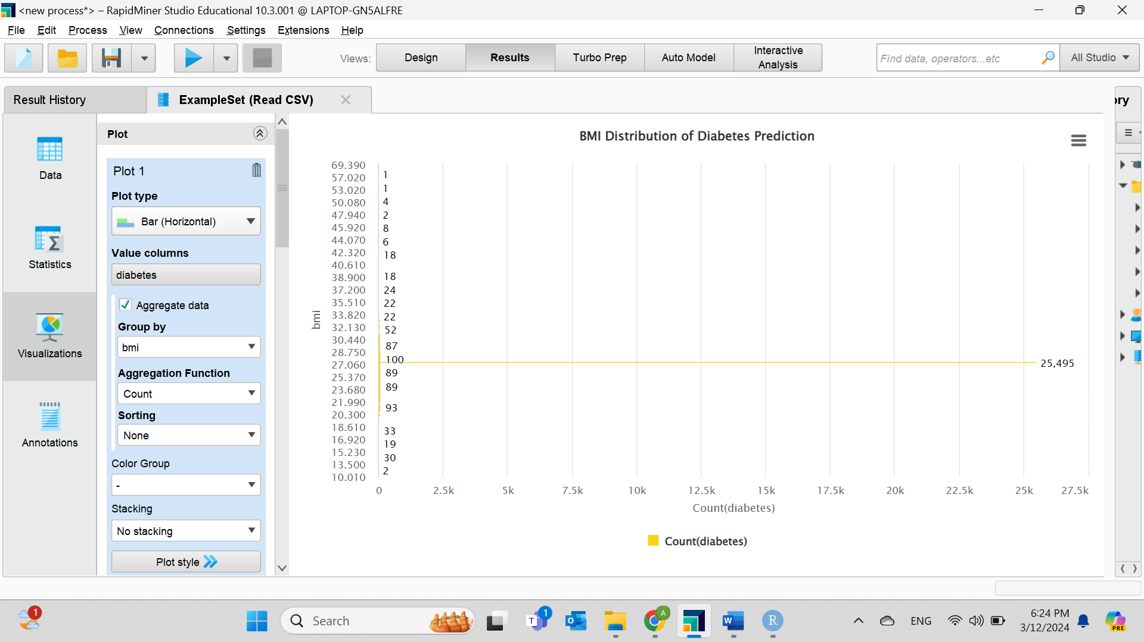

**Figure 13. Horizontal bar chart for BMI.** A diabetic patient's BMI is usually 27 as it is considered Overweight because it ranges from 25 to 29.9.

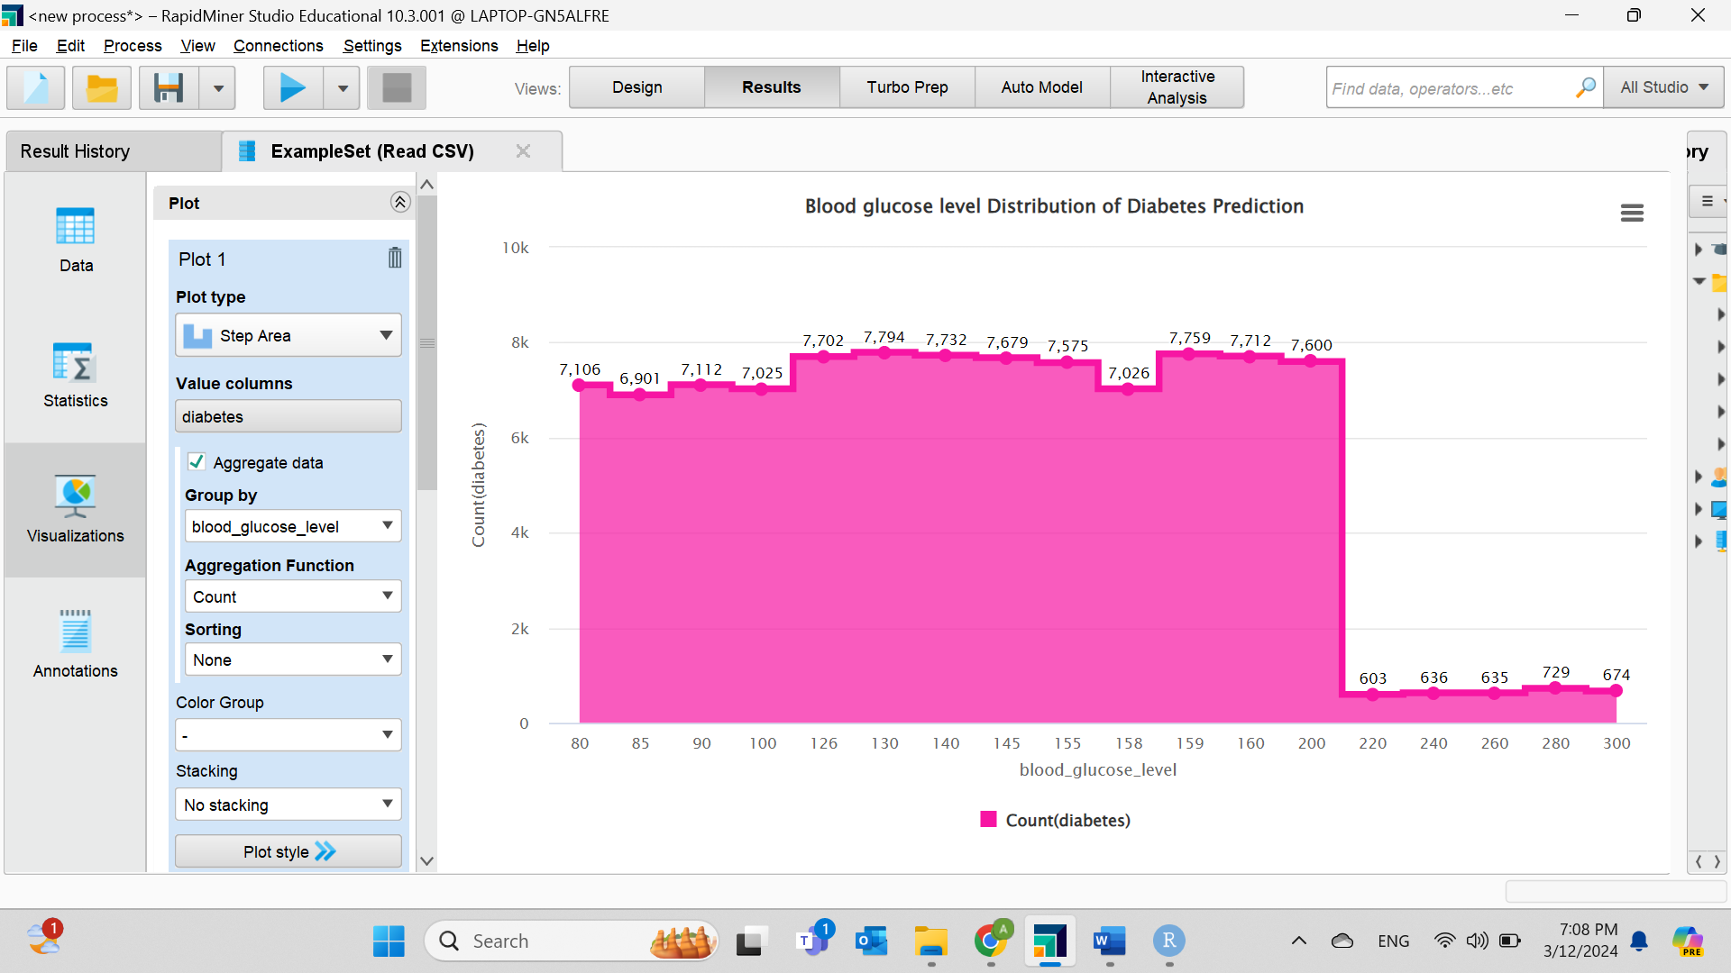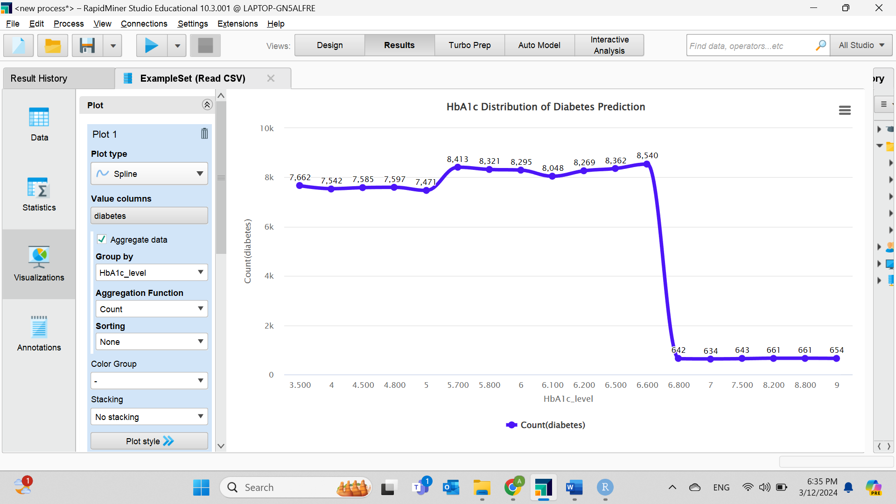**Figure 14. Spline chart for HbA1c.** Large number of diabetic patients have an HbA1c of 6.600 which is above normal, as 6.5 or greater is considered high.

**Figure 15. Step area chart for Blood glucose level.** Most patients have levels between 126 and 200, a glucose level of 100 to 125 indicates prediabetes, and a glucose level of 126 or higher indicates diabetes.

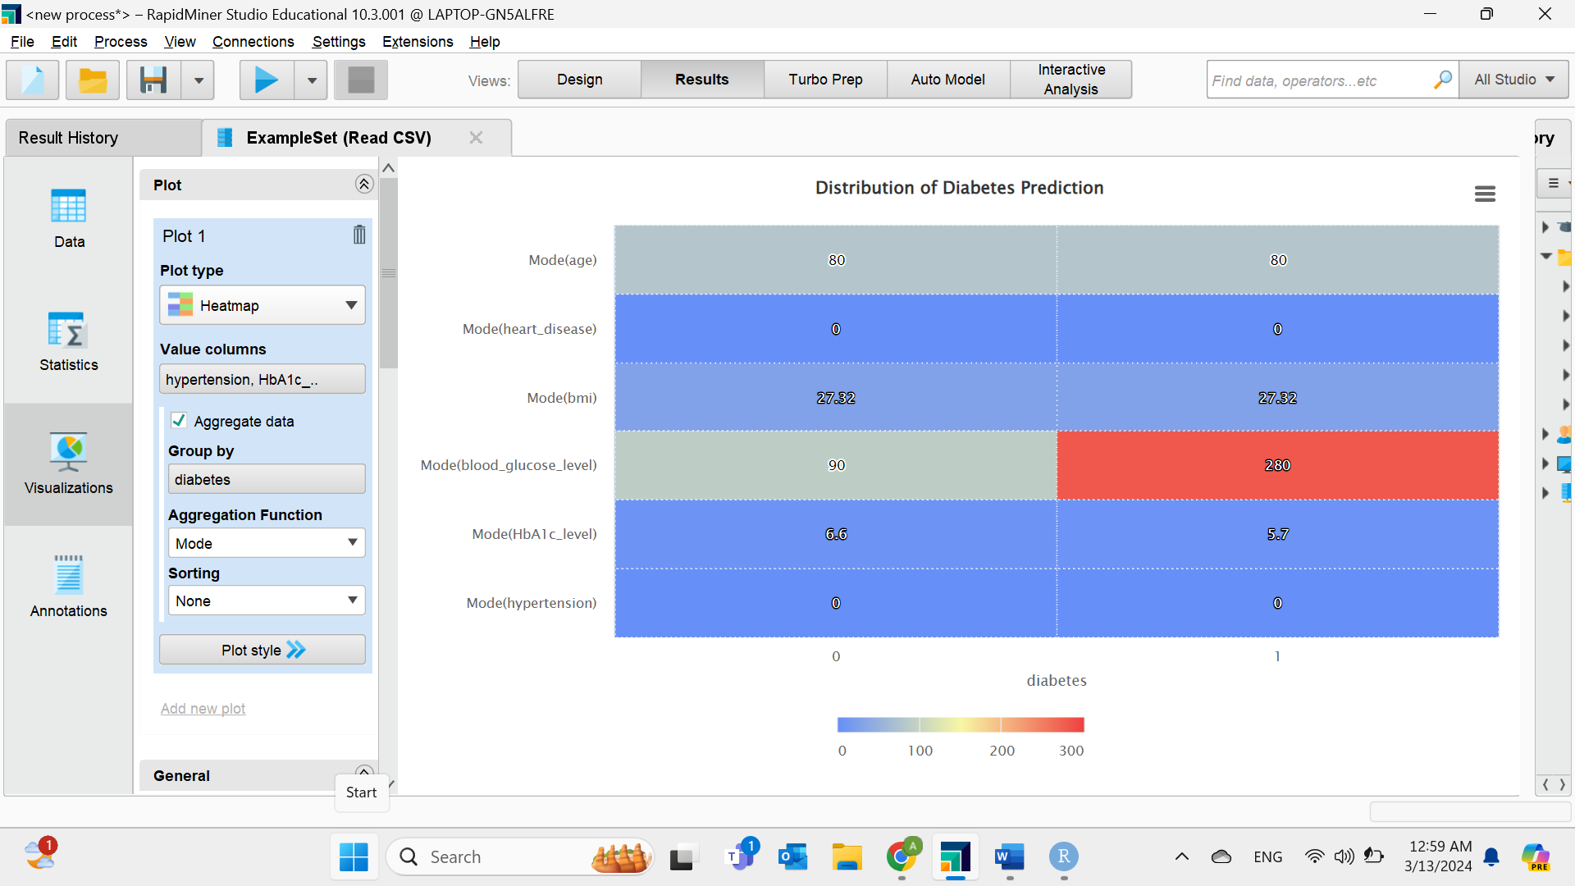

**Figure 16. Heat Map for measurable criteria.** In most cases, people with diabetes have high blood sugar, and getting older or increasing BMI increases the chance of suffering from the disease.

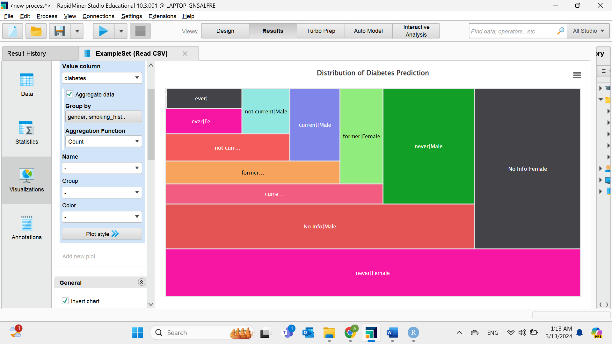

**Figure 17. Tree Map for Diabetes for qualitative criteria.** Females who have never smoked or have not shared their smoking history are at a higher risk of becoming ill.

As a result, older overweight women that are not necessarily, have a heart disease, hypertension, or smoke, have HbA1c more than 5.7 and a glucose level greater than 280 in their blood are more likely to have diabetes.

# Distribution of dataset before the data preparation

**Figure 18. Histogram showing the distribution of data sets.** The data are spread far from each other as the occurrence of a specific type within the range is different, heart disease has the highest number followed by diabetes and hypertension which mean most of patients in the collection suffer from these three factors.

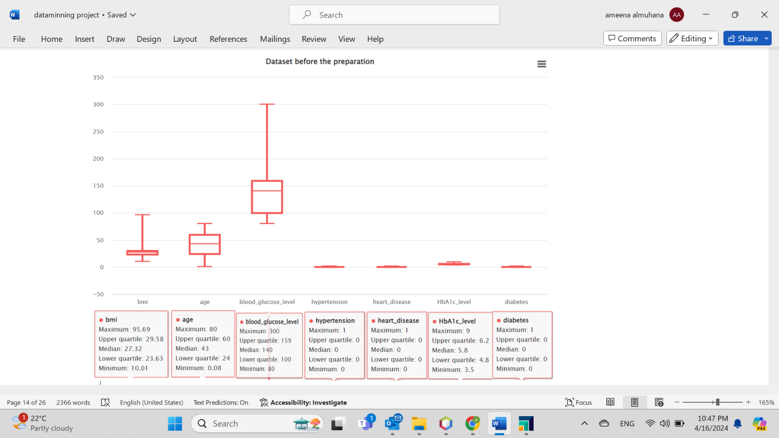

**Figure 19. Five Point Summary before data preparation.** As illustrated in the diagram, age has a normal distribution, but BMI and blood sugar have skewed distributions. It is most likely that a positively skewed distribution is caused by an increase in sugar, which increases body mass that is linked to chronic the illness. Moreover, the plot box does not show any outliers in the dataset.

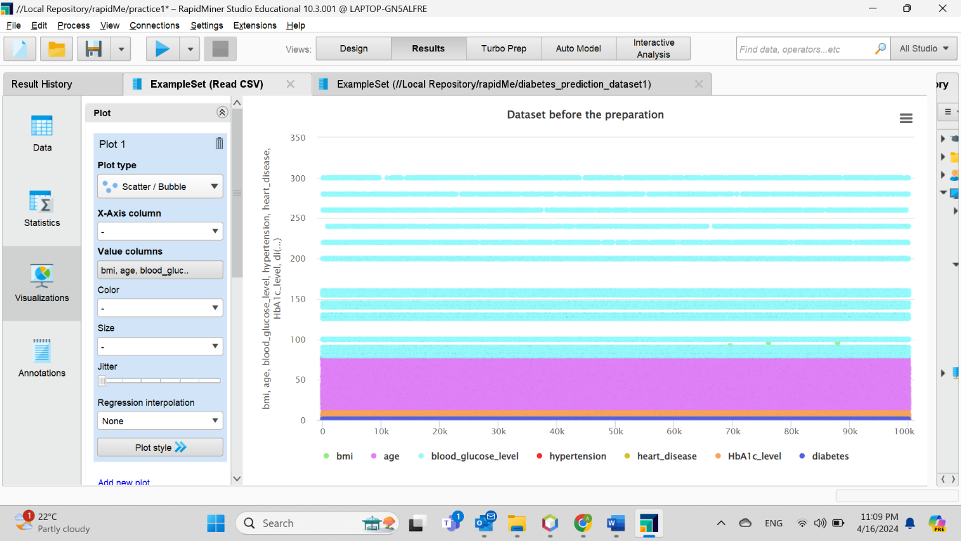

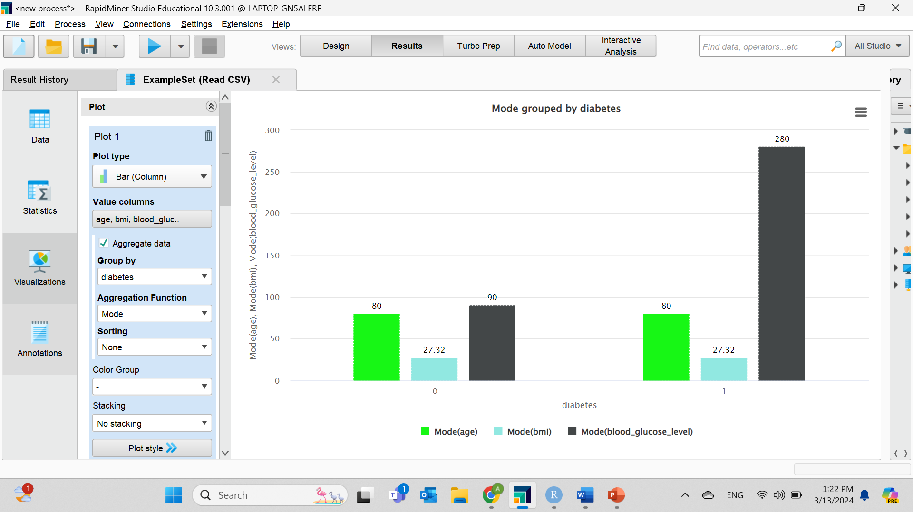**Figure 20. Scatter plot before data preparation.** The plot does not show any outliers, but the lines indicate the need to clean repeated data and remove errors.

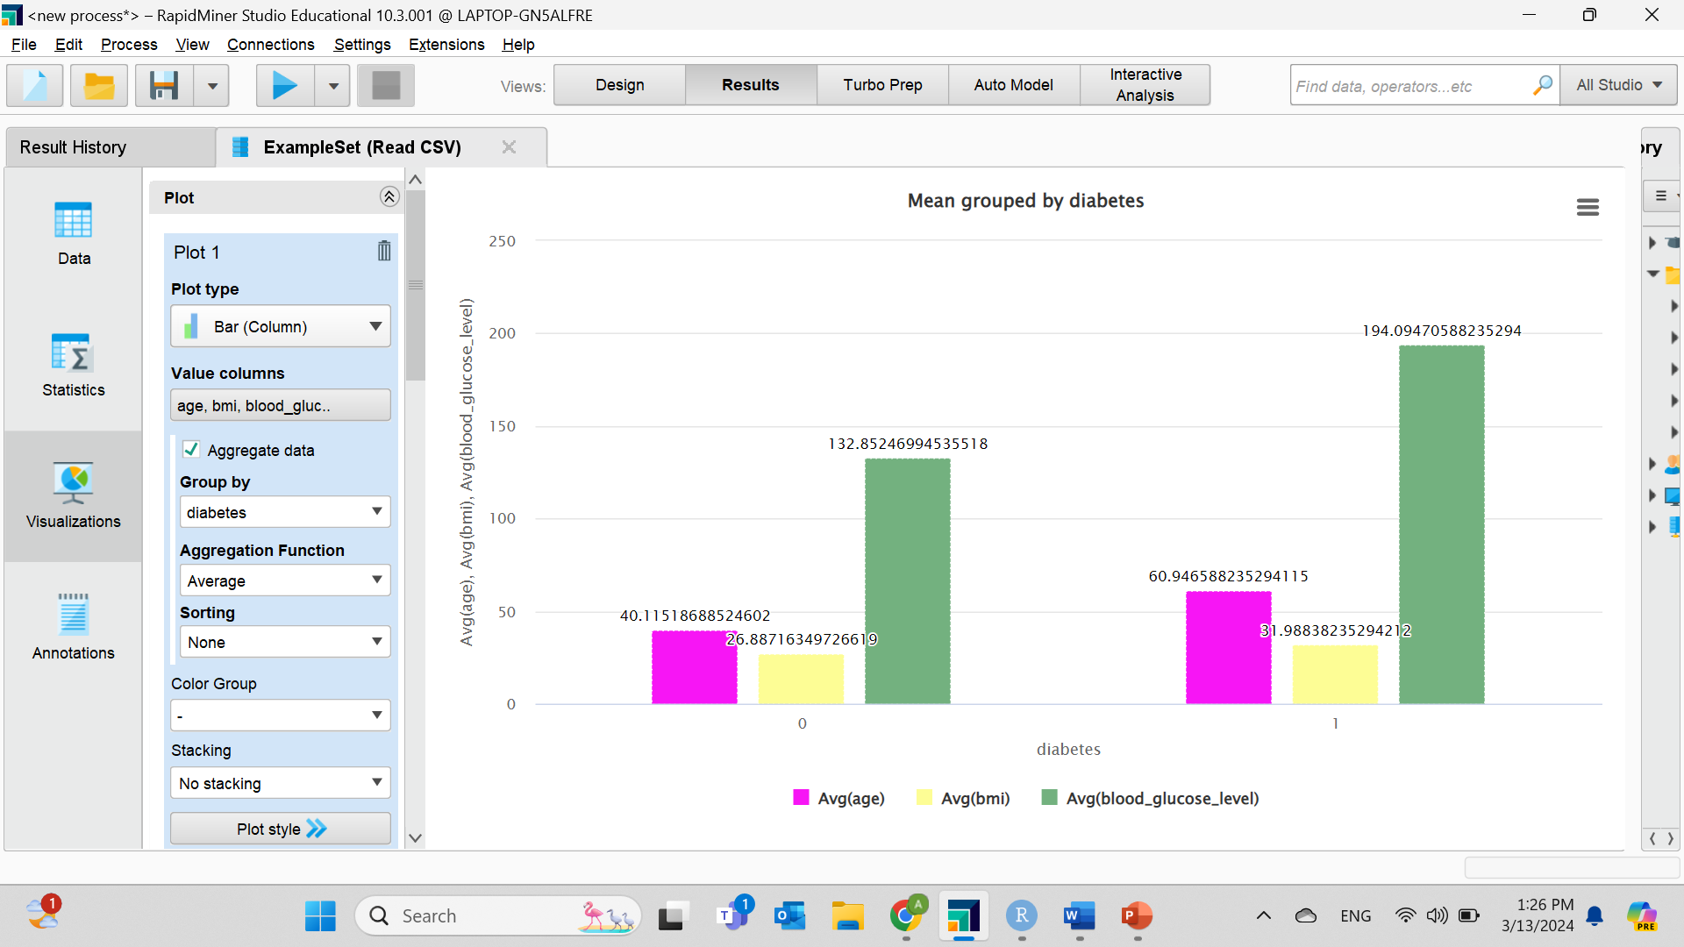**Figure 21. Mode.** The image presents the frequent values based on having the health problem versus not having it.

**Figure 22. Mean.** The picture shows the average numbers based on diabetes.

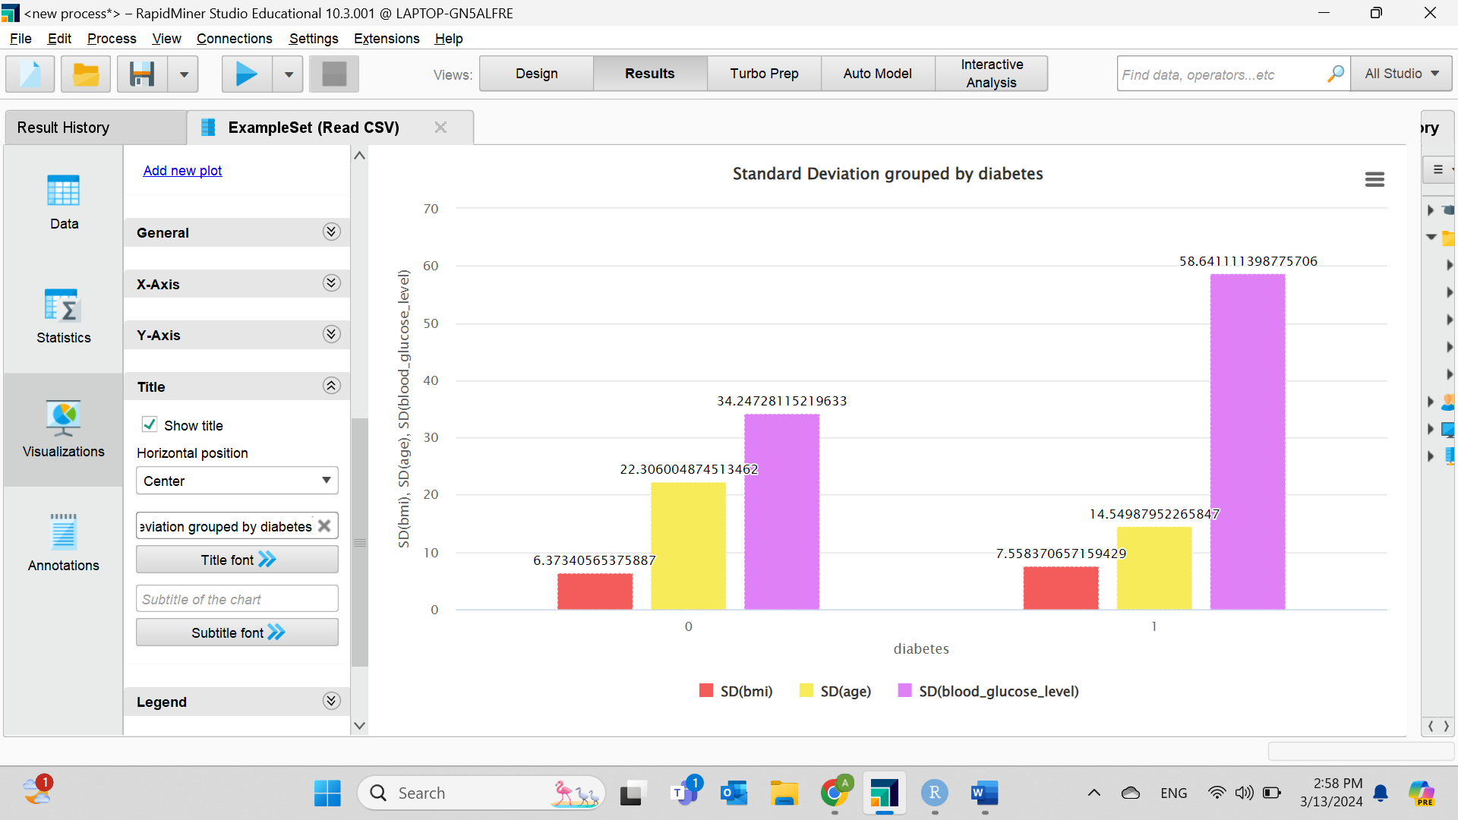

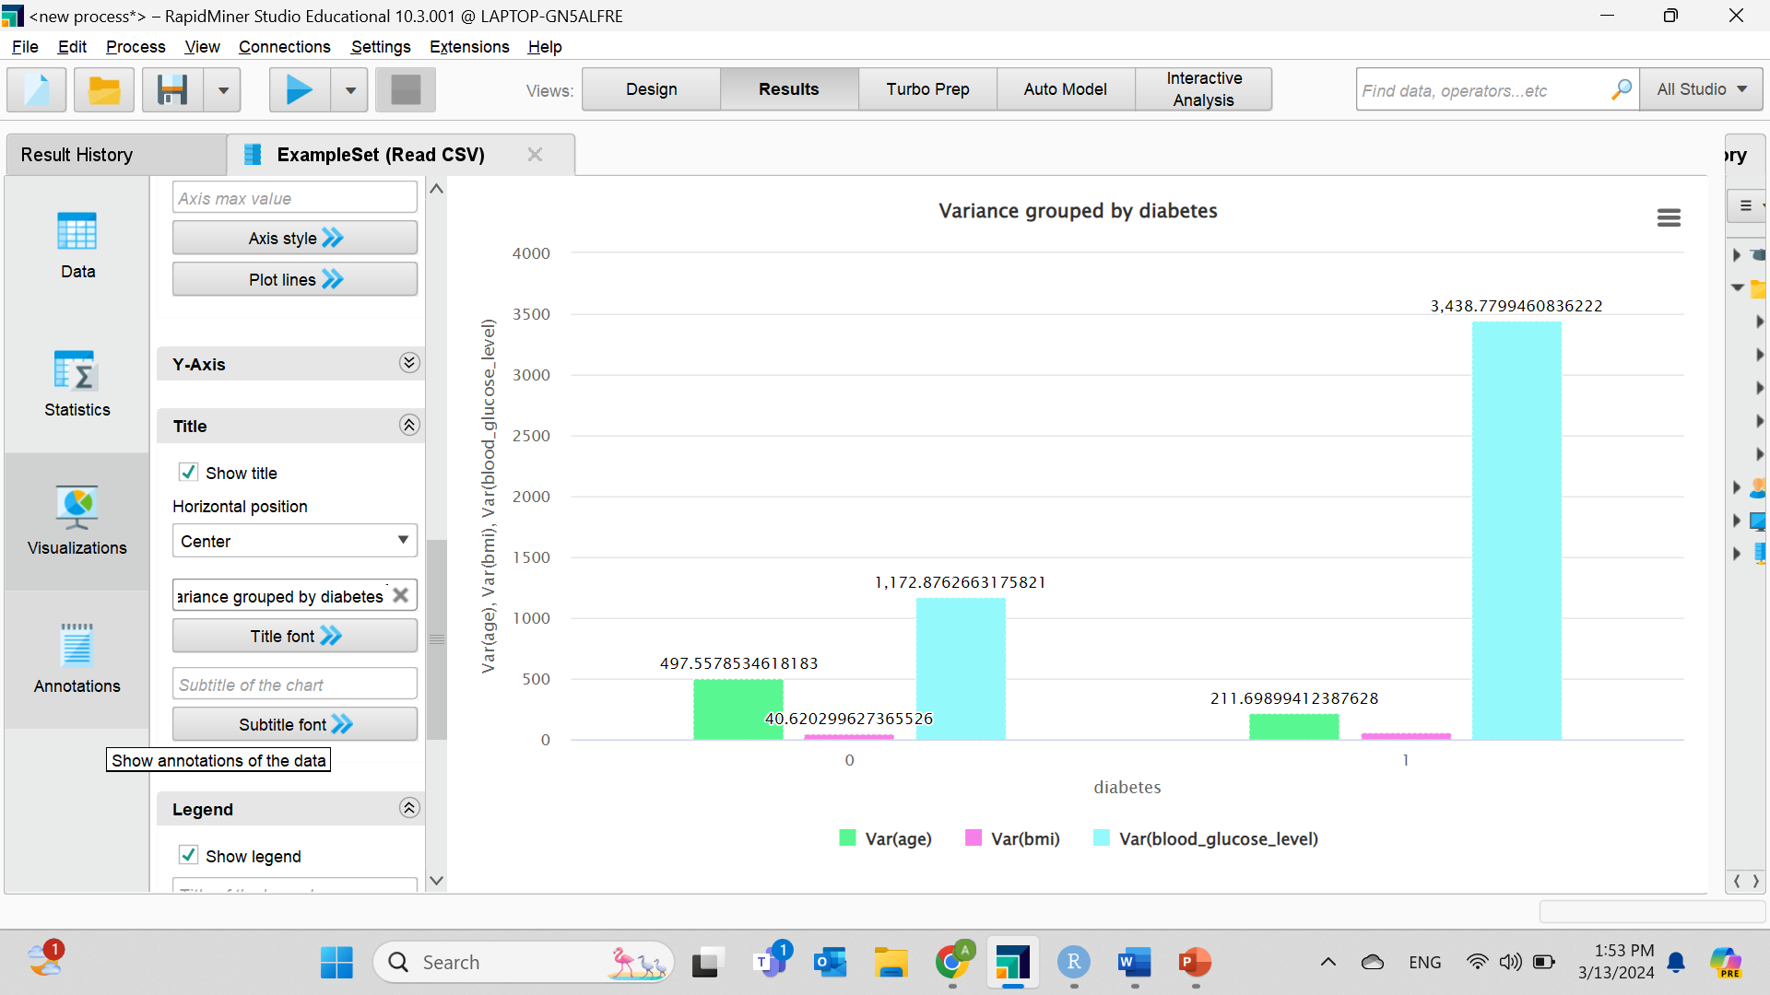**Figure 23. Standard Deviation.** A large standard deviation is evidence that the data are more spread out.

**Figure 24. Variance.** The graph explains the distance of numbers spread from the mean include large values which implies to the data huge distribution.

# **Task Three - Preparation and** **Pre-processing of Selected Data**

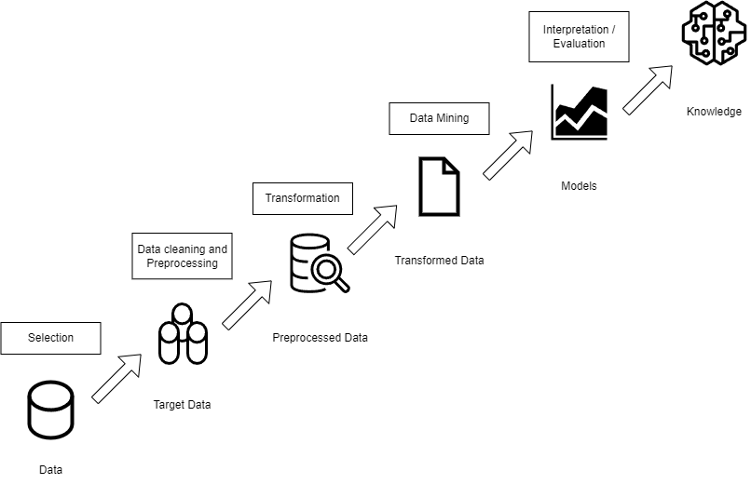Preparation and preprocessing involve transforming the initial data into a format suitable for analysis by making the data valid and organized. After data selection as shown in the previous step, data cleaning, preprocessing and transformation are the next steps according to the Knowledge Discovery in Databases (KDD) architecture to ensure quality of data, cost, and time.

**Figure 25. KDD diagram.** The diagram presents the KDD process where the selection is already done in the previous step.

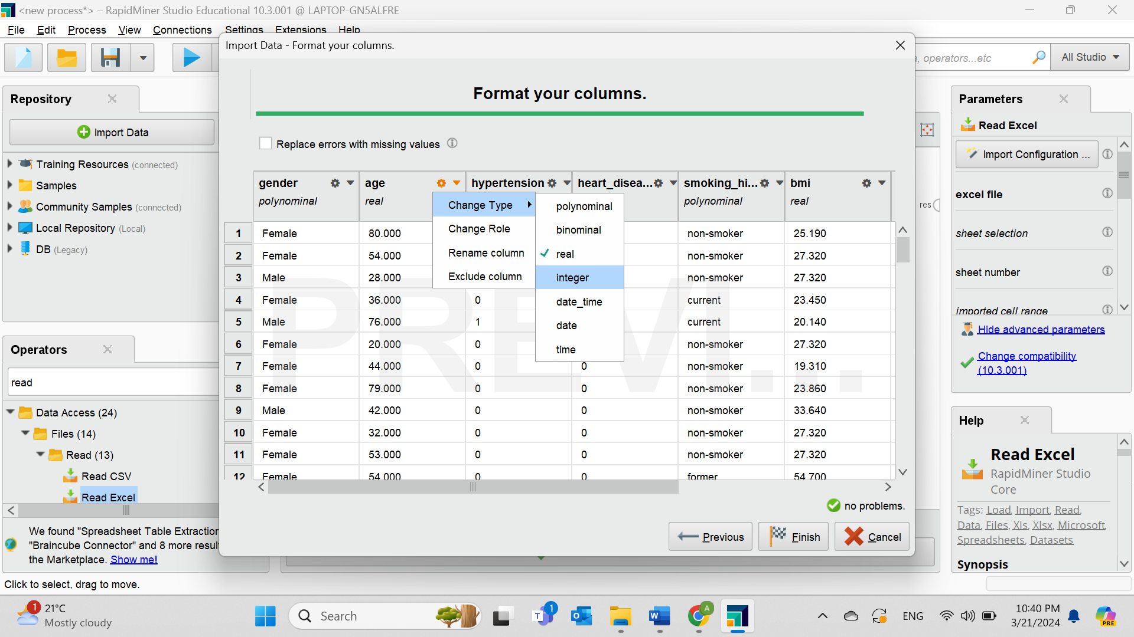

**Figure 26. Convert age format from real to integer.**

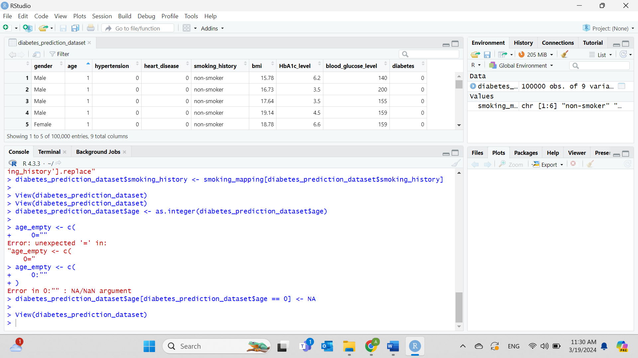

**Figure 27. Changing age value from 0 to null.** There is no age as 0, therefore, it is better to make it as a missing data.

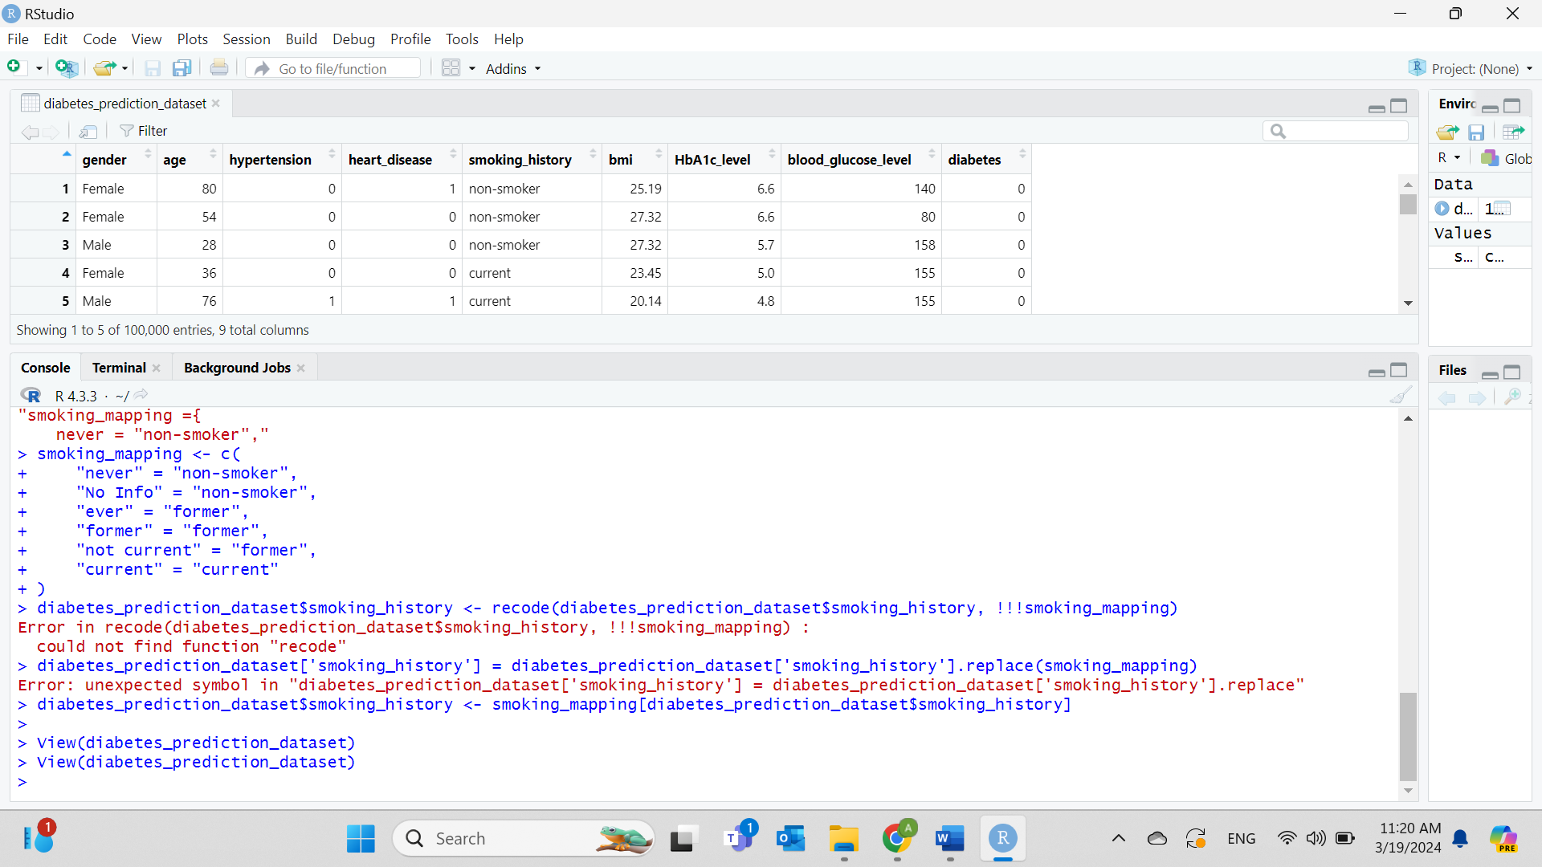

**Figure 28. Three categories of smoking could be created.** Making three categories for smoking instead (non-smoker), (not current), (current) and assign them to the values that have similar meaning:

* “never” =” non-smoker”
* “No info” =” non-smoker”
* “ever” =” former”
* “former” =” former”
* “not current” =” former”
* “current” =” current”

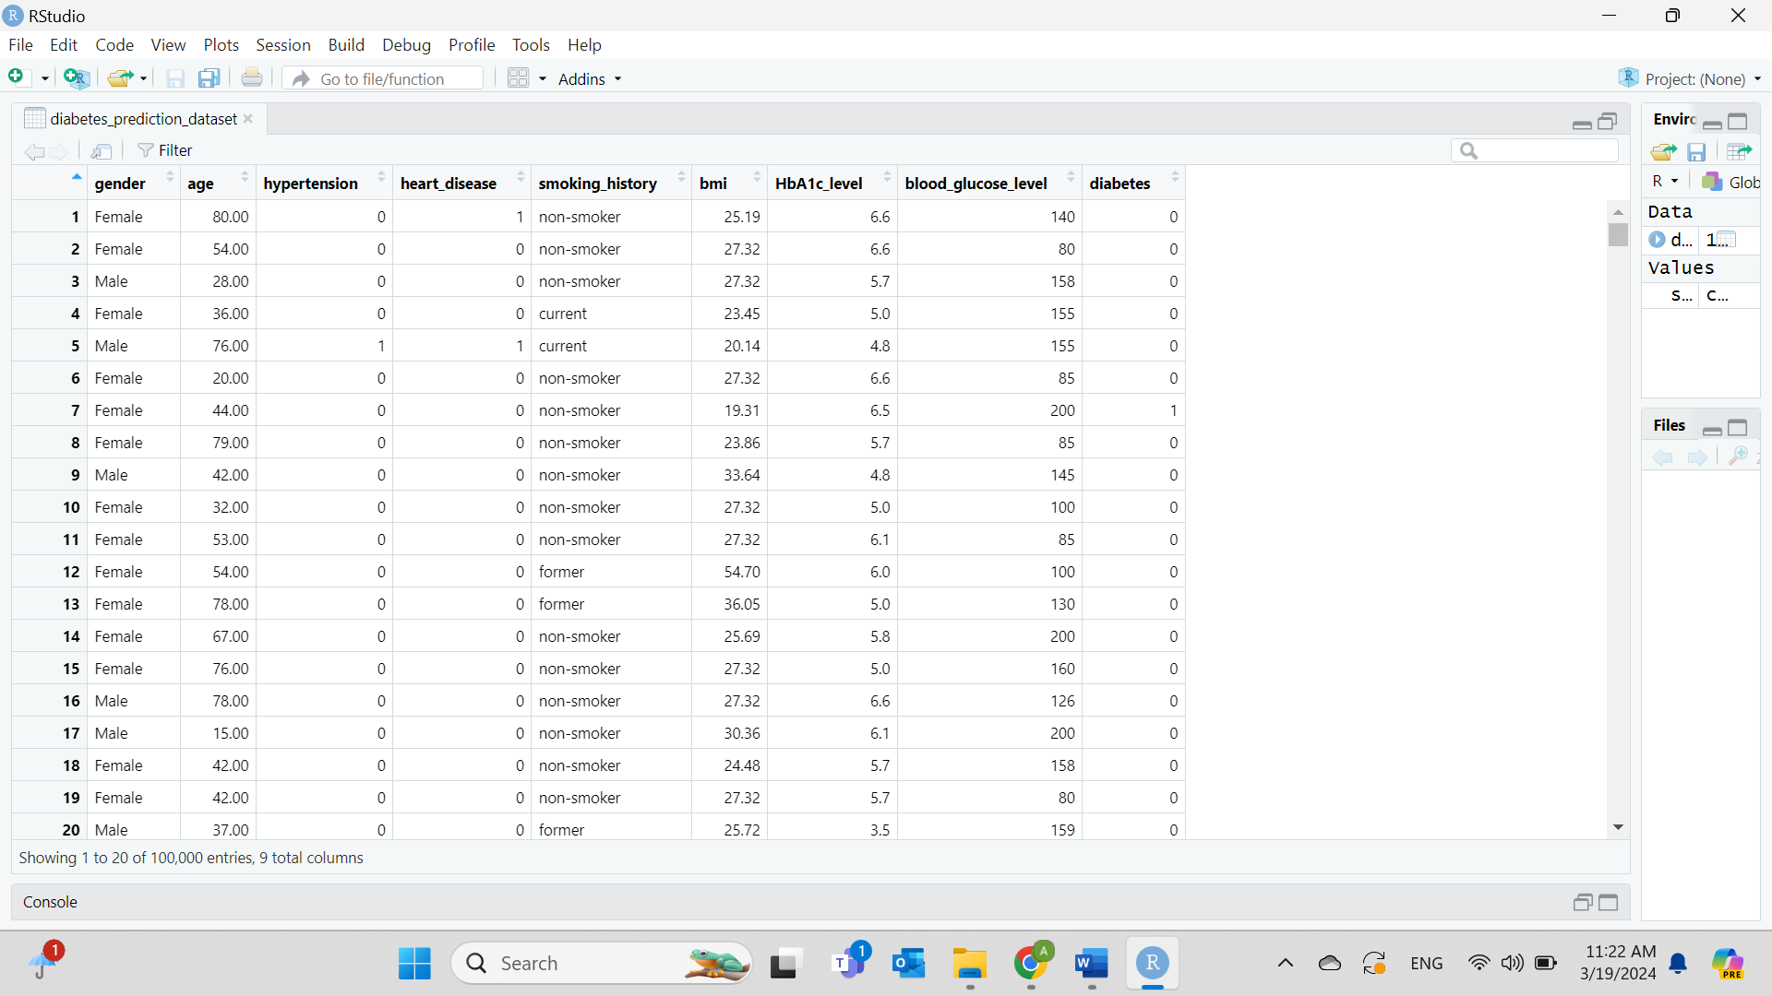

**Figure 29. New categories of smoking are created.** The result shows organized and clear values.

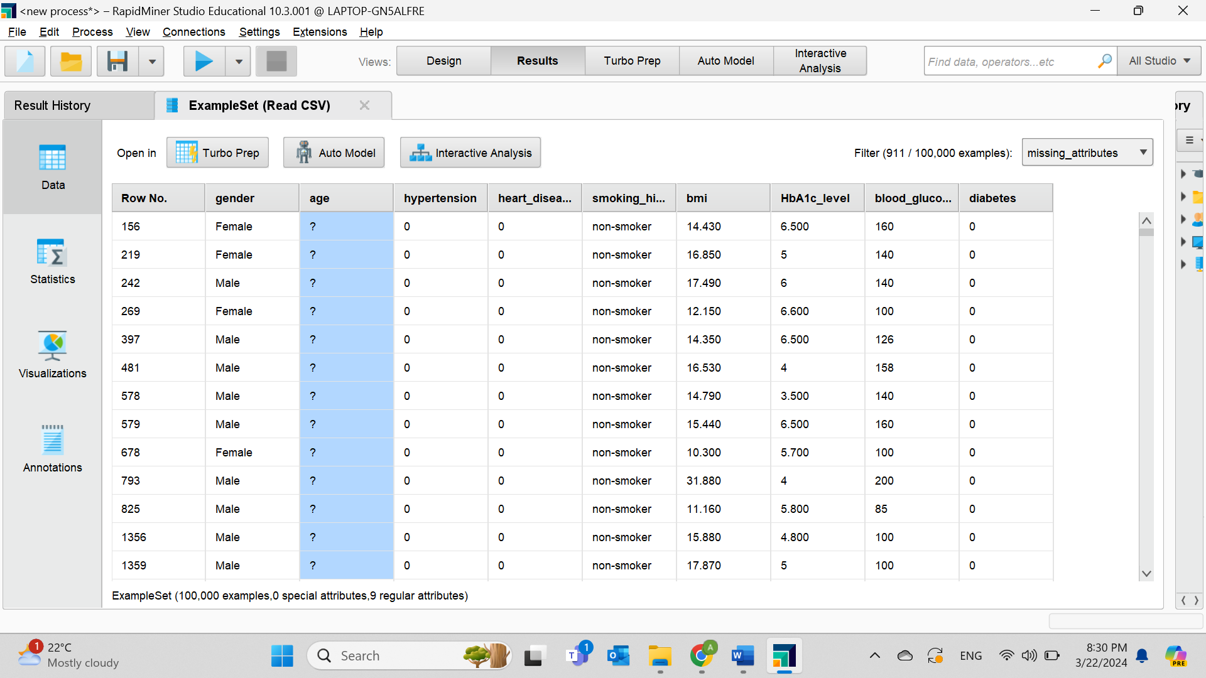

**Figure 30. The age field contains missing data.** Age attribute shows 911 missing instances.

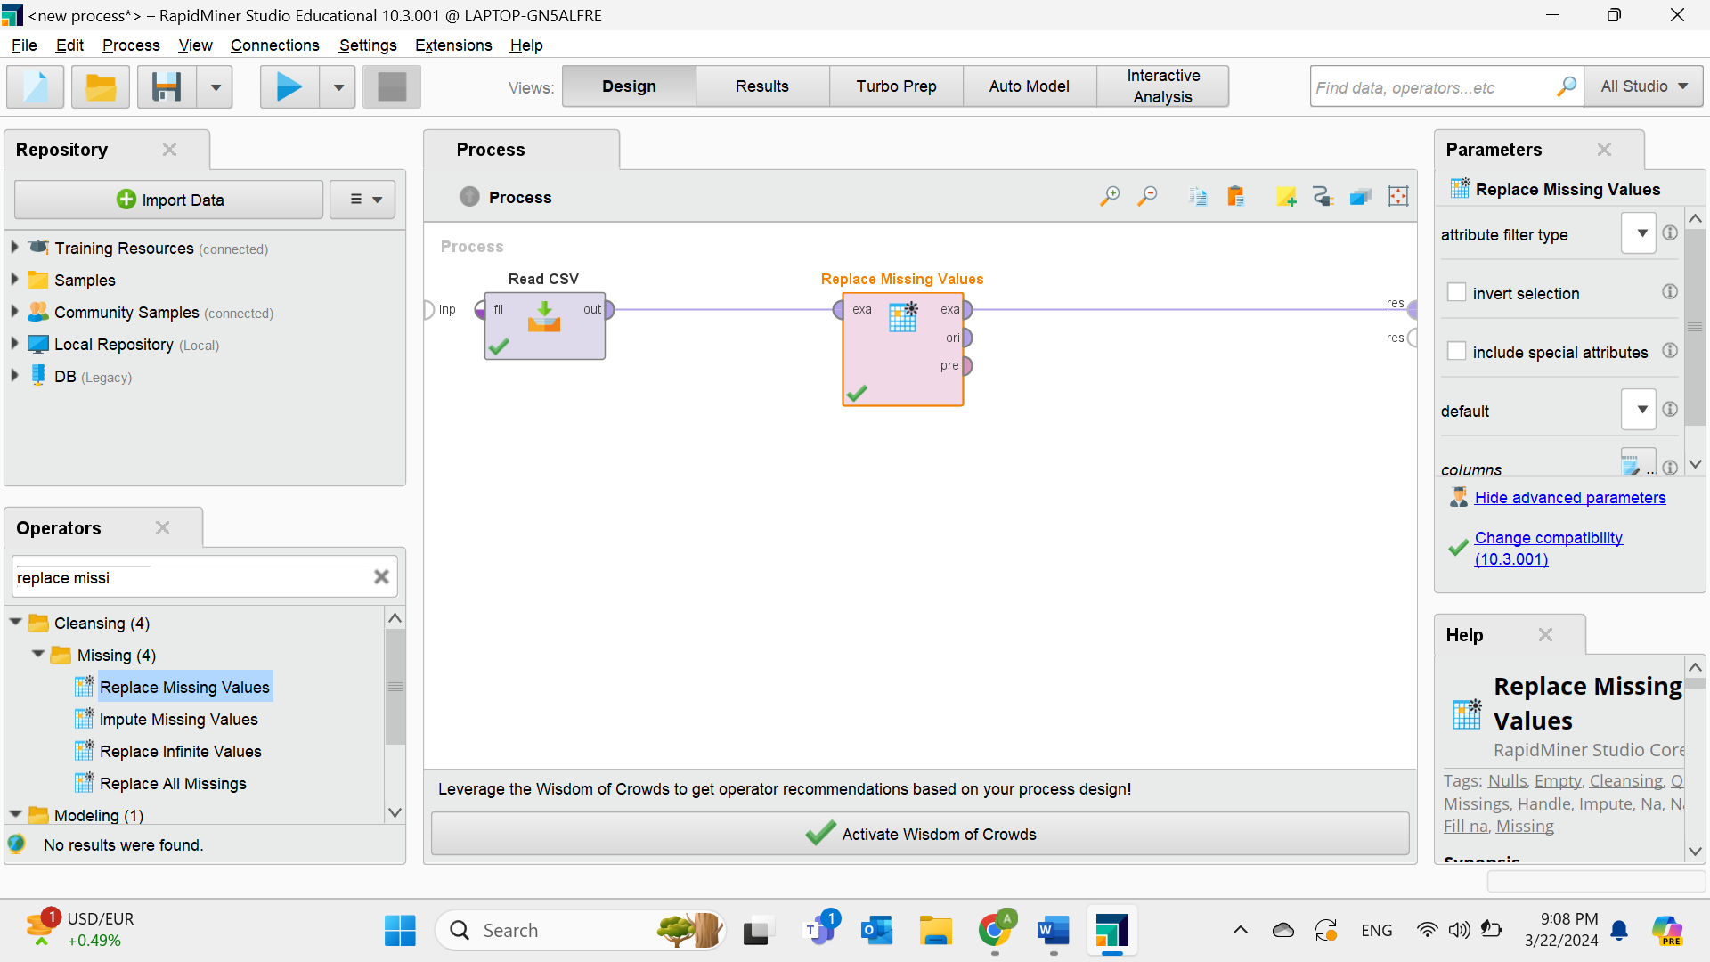

**Figure 31. Replace missing data with the average of the attribute.**

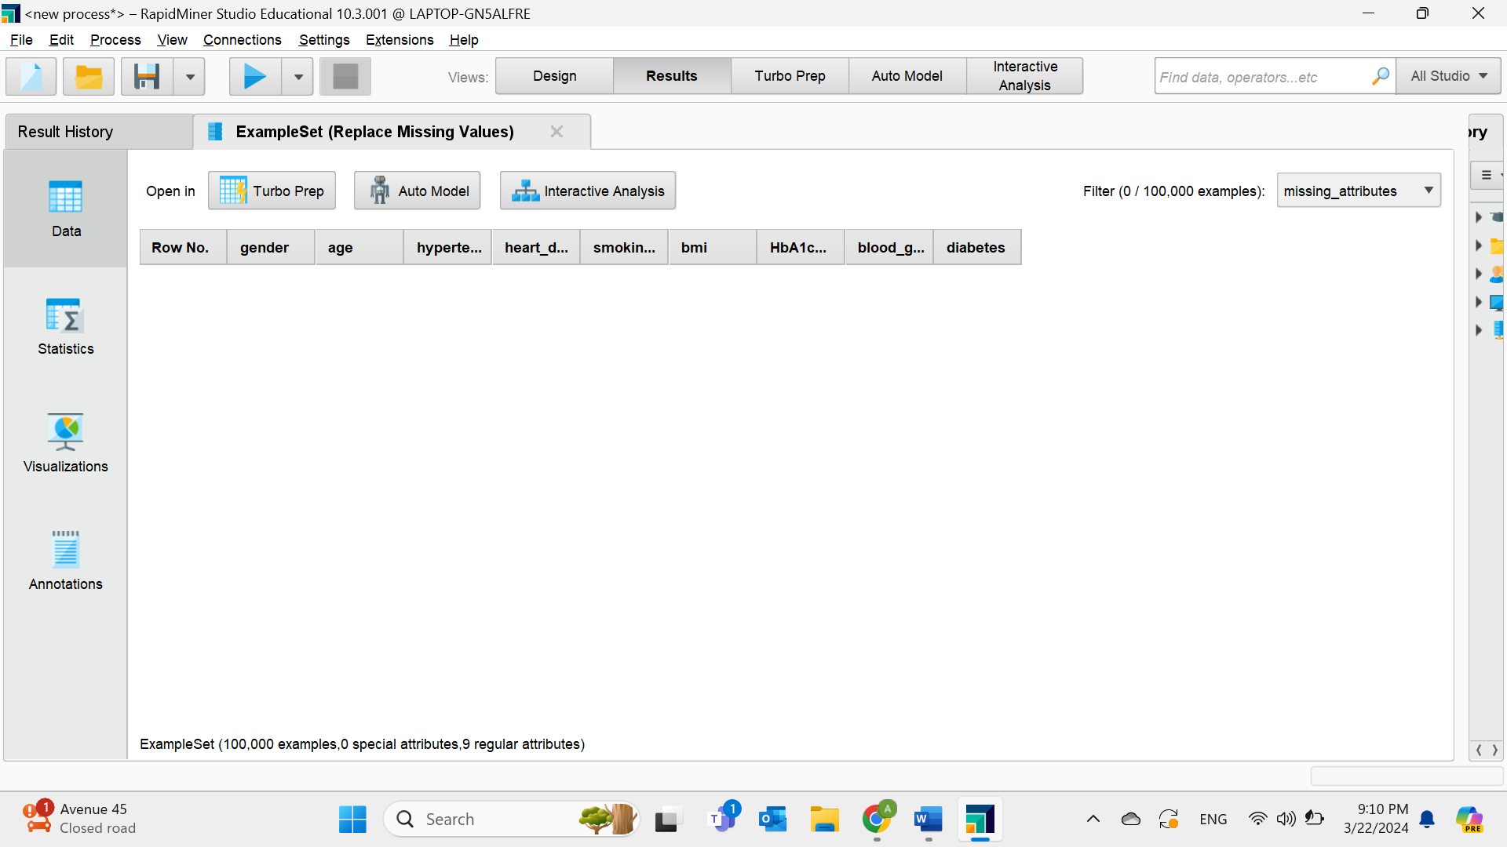

**Figure 32. Result after replacing missing data when choosing “missing_attributes”.**

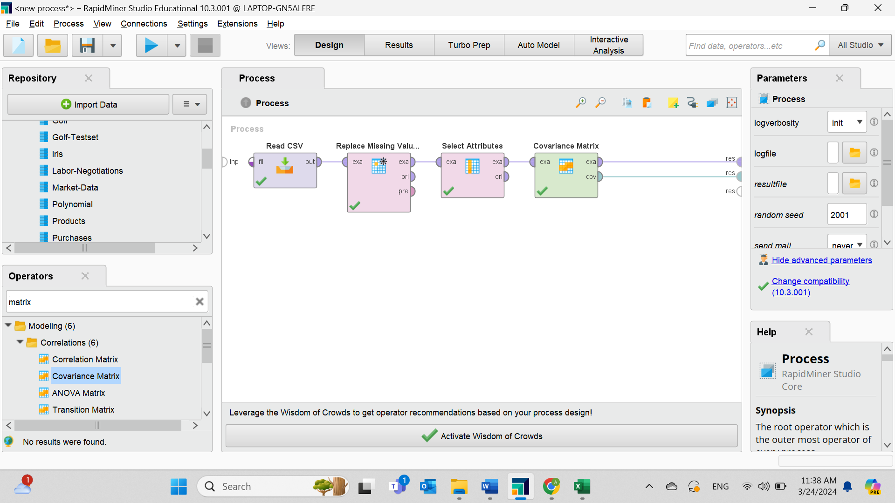

**Figure 33. Applying the “Covariance Matrix” operator and excluding nominal values by using the “Select Attribute” operator.**

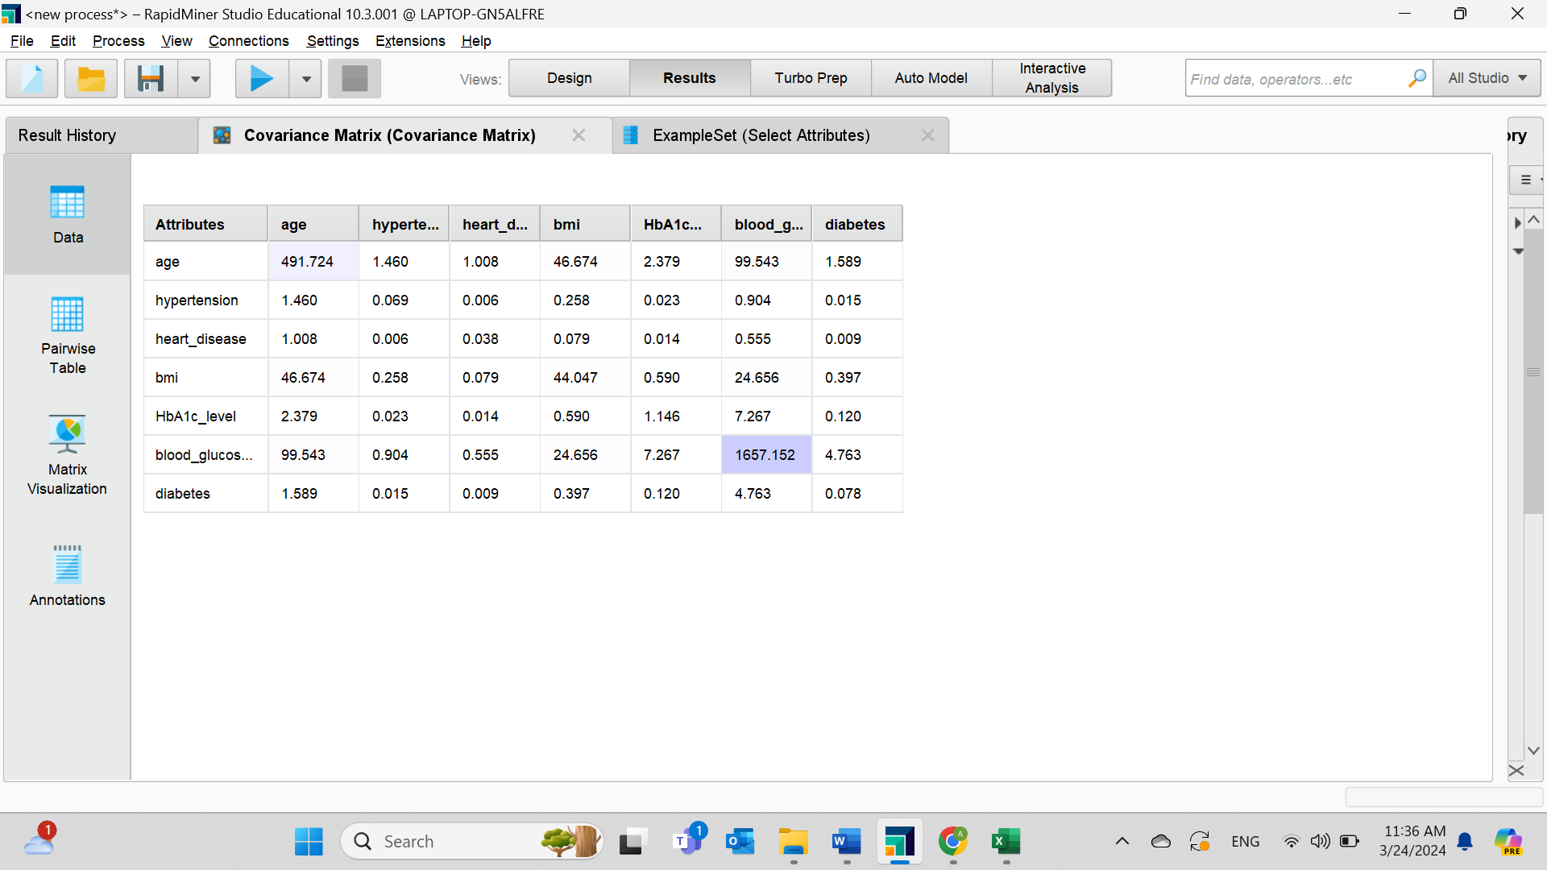

**Figure 34. The “Covariance Matrix”.** Using the operator after data preparation, all data positively related and increase together but diabetes with hypertension and diabetes with heart disease have low possibility of relationship.

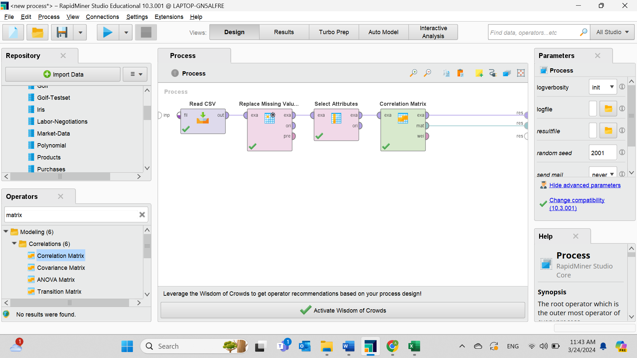

**Figure 35. Applying the “Correlation Matrix” operator and excluding nominal values by using the “Select Attribute” operator.**

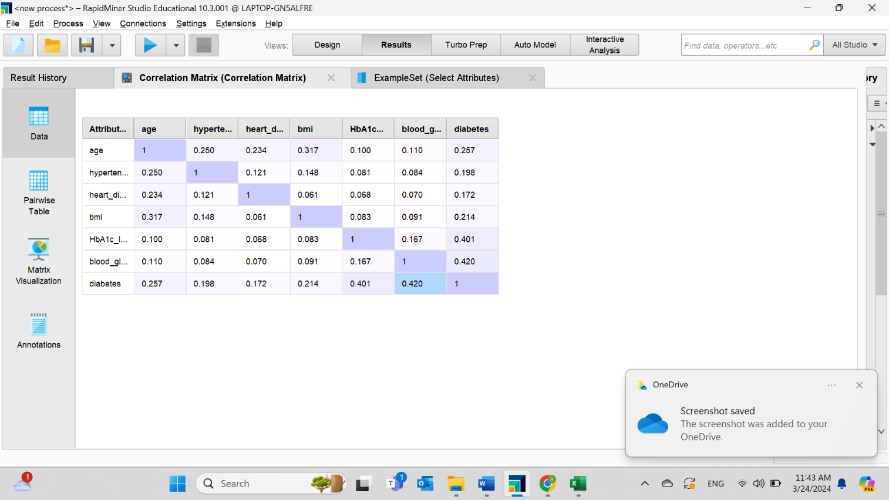

**Figure 36. The Correlation matrix.** The operator after data preparation, all data are near the zero and less than 0.5 which is considered weak.

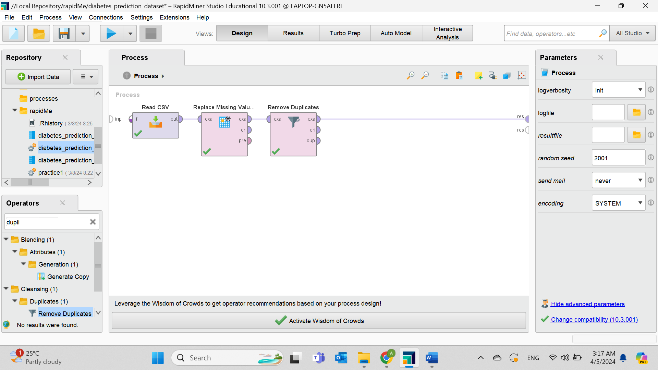

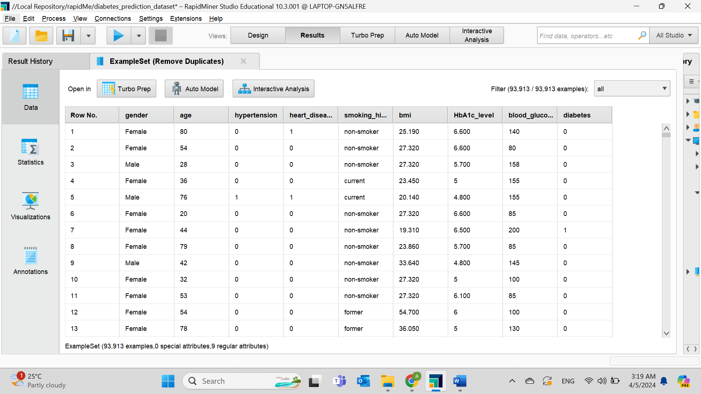**Figure 37. Delete redundant observations with the “Remove Duplicates” filter.**

**Figure 38. Outcome shows a decrease in the number of examples after applying the filter.**

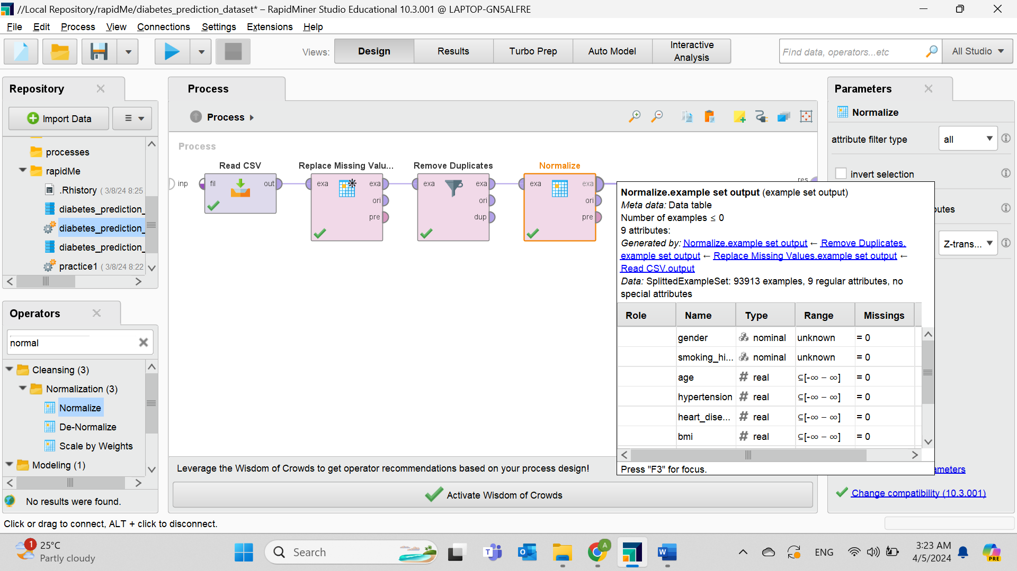

**Figure 39. The “Normalize” operator using Z-transformation method on numeric data.**

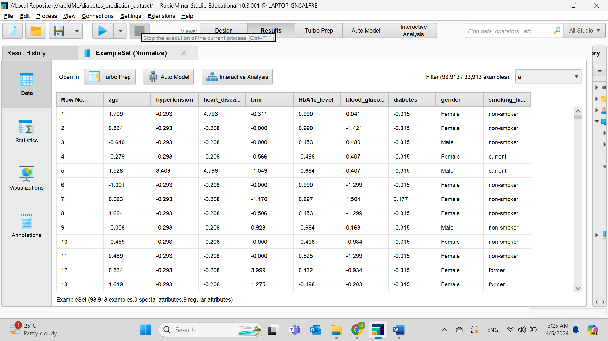

**Figure 40. Outcome of standardization.** It is essential to take advantage of it as completing any operation without it would take a long time.

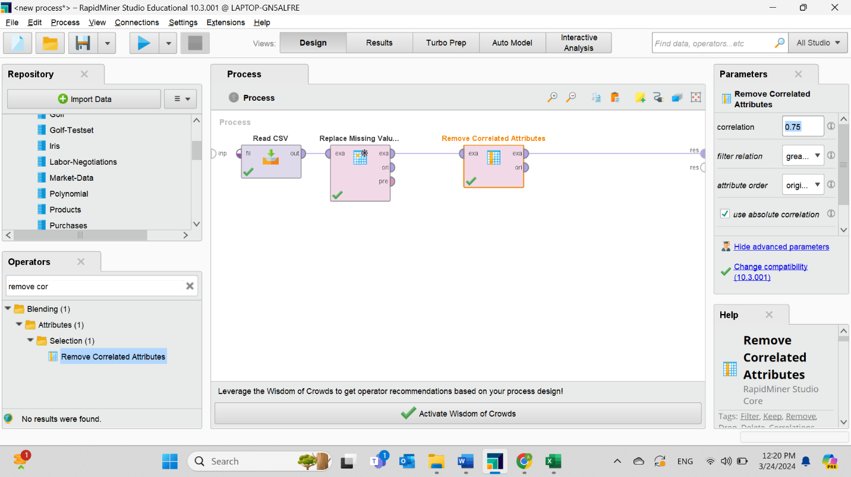

**Figure 41. Remove unnecessary attributes.** The “Remove Correlated Attributes” operator with a correlation value of 0.75 which represents a strong correlation, whereas between 0.2 and 0.5 represents a weak correlation.

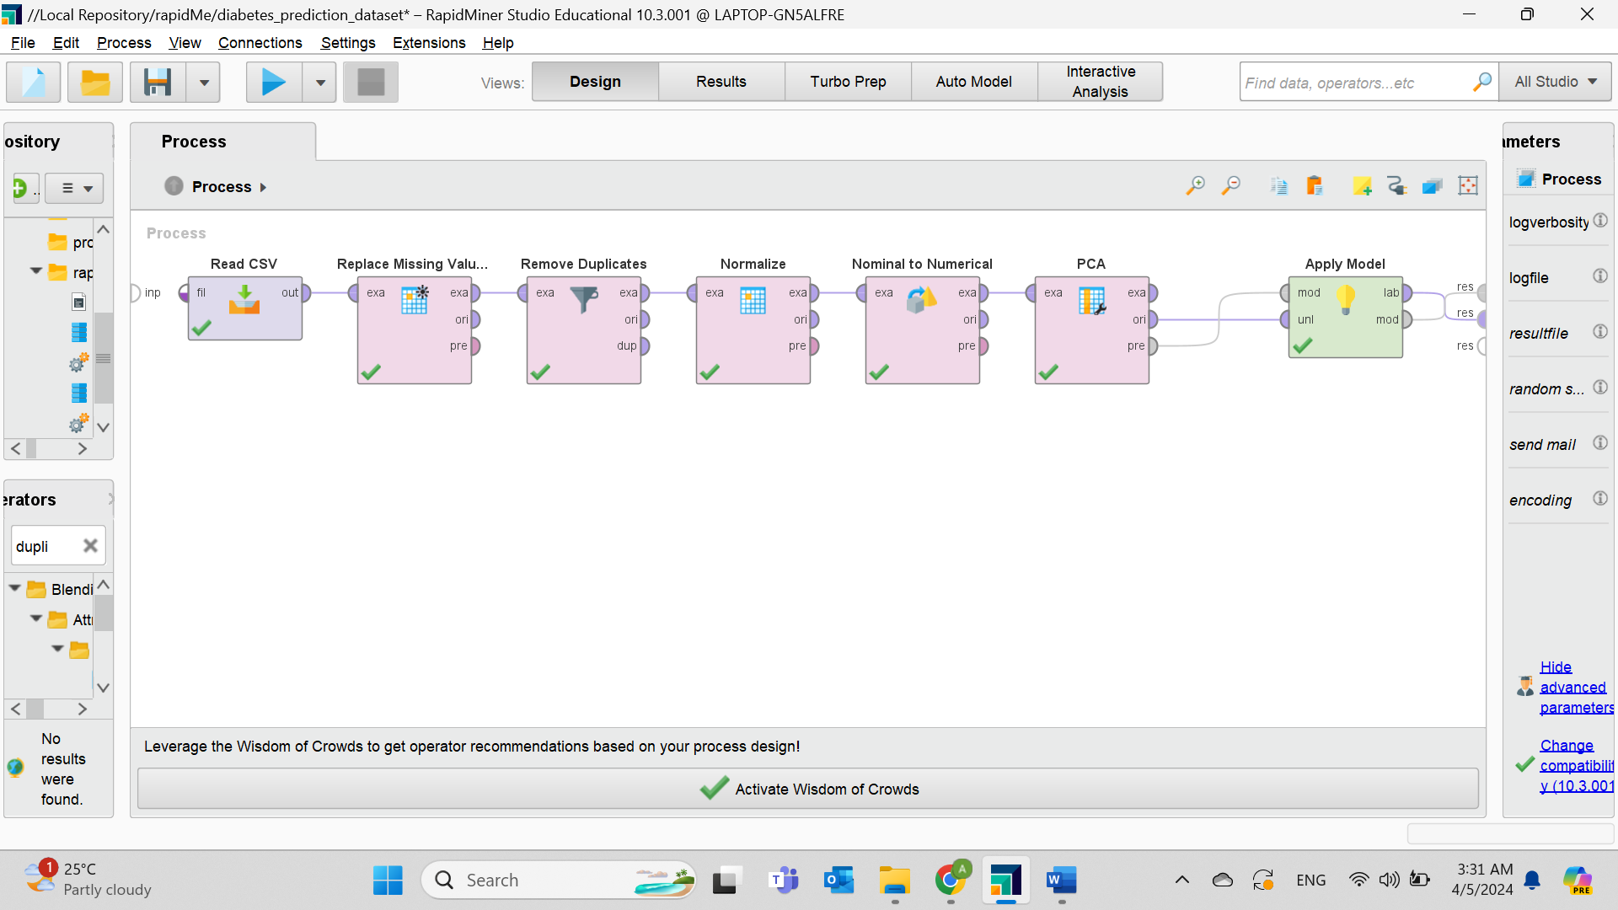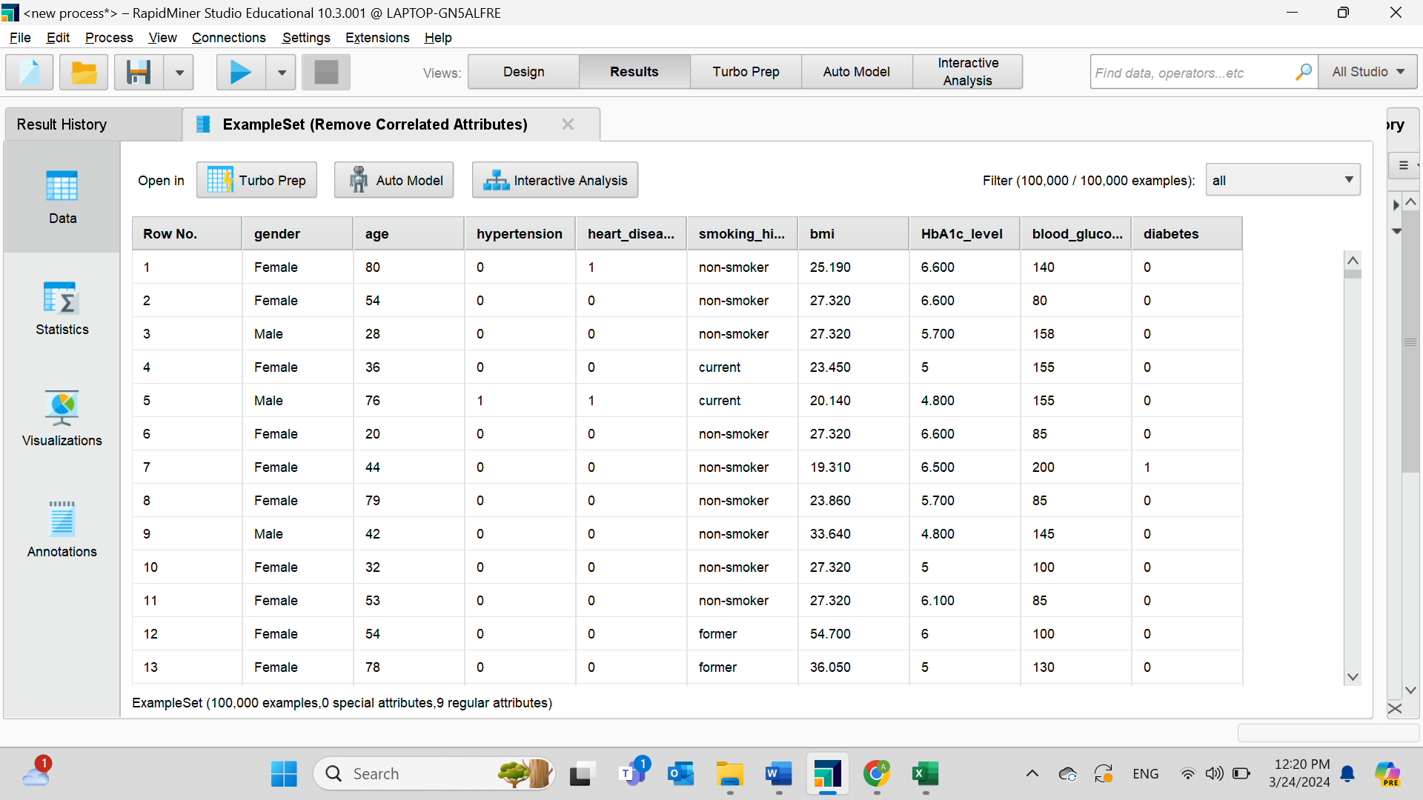**Figure 42. Result shows no column is deleted.** All dimensions are less than 0.5 that is why all nine columns are presented.

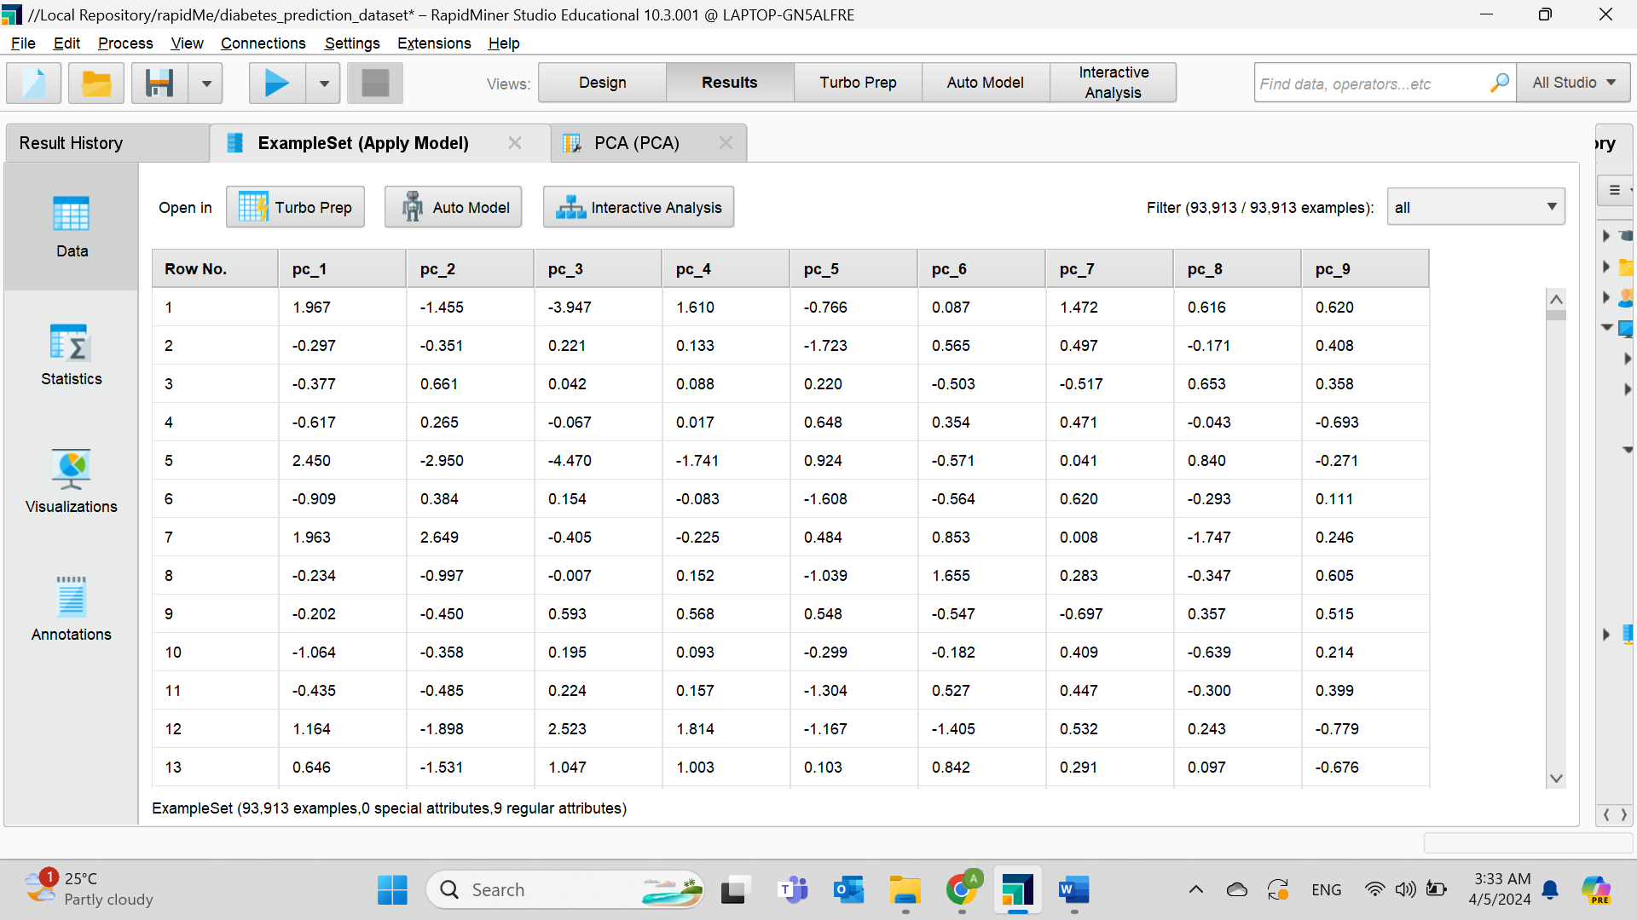**Figure 43. Another Data Mining Reduction Technique to confirm the previous method.** Conducting Principal Component Analysis (PCA), first by converting nominal data to numbers with the “Nominal to Numeric” operator, followed by the “PCA” operator with 0.95 Variance, and finally using the “Apply Model” operator to show the number of PCA for reducing the number of attributes in the dataset.

**Figure 44. The number of PCA.** Since the data collection includes nine dimensions, the result shows nine PCAs.

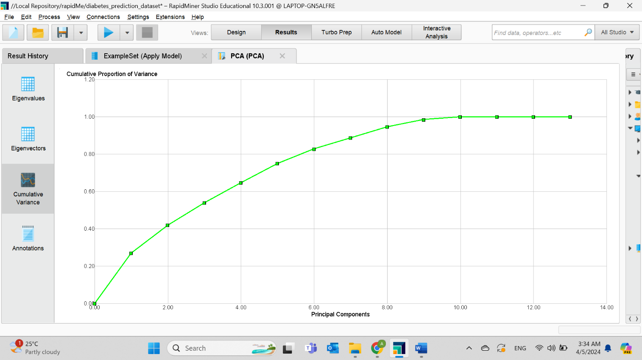

**Figure 45. PCA result for the “Cumulative Variance” tab.** As the graph displays, the line breaks after the ninth point, indicating that all attributes are necessary and providing rich information.

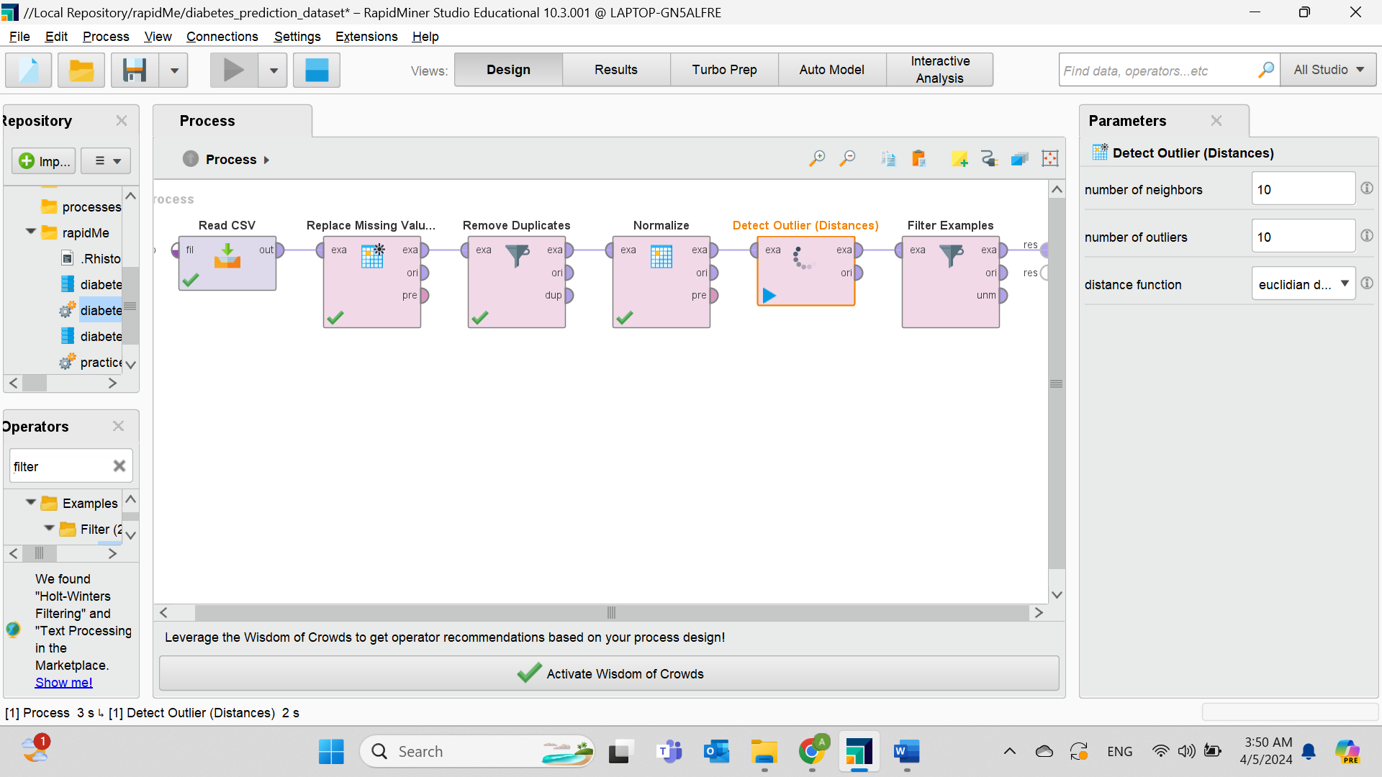

**Figure 46. Remove Outliers.** Because our data set is too big, the anomaly finder is not working in RapidMiner and in RStudio we got the same error regarding memory efficient in PC and laptop, so we used the boxplot method which showed no outliers which may lead to having this error using the operator. However, use the “Detect Outlier (Distance)” operator and assign the number of neighbors and number of outliers to 10, and the distance function will be “Euclidean distance”. Finally, put the “Filter Examples” and set the outliers equal to false.

# A screenshot of a computer Description automatically generated Distribution of dataset after the data preparation

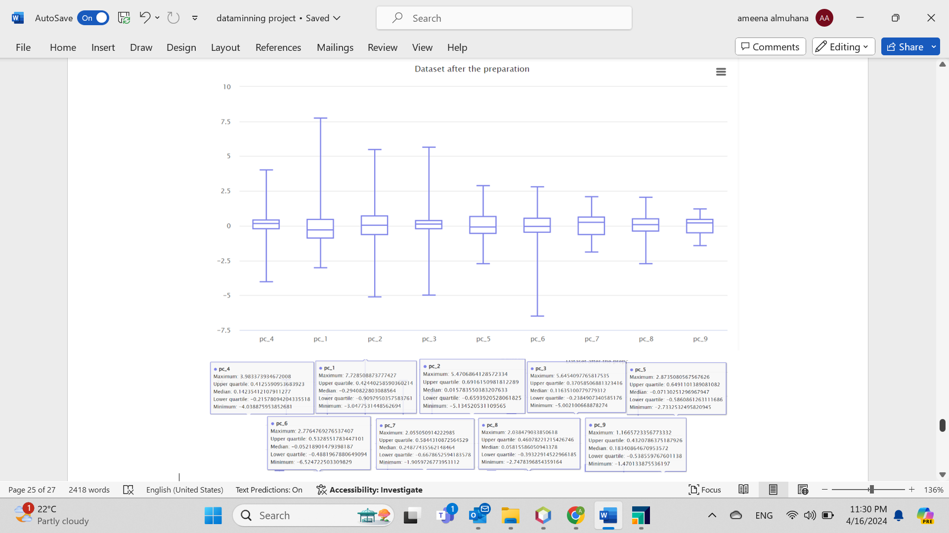 **Figure 47. Histogram after preprocessing.** The distribution illustrates that all data are distributed in the middle, which means all of them are important and contain useful information.

**Figure 48. Box plot after preprocessing.** The plot does not show any outliers. Moreover, it shows the five-point summary and the skewness of data. For example, PC2 indicates a normal distribution. While PC1 indicates a slightly negative skewed distribution.

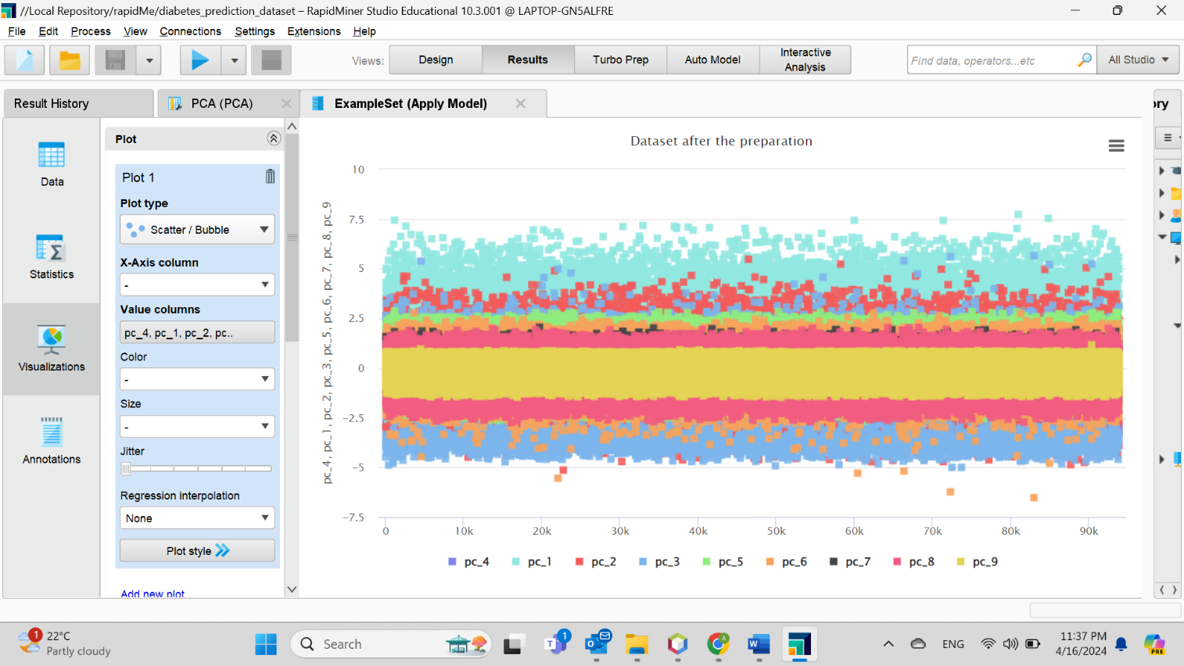

**Figure 49. Scatter plot after preprocessing.** The plot shows a normal representation of the data with no noticeable distinct outlier.

# Inferences before and after data pre-processing

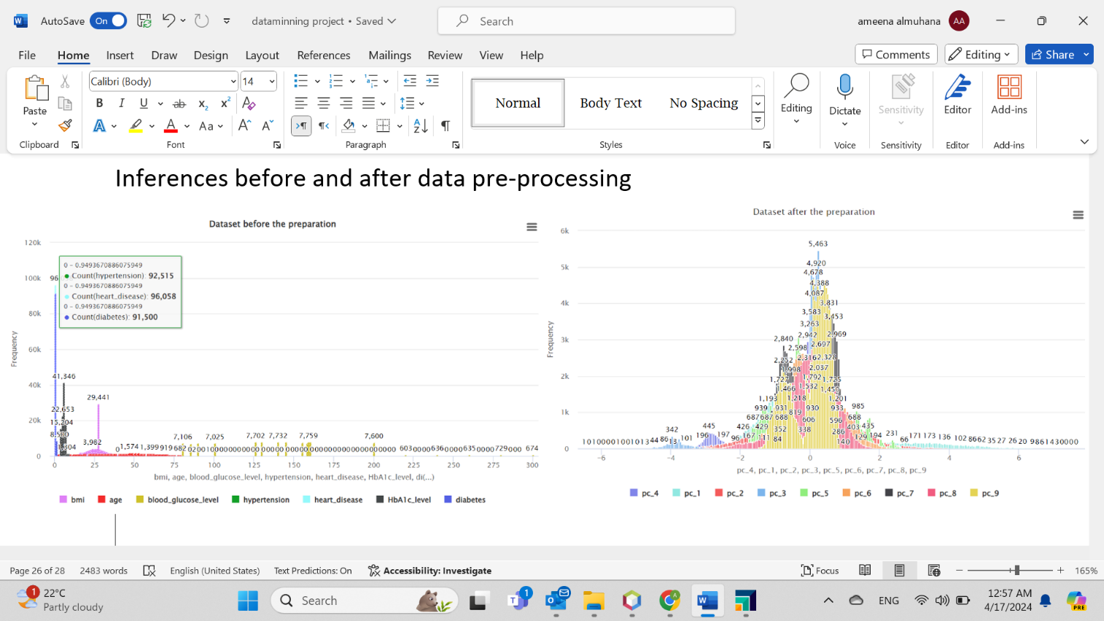

**Figure 50. Histogram before and after preparation.** Before, the data are spread far from each other, whereas after, they are clustered mostly in the middle because replacing missing values of age with the mean moved the data towards the mean. Also, the reduction of redundant rows may contribute to the change of distribution.

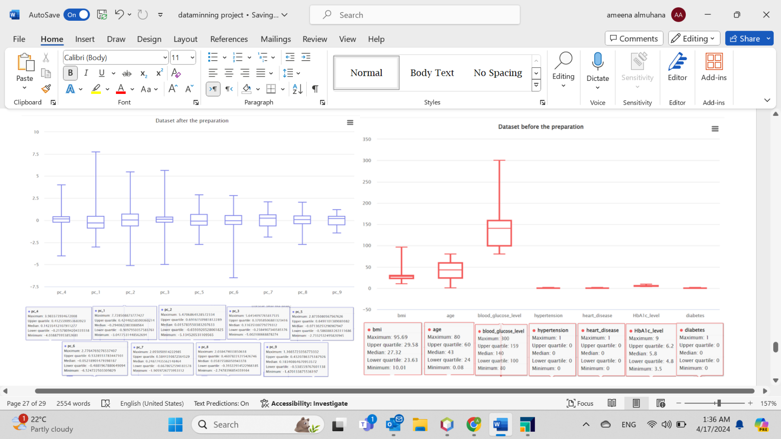

**Figure 51. Box plot before and after preparation.** Theresult indicates a noticeable change in the length of the boxes, upper and lower whisker and the skewness which may be due to using normalization to a certain range that caused wider interquartile range (IQR).

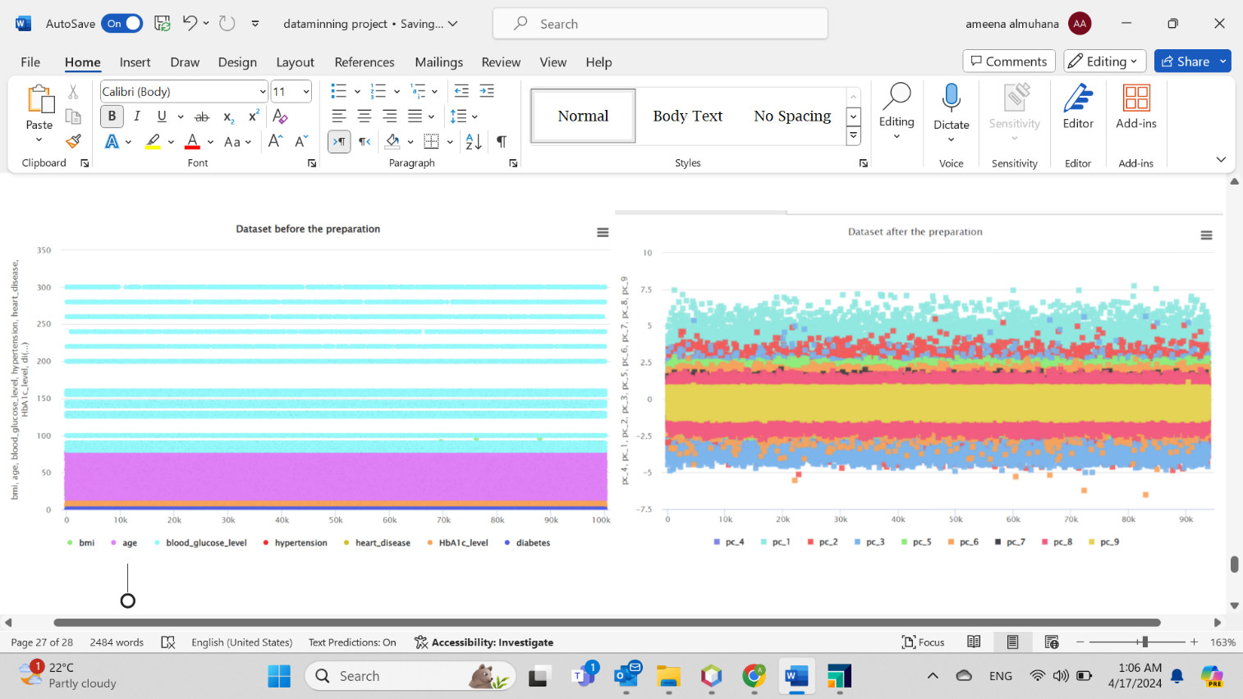

**Figure 52. Scatter plot before and after preparation.** The data before presenting horizontal lines of data points that are above each other, signaling possible duplicate data points or errors in the data. On the other hand, the plot reveals a larger range of data points distributed, which means a reduction in errors or duplication of data that leads to a clearer scattered and dispersed pattern.

# **Task Four - Building Data Mining Models**

The supervised approach type like classification seems more appropriate as the dataset is based on patients having and not having diabetes. Therefore, it is better to label the data depending on diabetes to have a predictive model. Classification models work well for the collection set and lead to accurate prediction as other methods like hybrid is complex and unsupervised which focuses on hidden pattern instead of predicting a specific result such as a person having diabetes or not. This is selected by experimental basis. The reason to select random forest and decision tree models which are Parallel Ensemble learning (Bagging) is to decrease variance, reduce bias, handle both quantitative and qualitative types, large set of data and provide feature importance. Four models are going to be compared, First model (Decision Tree), Second model (Random Forest) and two ensemble models (Decision tree and Random Forst).

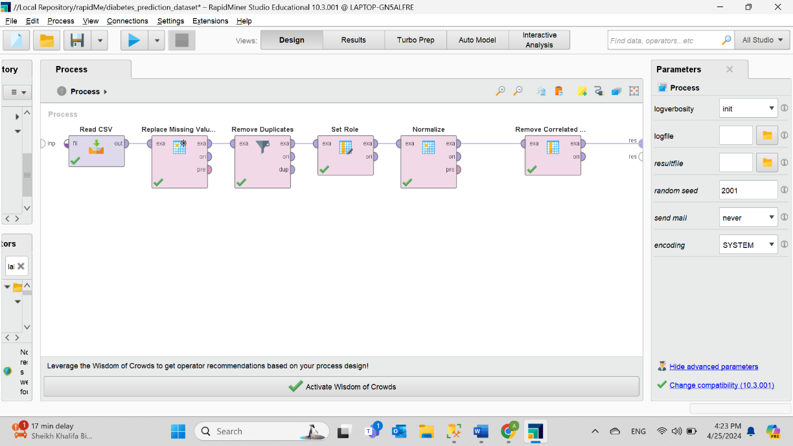First, labeling is important to create a supervised model.

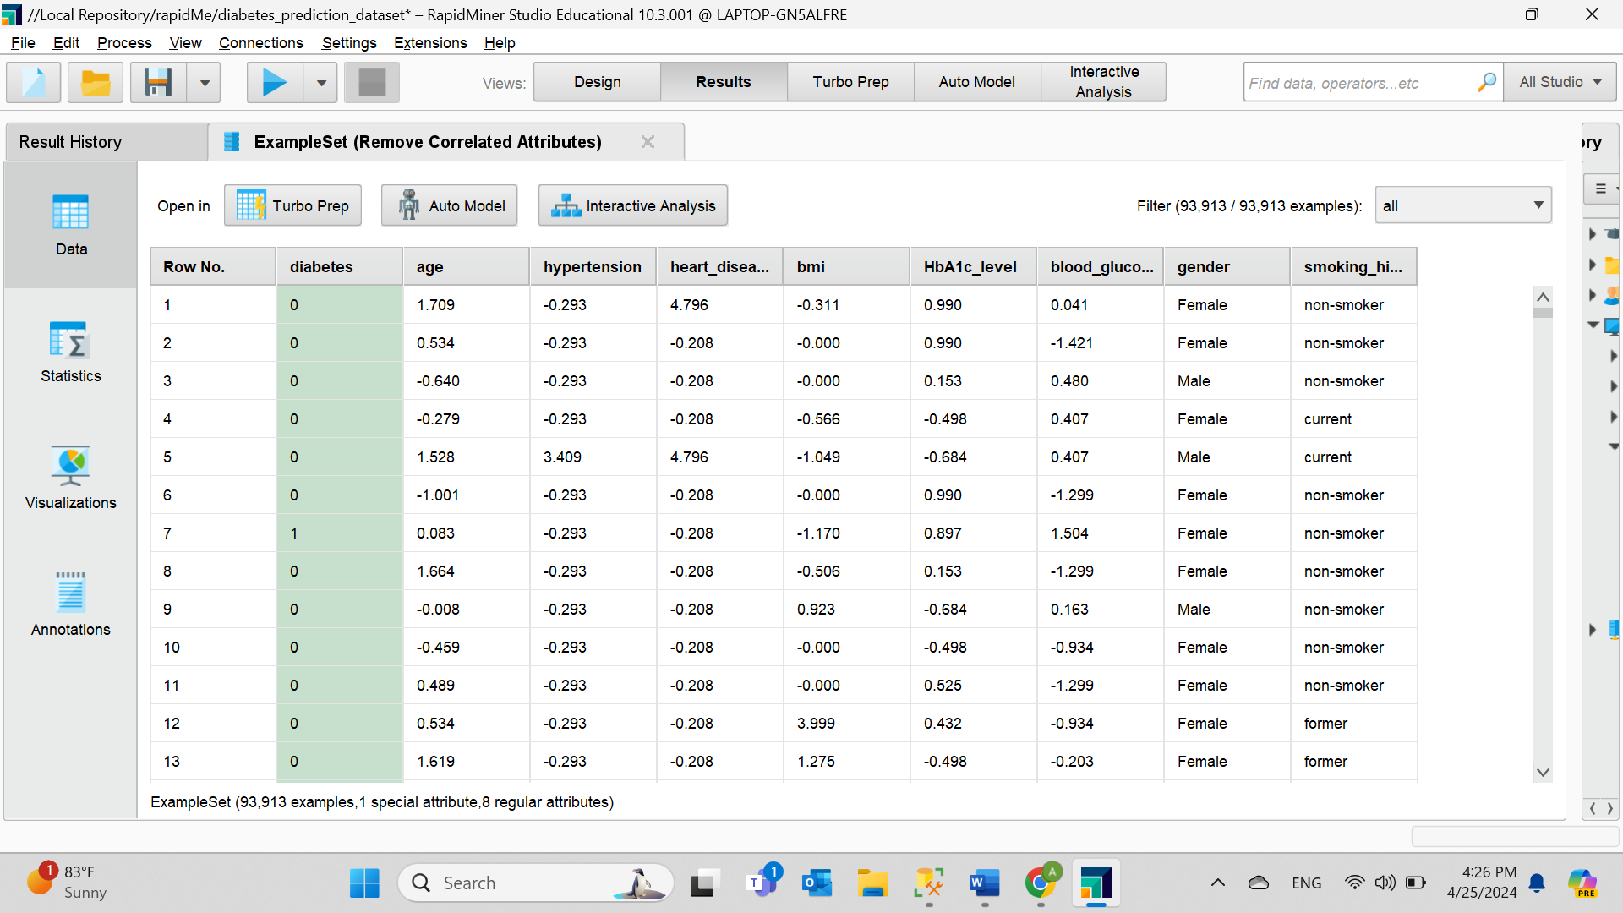**Figure 53. The “Set Role” operator to label the diabetes column.** The same data set before but adding the labelling operator to prepare it for the supervised technique.

**Figure 54. Outcome of the labeling.** The diabetes attribute becomes binary and green.

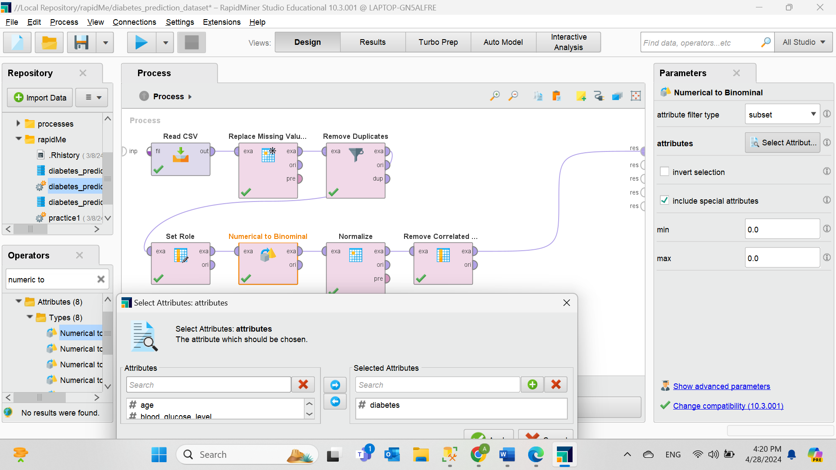

**Figure 55. The “Numerical to Binominal” operator only on the diabetes label and ticking “include special attributes”.** The operator is required for the classification criteria.

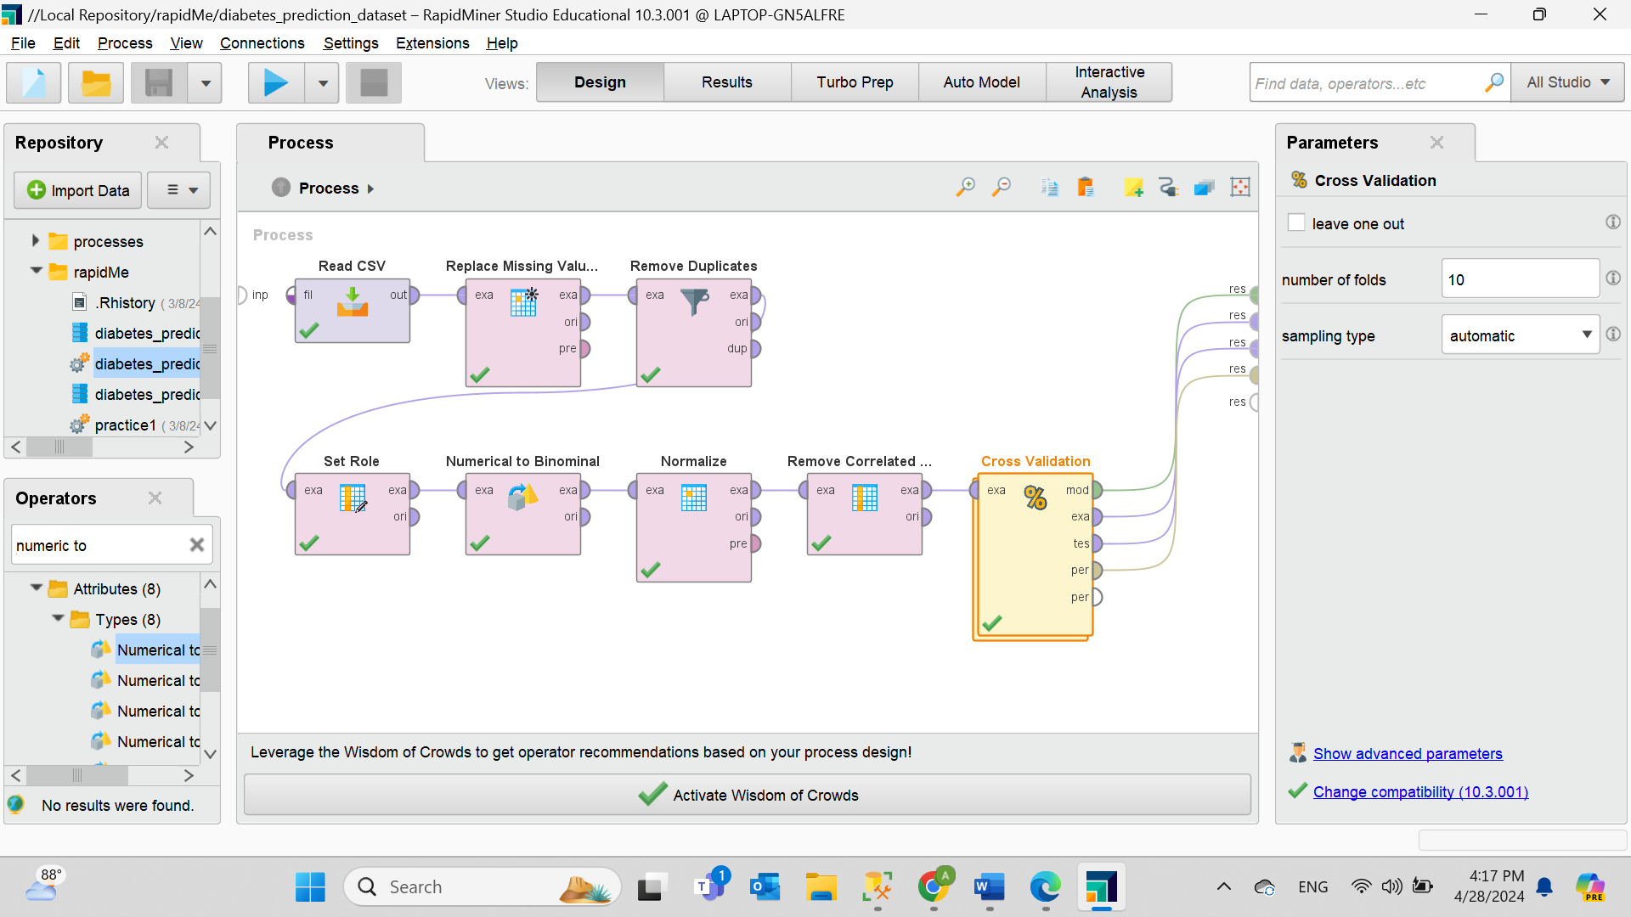

**Figure 56. The “Cross Validation” operator.** Using 10 folds and auto sampling type.

Details of the first model

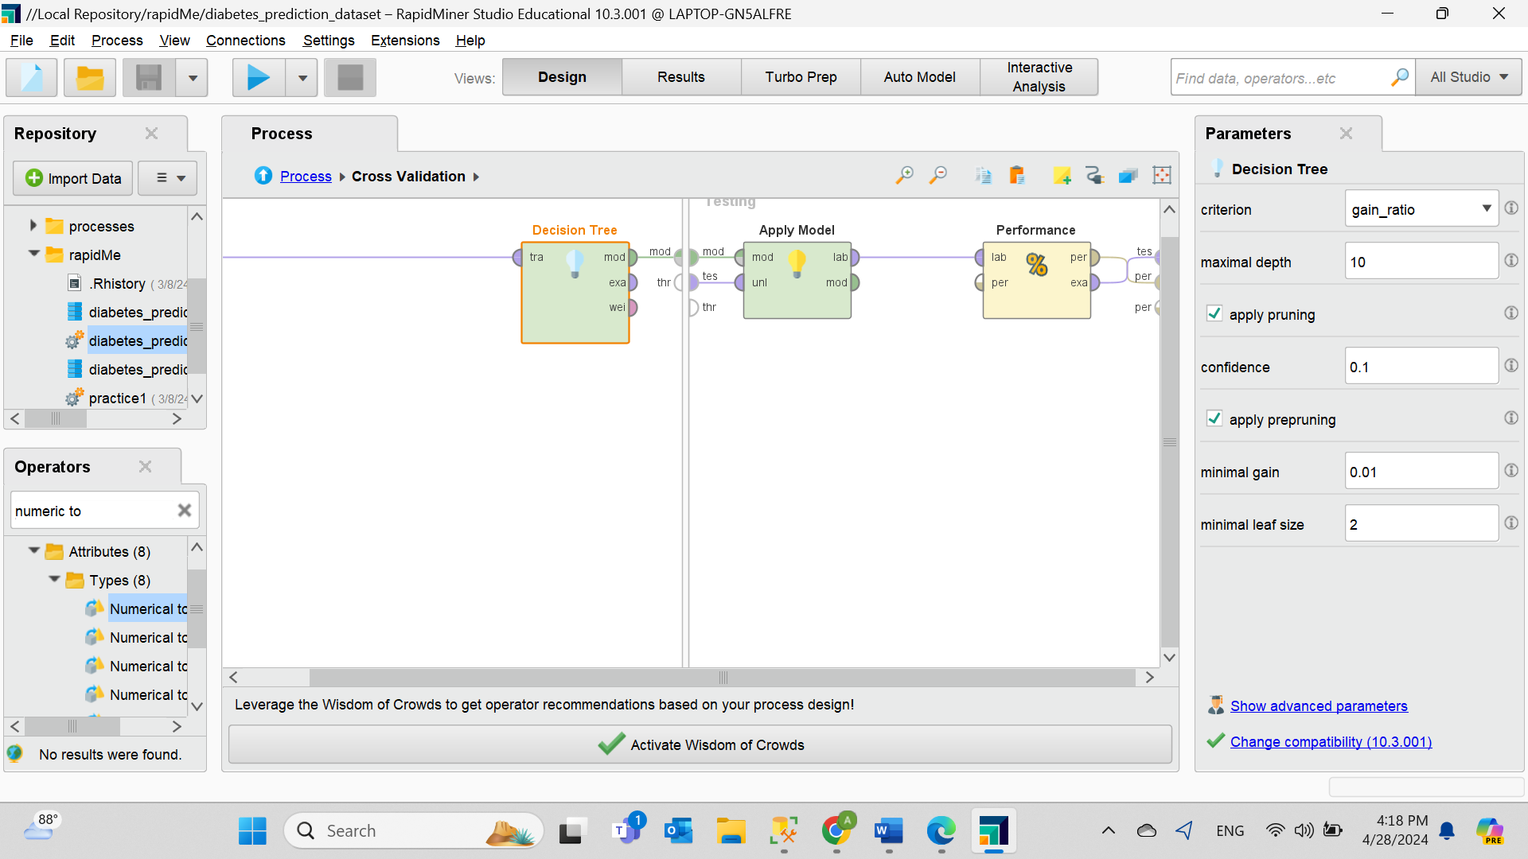

**Figure 57. The first classification model technique “Decision Tree”.** Setting the criterion as “gain_ratio”.

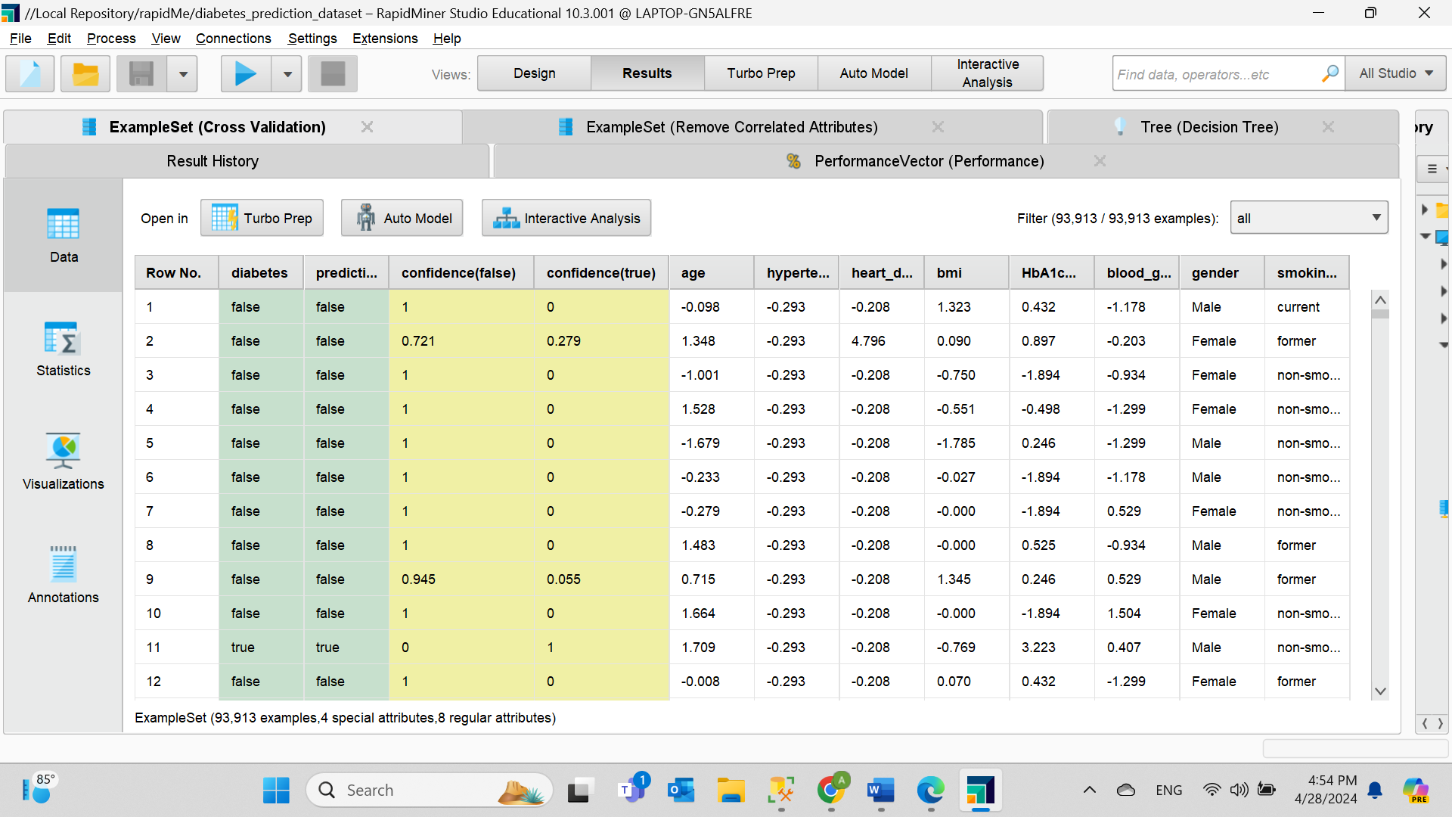

**Figure 58. Result of the first model.**

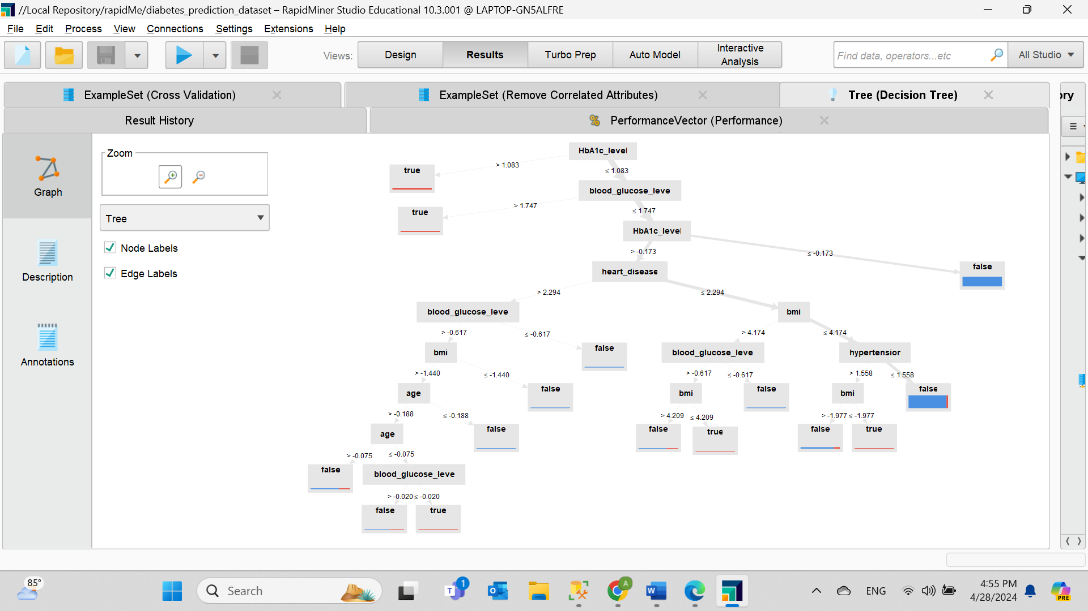

**Figure 59. Graph of the first model.** According to the graph, high HbA1c levels and blood glucose levels are the most important predictors of diabetes. Other factors, such as heart disease, BMI, and age, contribute less to the prediction but are still important.

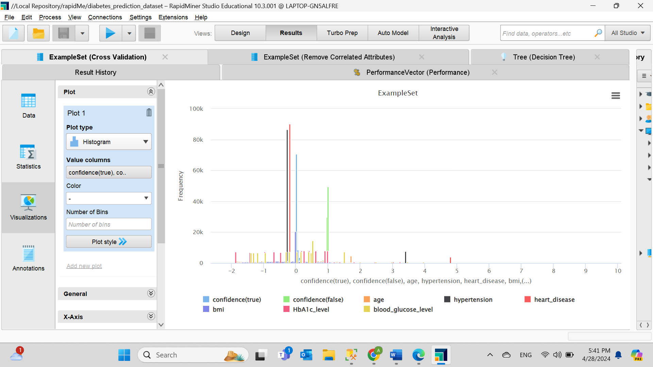

**Figure 60. Visualization of the first model.**

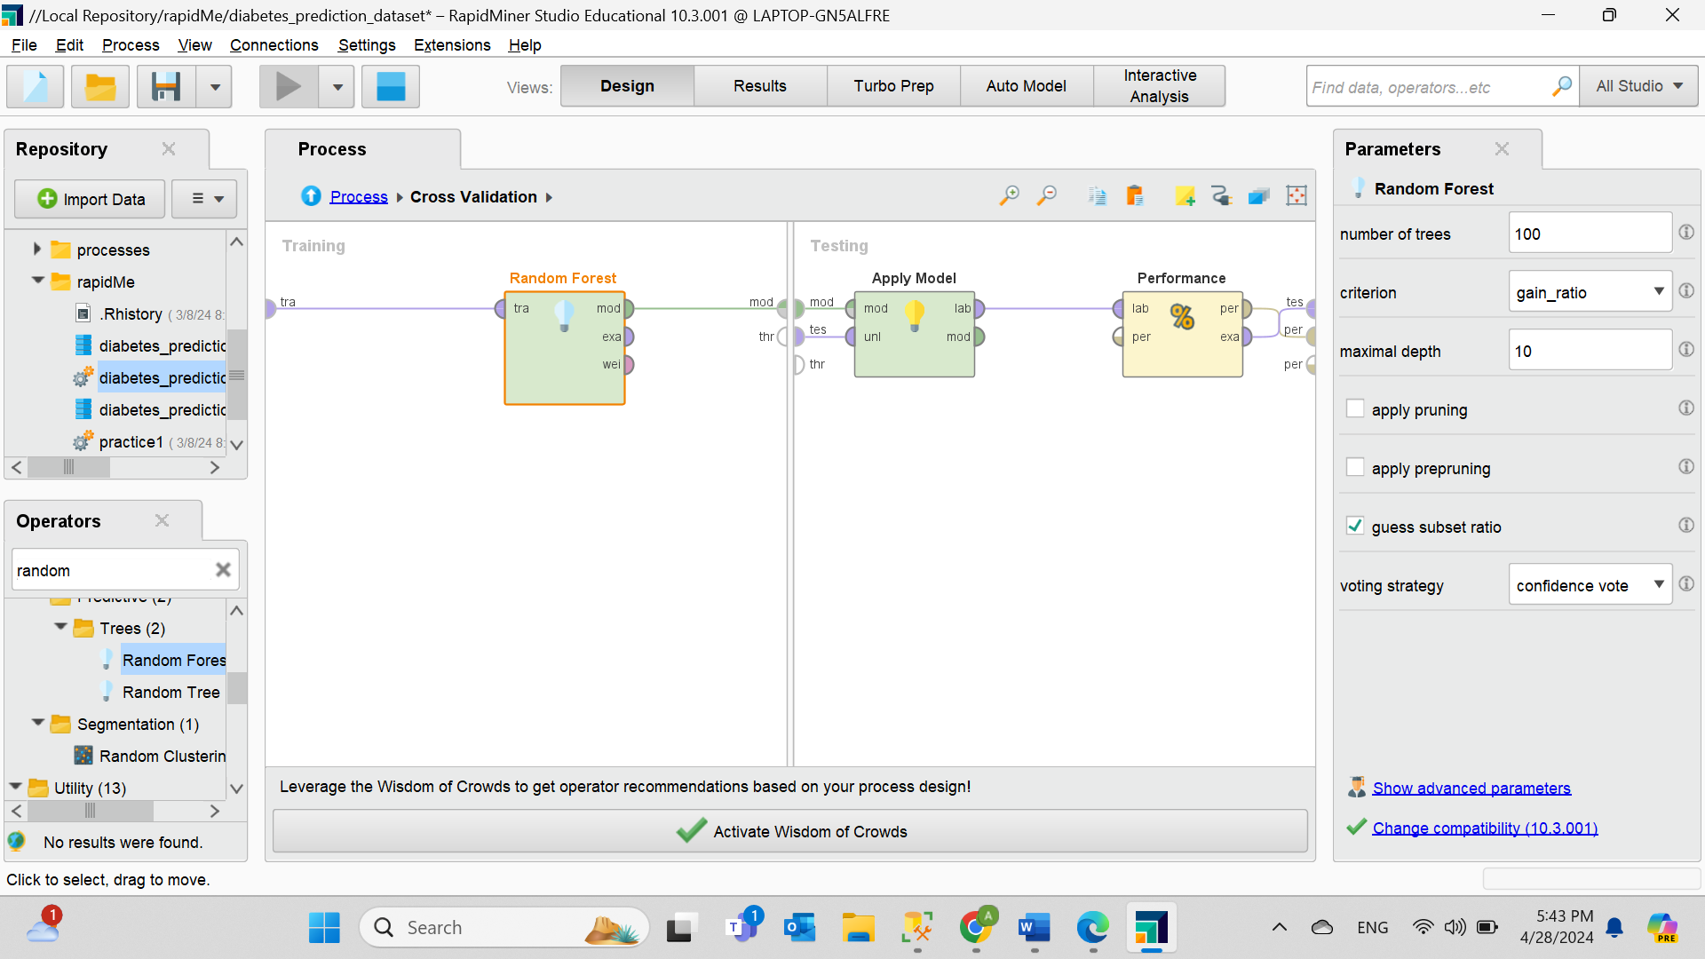Details of the second model

**Figure 61. The second classification model technique “Random Forest”.** Setting the criterion as “gain_ratio”.

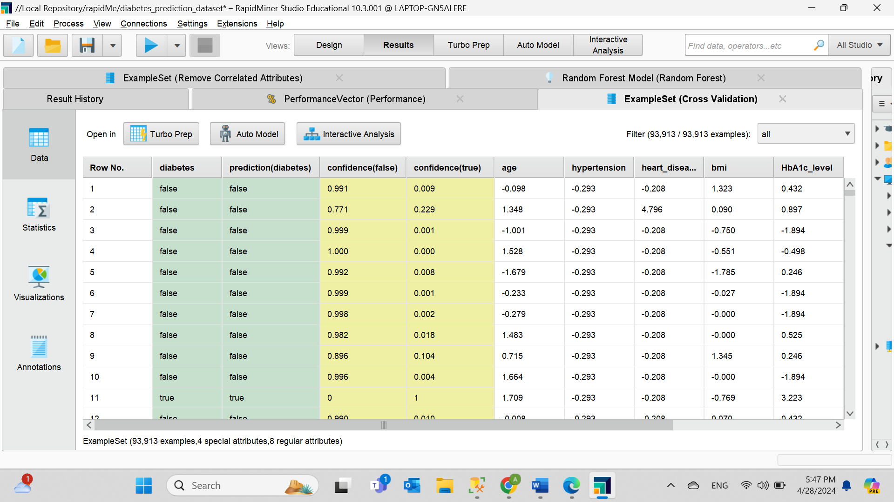

**Figure 62. Result of the second model.**

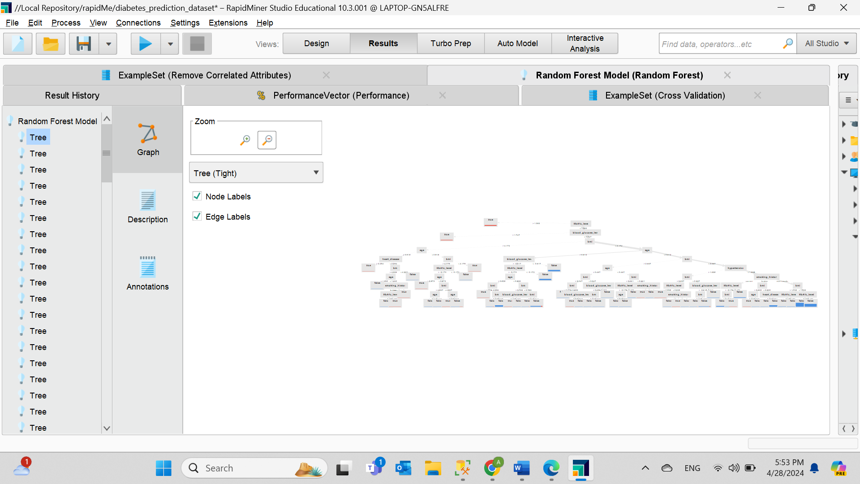

**Figure 63. Graph of the second model.** The model shows several graphs with more detailed information and assignments.

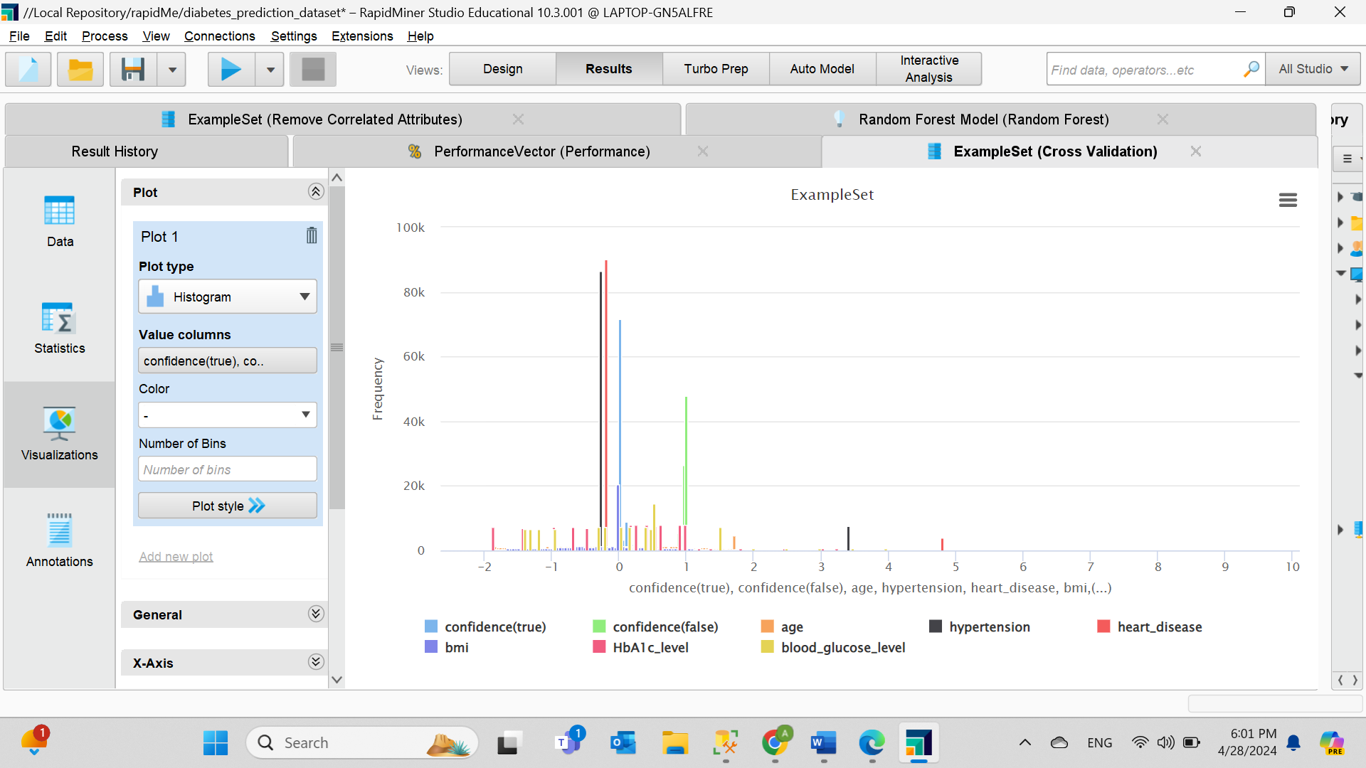

**Figure 64. Visualization of the second model.**

The ensemble modelling

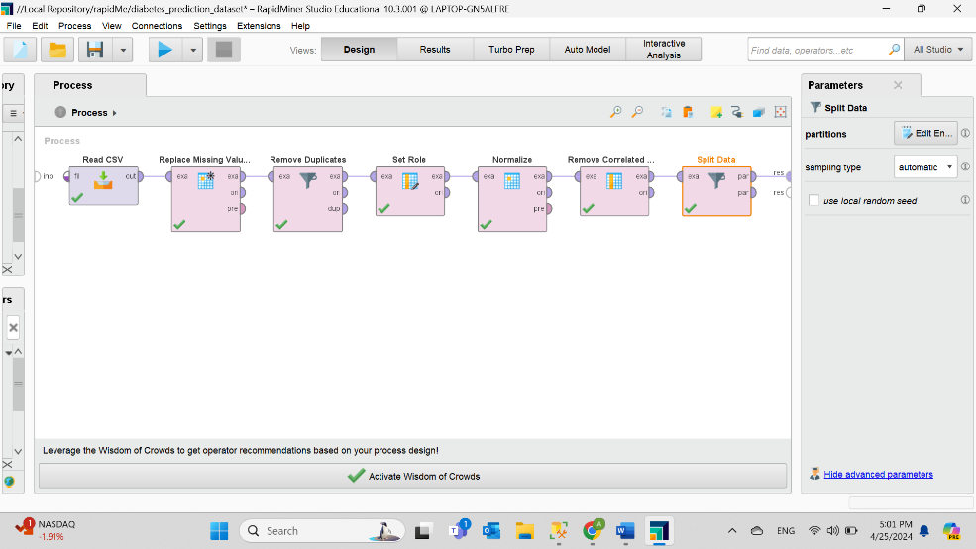

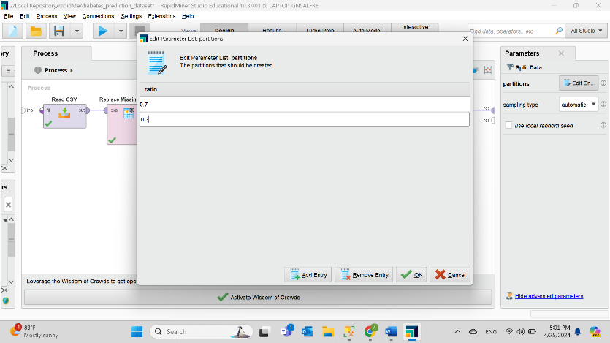**Figure 65. Splitting the data.** Applying the “Split Data” operator to divide the data to training and testing using the sampling type as automatic.

**Figure 66. Setting the ratio 0.7 and 0.3.** 70% and 30% for training and testing respectfully. Choosing the suitable ratios depends on the data collection size and the requirements for evaluation. Because the data set is large, numerous information should be provided for the model and enough data for the evaluation which Identifies potential overfitting risks which makes the ratio splitting balanced and improve the model performance.

Model Building

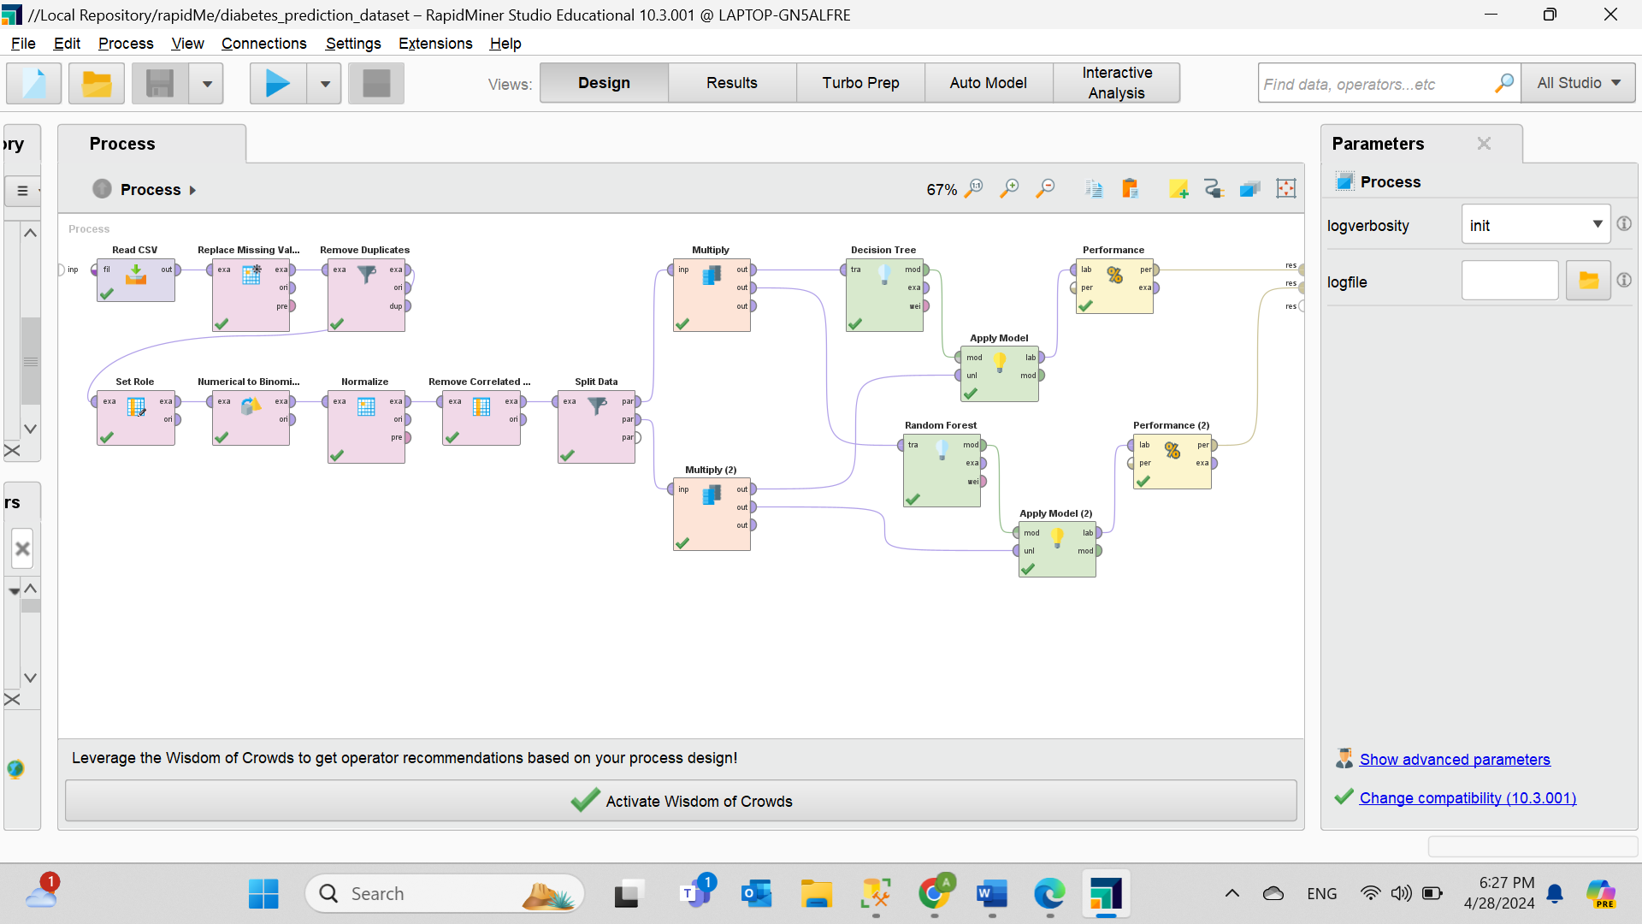

**Figure 67. Building the models.** The "Multiply" operator does the multiplication of data. Then, two classification techniques to build two different models are created, the “Decision Tree” and “Random Forest”, Where the criterion for the “Random Forest” is “gain_ratio”.

**Details of the ensemble modelling**

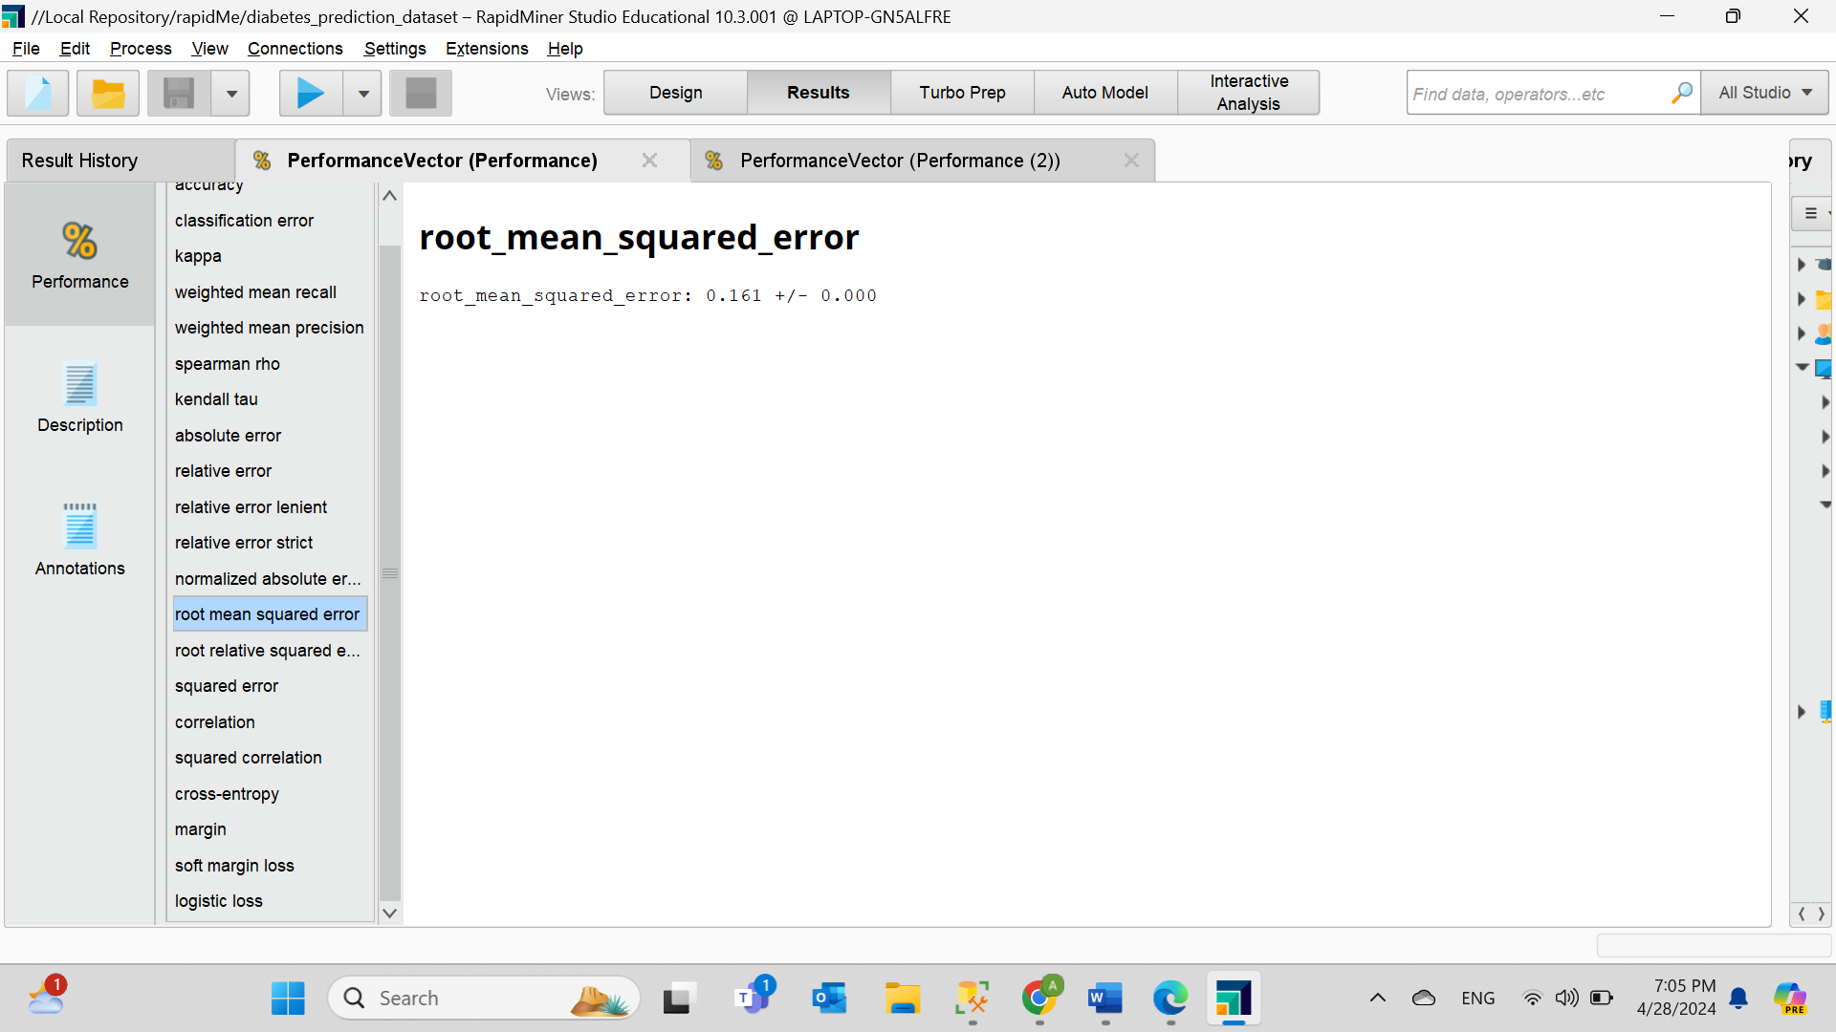Performance of the first model

**Figure 68. Root mean squared error of the first model is very low or almost 0.**

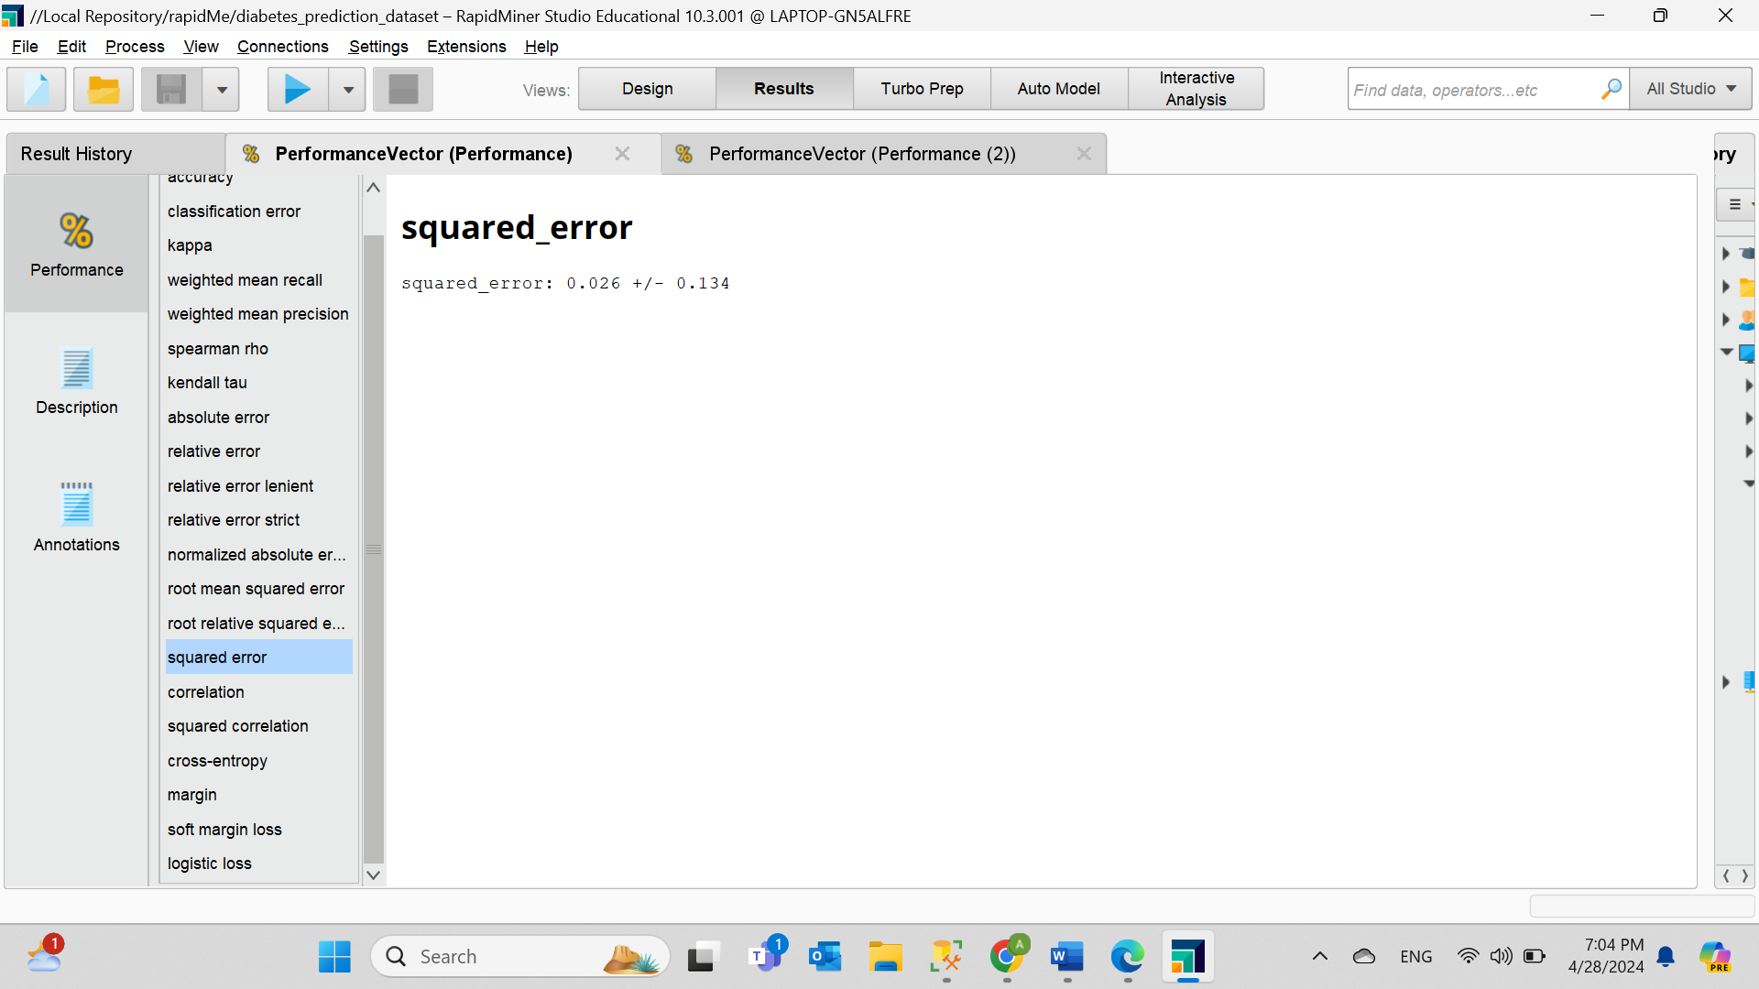**Figure 69. Squared error of the first model very low or almost 0.**

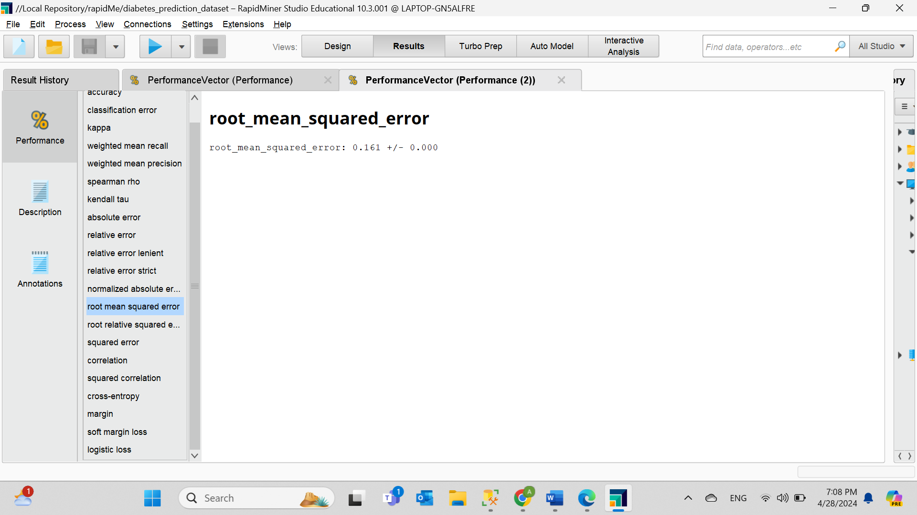Performance of the second model

**Figure 70. Root mean squared error of the second model is the same of the first model.**

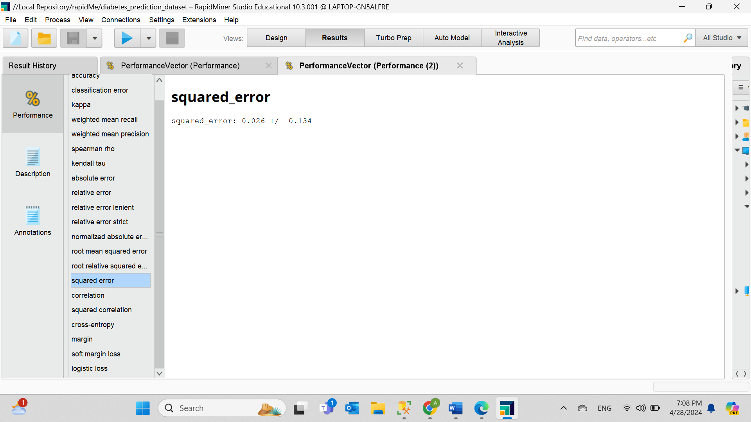

**Figure 71. The squared error of the second model is the same as the first model.**

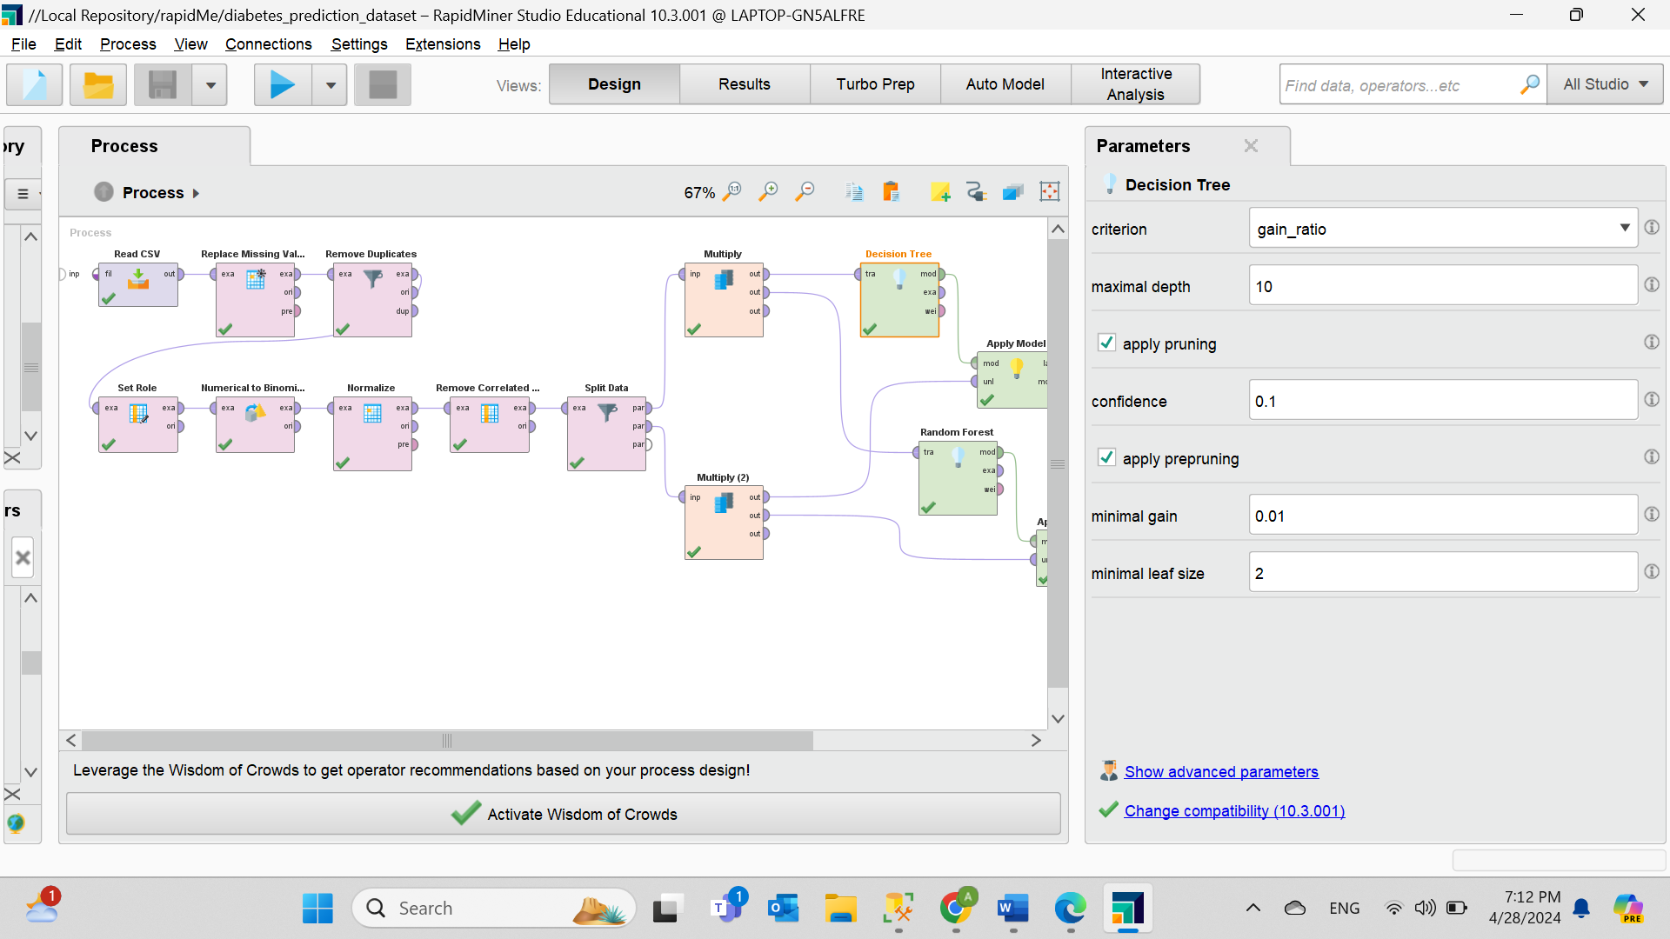Parameter settings of each models.

**Figure 72. The parameter settings for the first model (Decision Tree).** The criterion is “gain_ratio”.

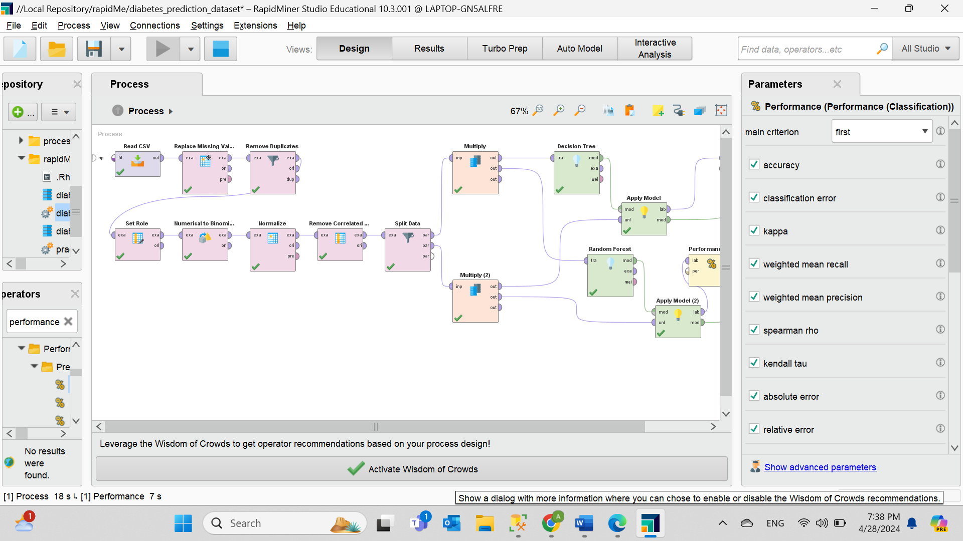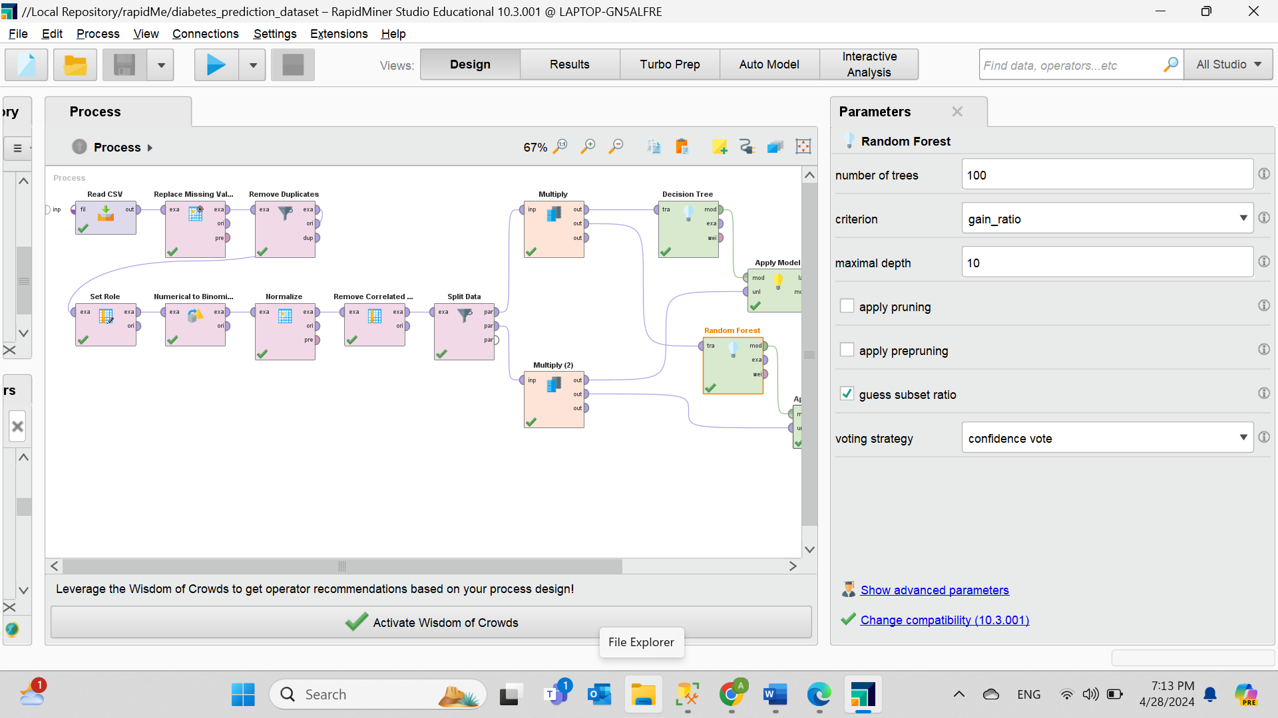**Figure 73. The parameter settings for the second model (Random Forest).** Thecriterion is “gain_ratio”.

**Figure 74. The parameter settings for performance for both models.**

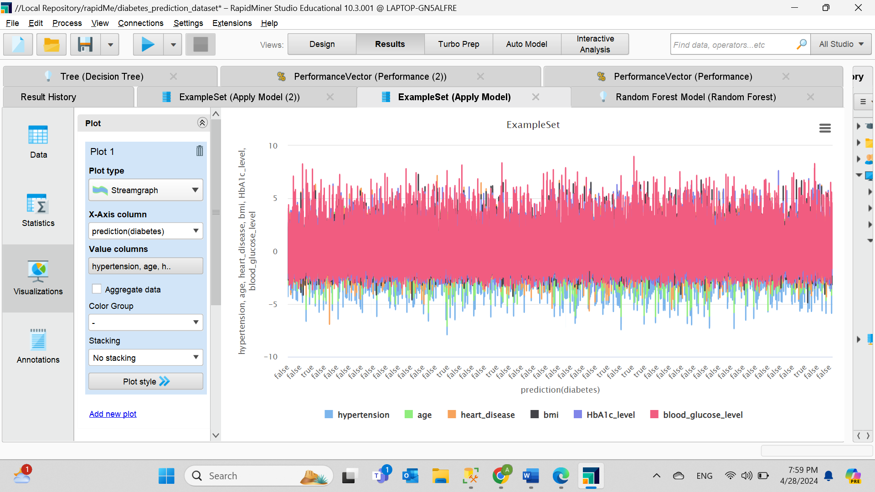Visualizations of the process

**Figure 75. The stream graph for the first models.**

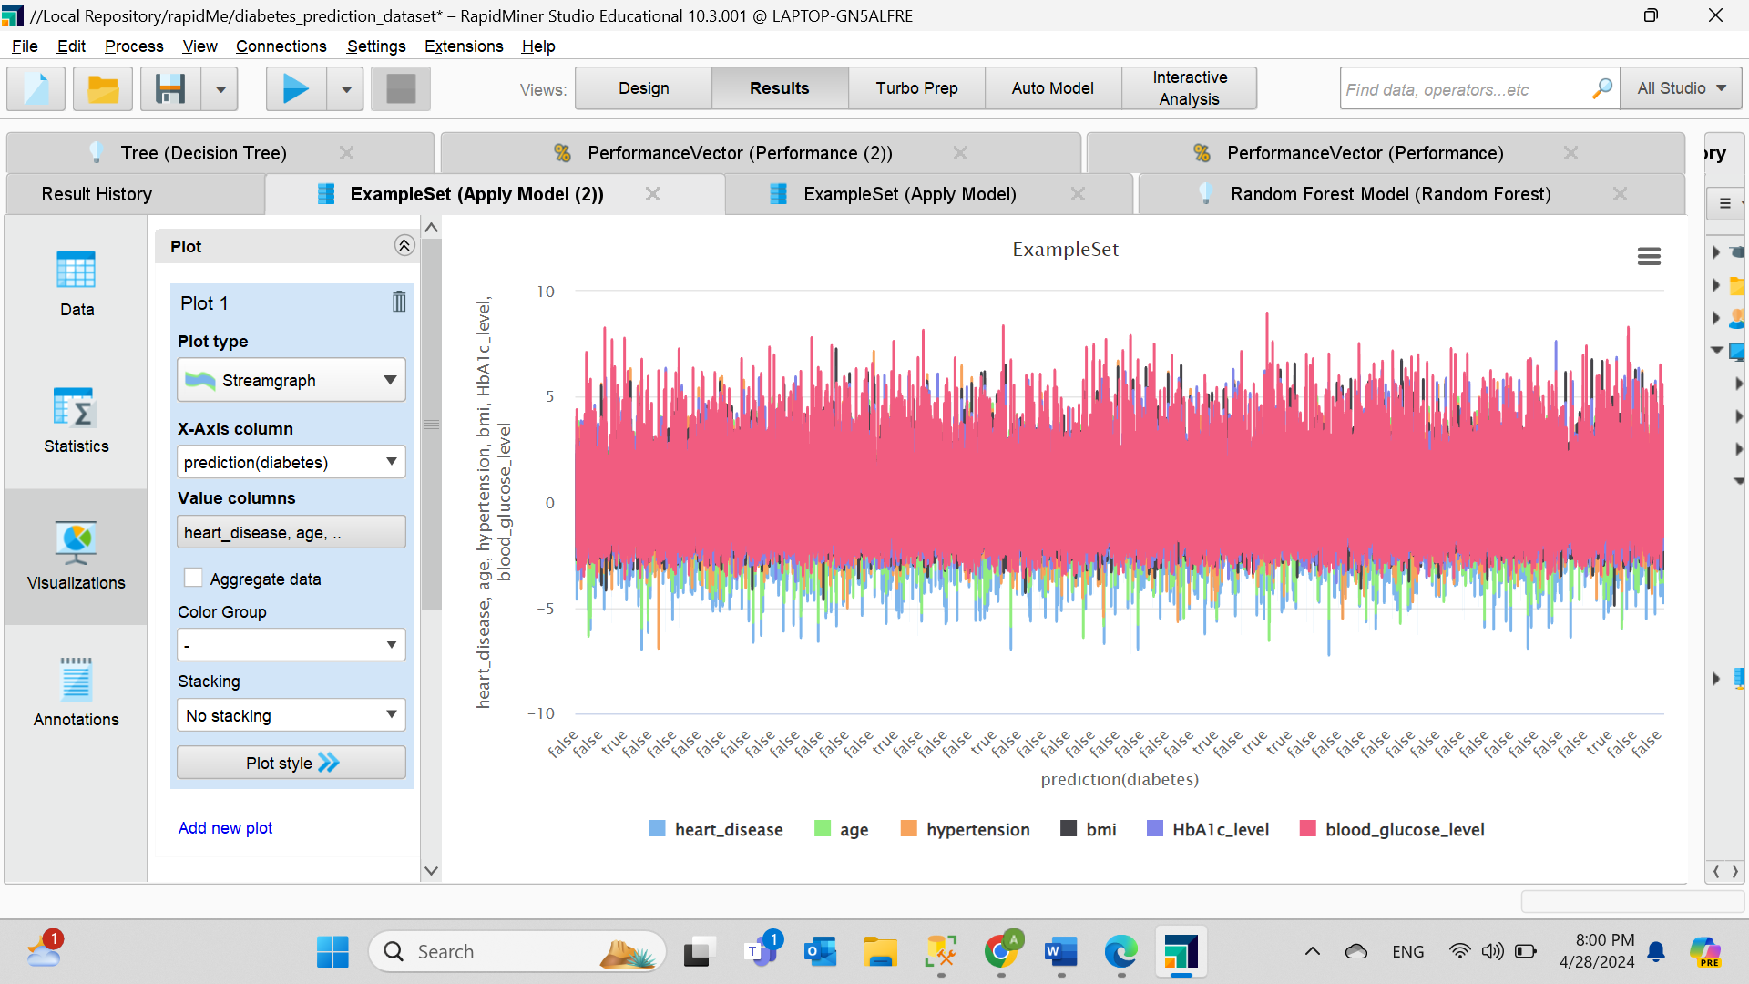

**Figure 76. The stream graph for the second model.** Both models have the same result.

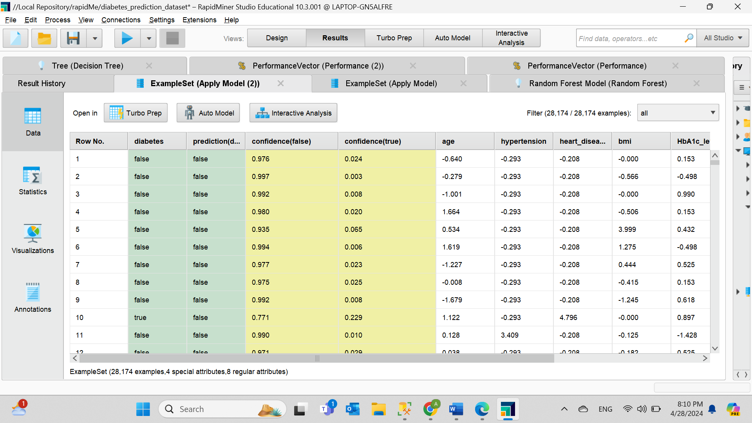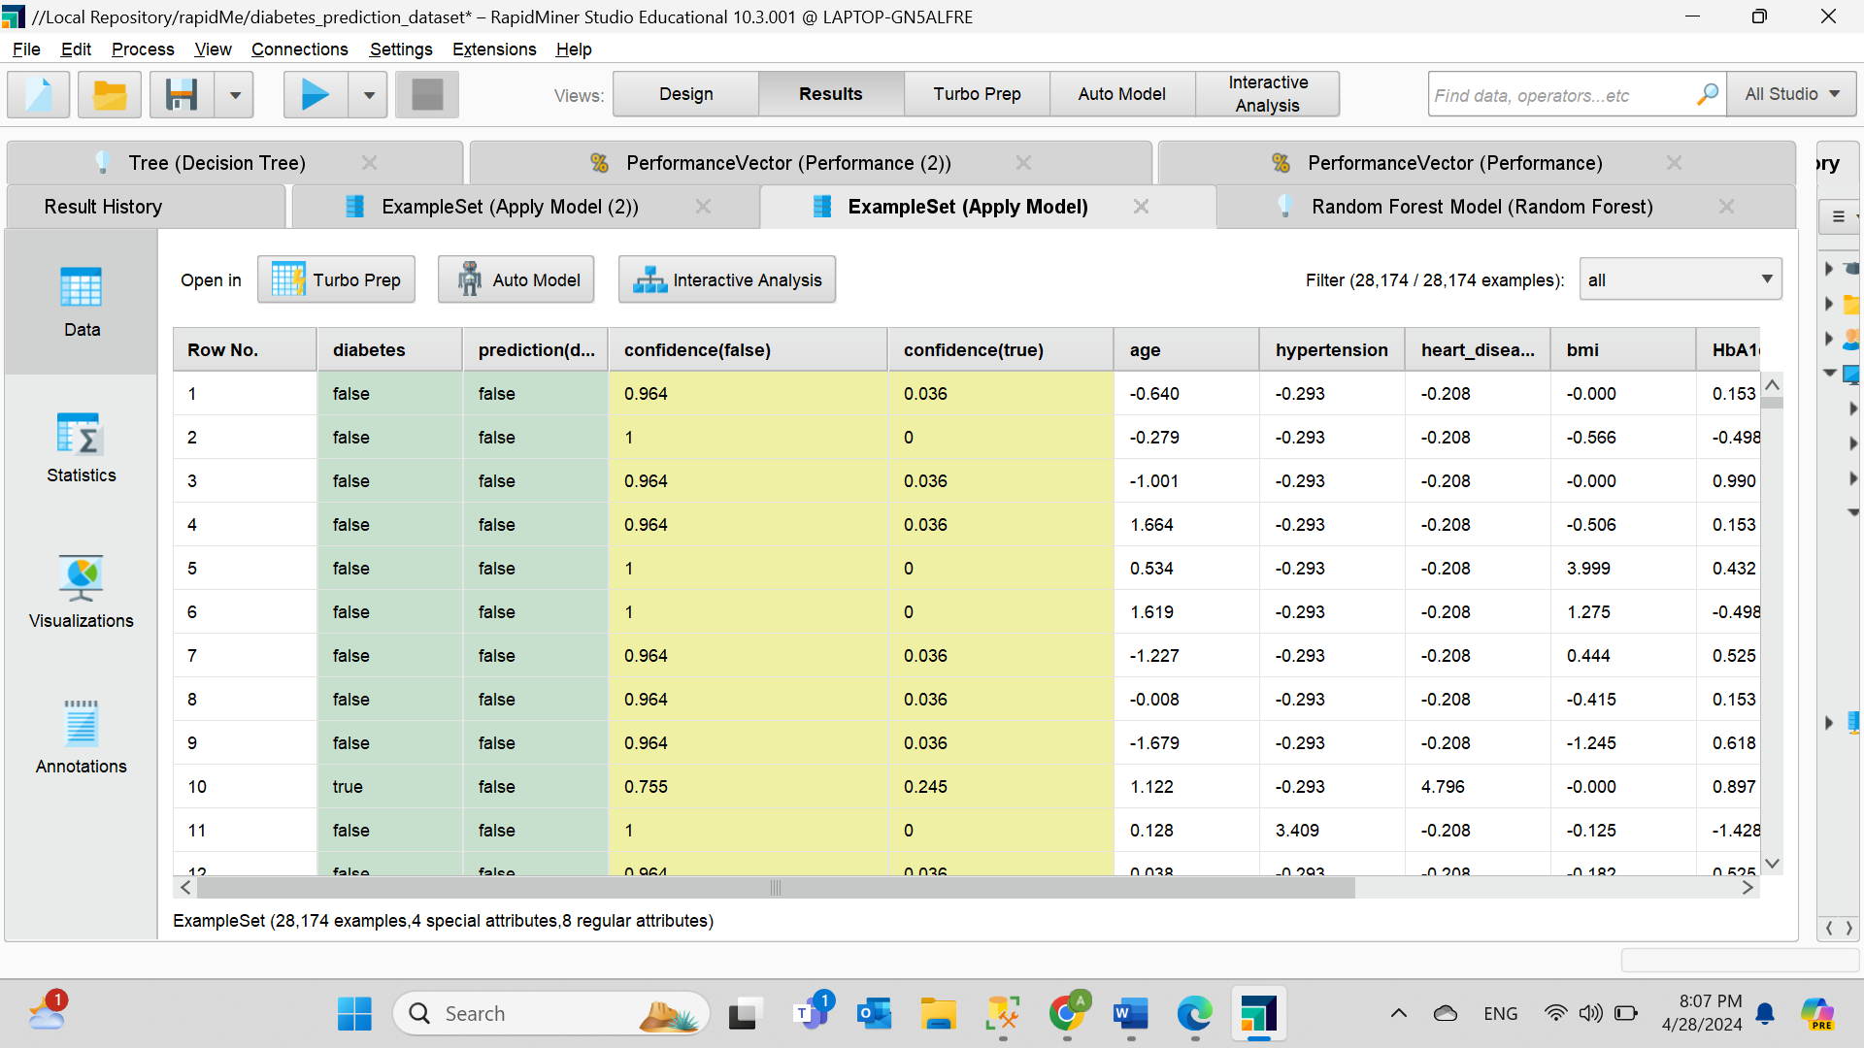**Figure 77. The result for the first model.**

**Figure 78. The result for the second model.**

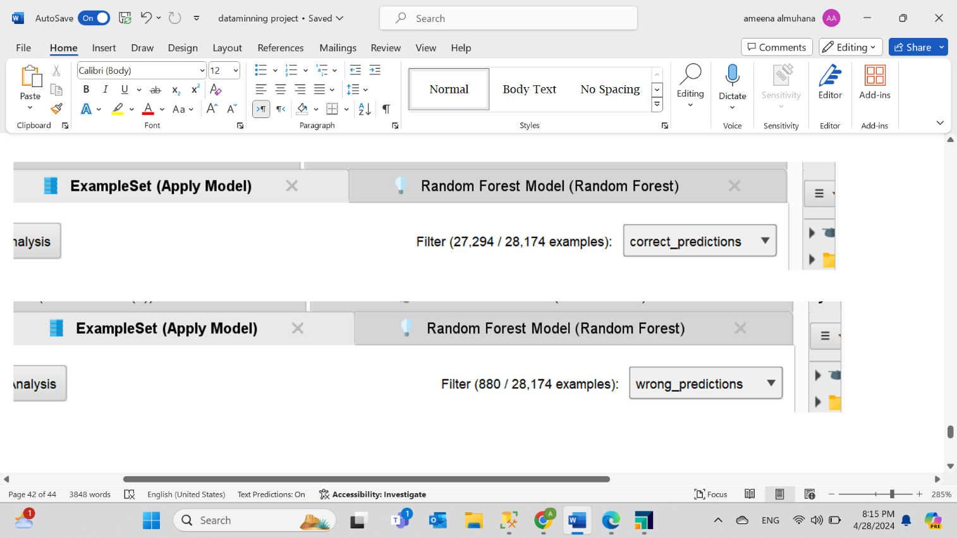**Figure 79. The correct and wrong predication for the first model.** The correct prediction shows 27,294 out of 28,174, where the wrong prediction shows 880 out of 28, 174.

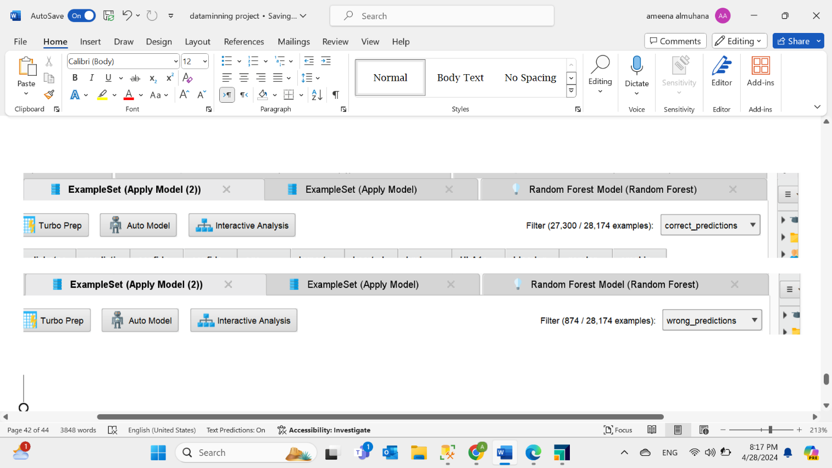

**Figure 80. The correct and wrong predication for the second model.** The correct prediction shows 27,300 out of 28,174 which is higher than the first model, where the wrong prediction shows 874 out of 28, 174 which is lower than the first model.

# **Task Five - Evaluating Data Mining Models**

Metrics applied: -

**Accuracy**: Measures the model's overall correctness, which is essential for assessing its general performance. A high level ensures that the model correctly identifies diabetics and non-diabetics.

**Confusion** **Matrix**: A table displaying a classification model's performance divided into four categories: true positives, true negatives, false positives, and false negatives. Which help Identify strengths and weaknesses of the model, and identify improvements that need to be made

**Precision**: The measure of correctly predicted positive data out of all positive predicted such as correctly identifying diabetes (positive) cases with a minimal rate of false positives.

**Recall**: Measures the correctly predicted positive data out of all actual positive. To ensure that no positive cases are missed, it captures all cases of diabetes.

**F1 Measure**: Measure the balance's precision and recall, which is useful when there are more positive than negative data or vice versa. Consequently, it is possible to assess the overall effectiveness of the model in identifying diabetes cases correctly while minimizing false positives and false negatives.

Evaluation of first model (Decision Tree)

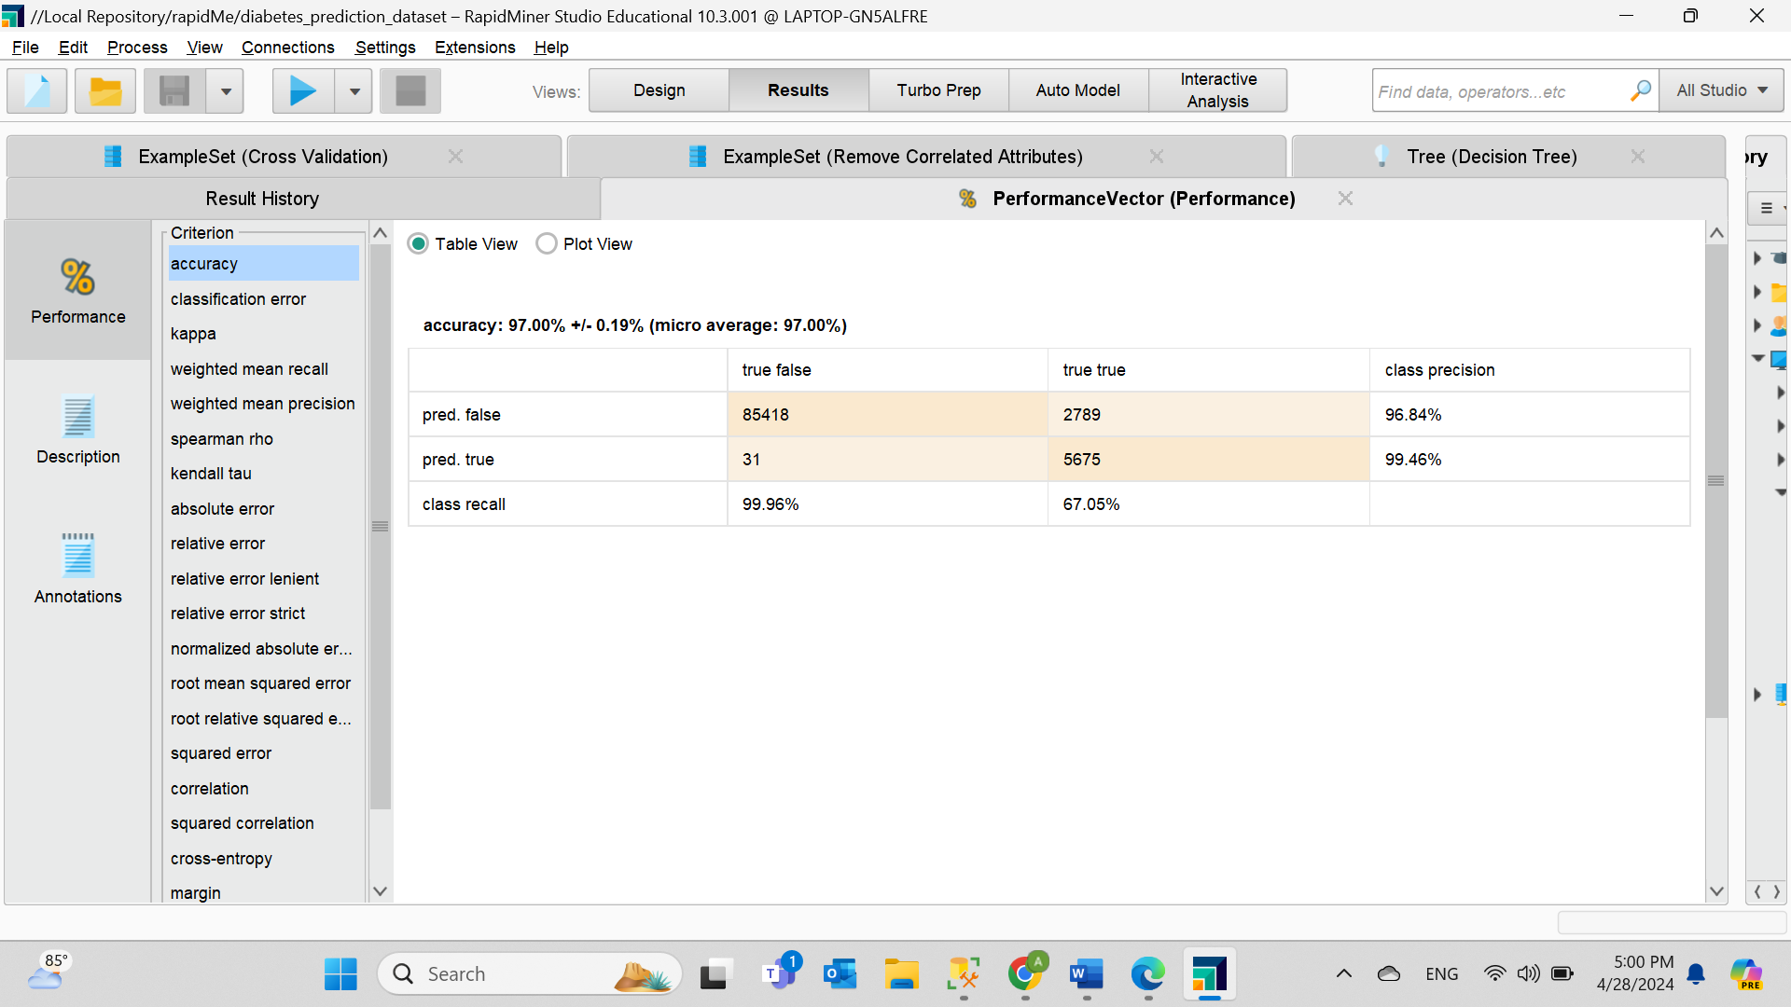 Accuracy and Confusion matrix

**Figure 81. The Accuracy and Confusion Matrix for the First Model.** The accuracy exhibits a high percentage of 97%, indicating good performance in detecting both positive and negative values. Moreover, the confusion matrix displays a total of 5675 true cases and 85418 false cases were correctly identified. In contrast, incorrectly classified is 2789 cases as true and 31 cases as false. Which means almost every time the model predicts true with a precision of 99.46% and a slightly lower recall, at 67.05%, indicating it may be missing some real cases.

Recall

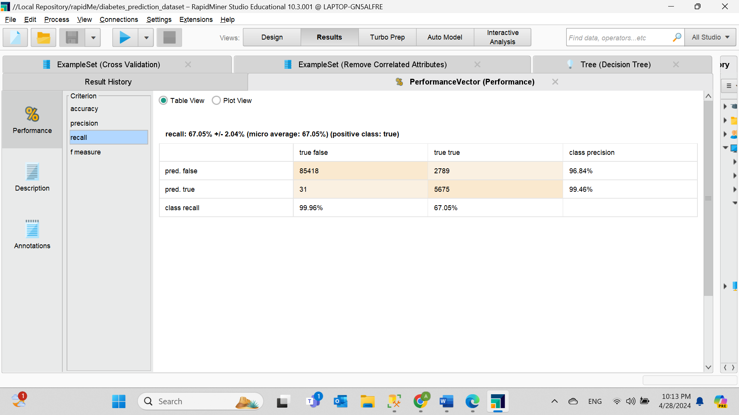

**Figure 82. The Recall for the first model.** Shows a 67.05% in correctly identifying diabetes instances in the dataset.

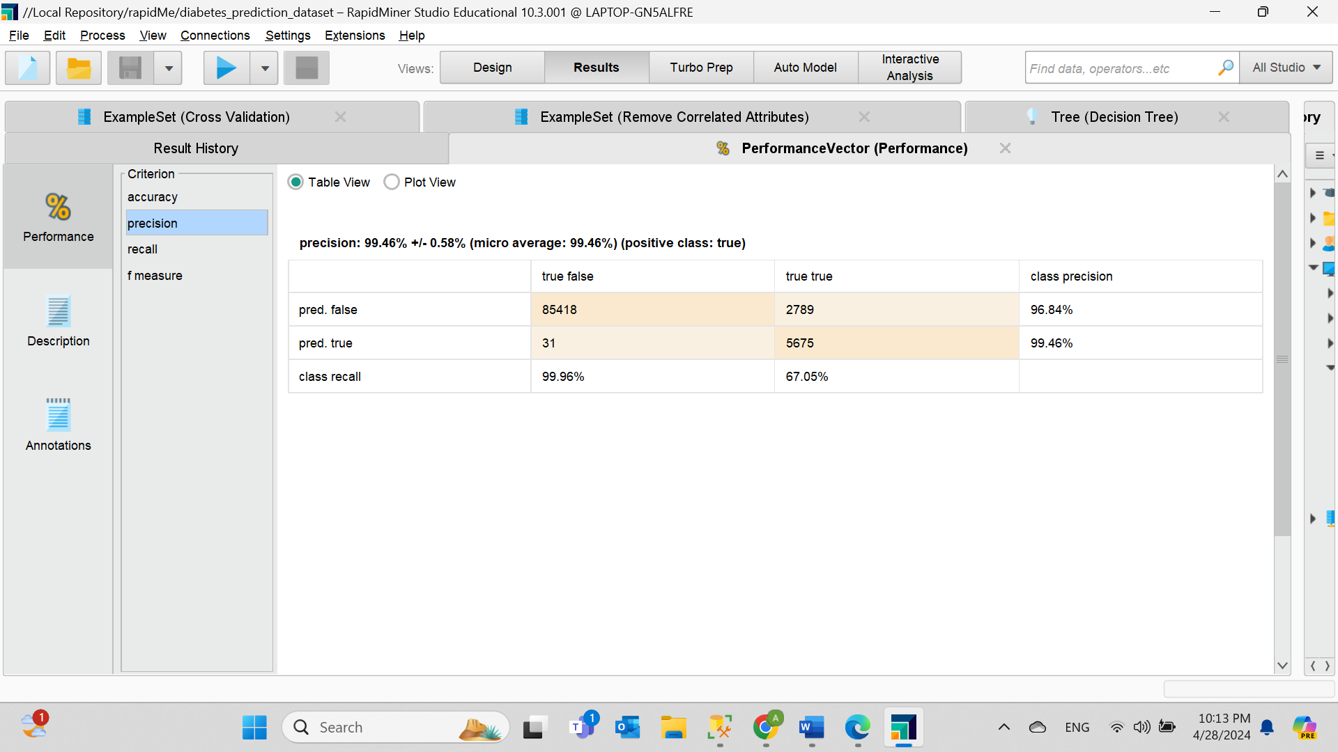Precision

**Figure 83. The Precision for the first model.** It displays 99.46% of all instances predicted as positive as true positives with high precision and low margin of error.

F-measure

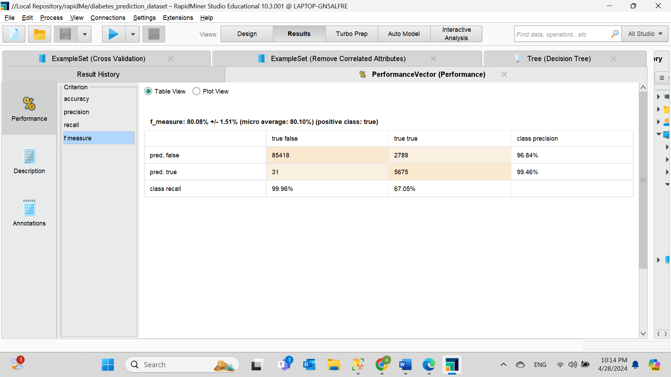

**Figure 84. The F-measure for the first model.** High value of 80.08% indicate that the model reaches a balance between precision and recall, indicating excellent general performance.

Evaluation of second model (Random Forest)

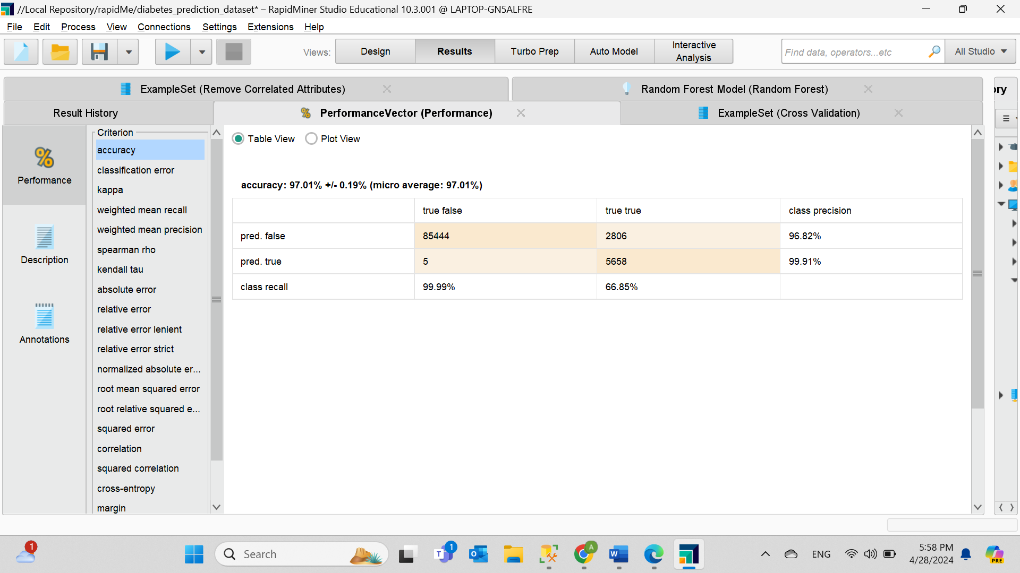 Accuracy and Confusion matrix

**Figure 85. The Accuracy and Confusion Matrix for the second model.** Similarly, it indicates a high percentage of accuracy of 97.01%. On the other hand, the confusion matrix exhibits the successful detection of 5658 as true examples and 85444 as false examples. However, 2806 instances were incorrectly classified as true and 5 instances as false. With a precision of 99.91%, it is almost always right when it predicts true. Nevertheless, recall is only 66.85%, indicating that some true cases are missed.

Recall.

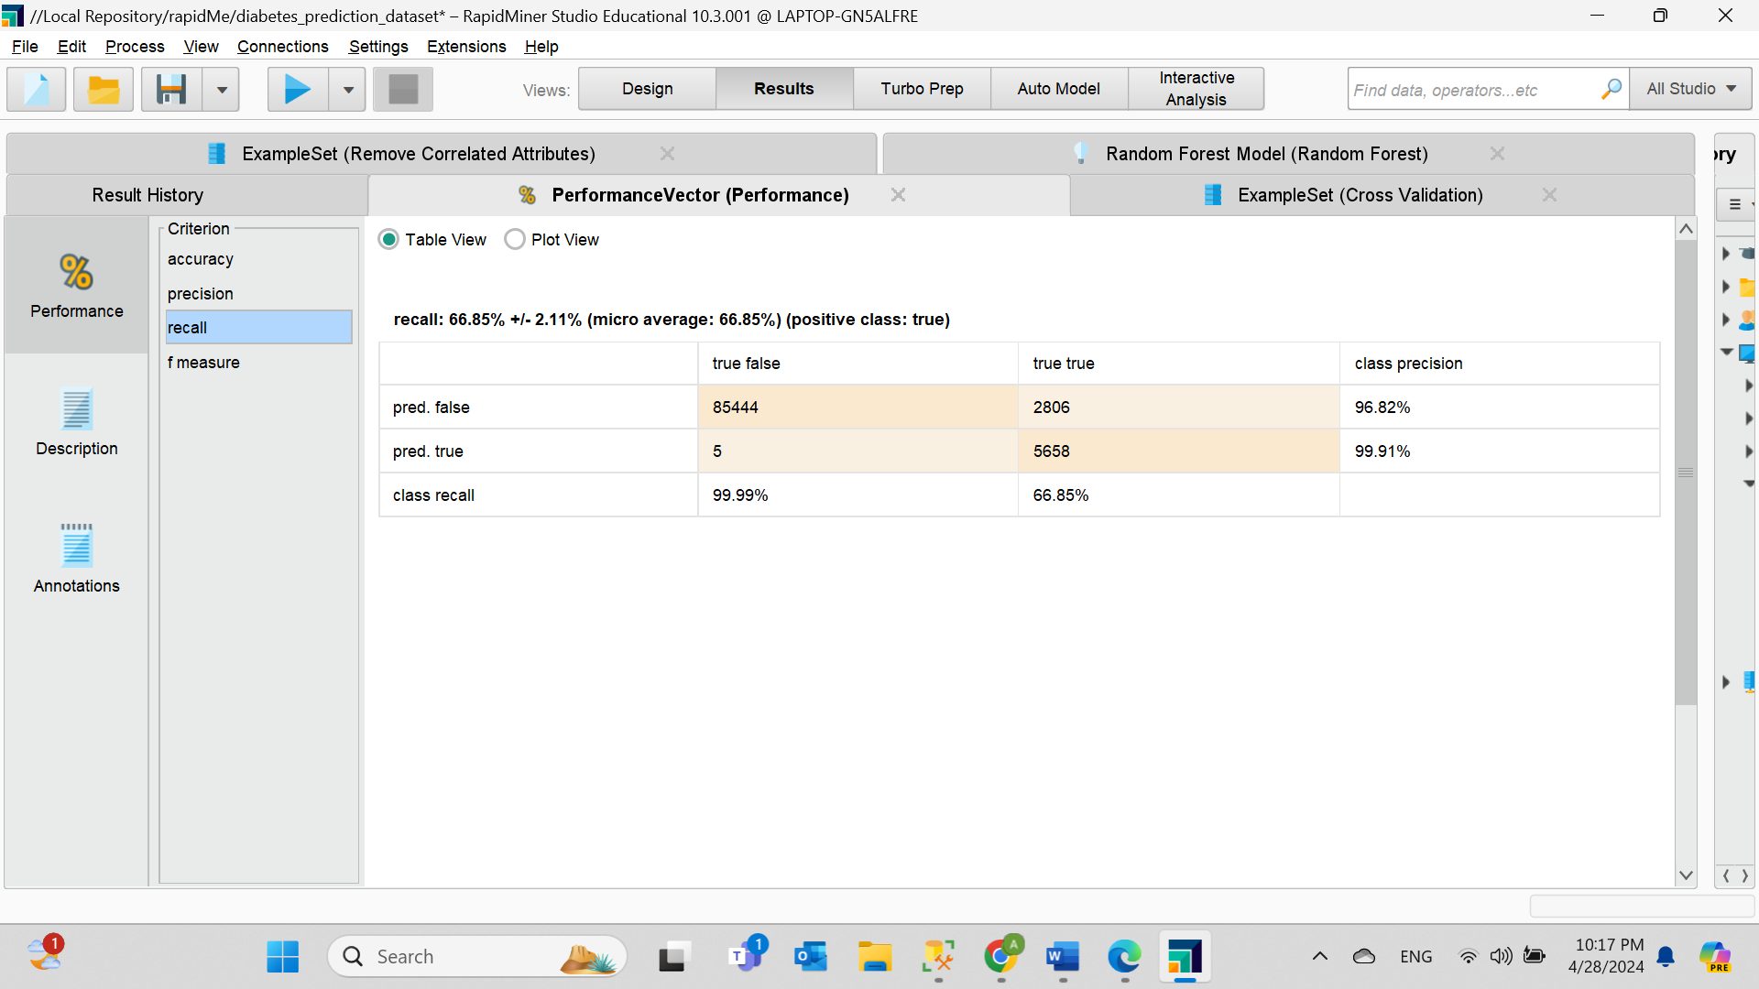

**Figure 86. The Recall for the second model.** Shows a 66.85% in correctly identifying diabetes.

Precision

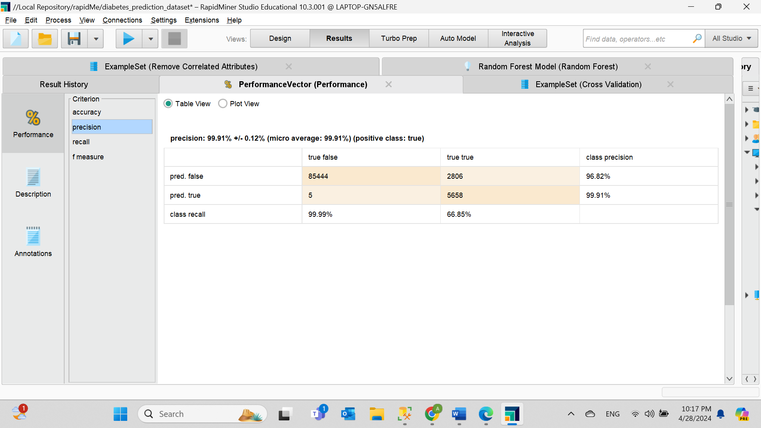

**Figure 87. The Precision for the second model.** High value of 99.91% with large precision and low error.

F-measure

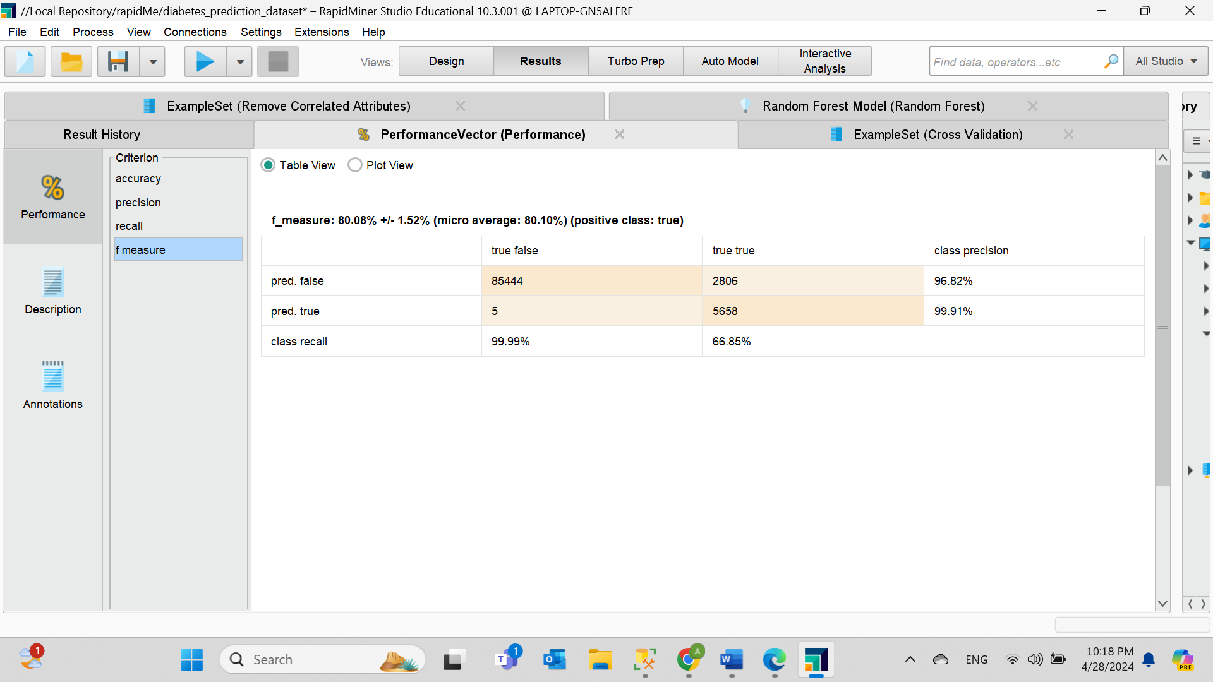

**Figure 88. The F-measure for the second model.** A high value of 80.08% indicates that the model has a good balance between precision and recall, indicating good performance in general.

Evaluation of ensemble models (Decision Tree) and (Random Forest)

Accuracy and Confusion matrix

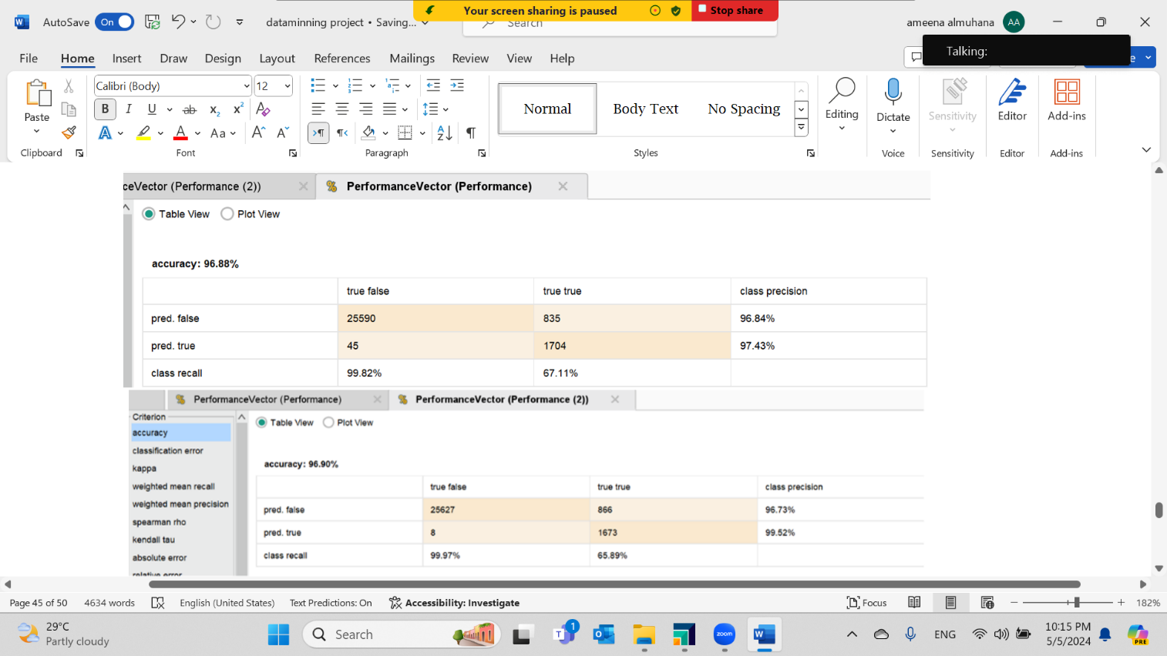

**Figure 89. The Accuracy and Confusion Matrix of the ensemble first model and second model.** The accuracy of the first model is 96.88% and of the second model is 96.90%. As for the confusion matrix, the first model properly predicted 1704 true cases and 25590 as false, incorrectly marked 835 cases as true and 45 cases as false, a precision of 97.43% and have a recall of 67.11%, suggesting that it may miss some true cases. However, the second model correctly predicted 1673 true cases and 25627 as false cases. And mistakenly classified 866 as true and 8 as false cases. With a higher precision at 99.52% whereas the recall is slightly lower at 65.89%.

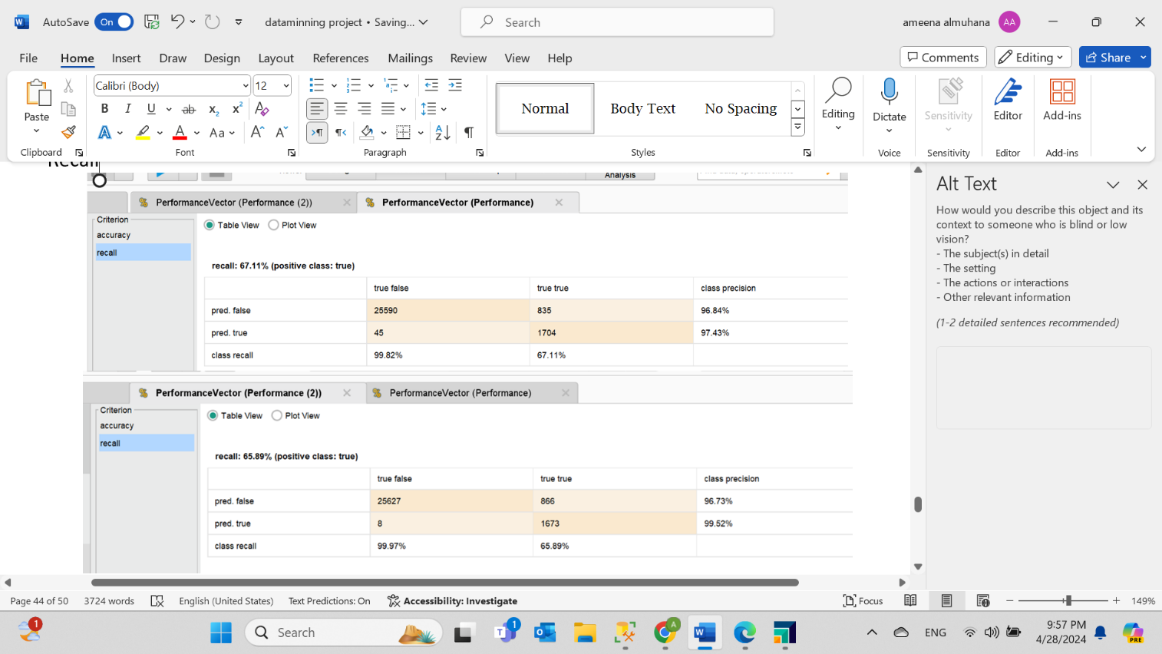Recall

**Figure 90. The Recall of the ensemble first model is 67.11% and Recall of the second model is 65.89%.** The first model has more recall compared to the second model.

Precision

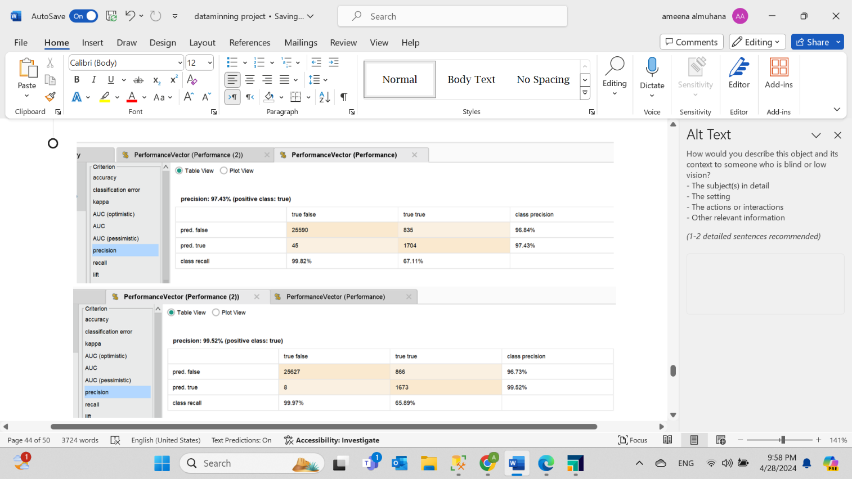

**Figure 91. The Precision of the first model is 97.43% and Precision of the second model is 99.52%.** The second model has more precisioncompared to the first model.

F-measure

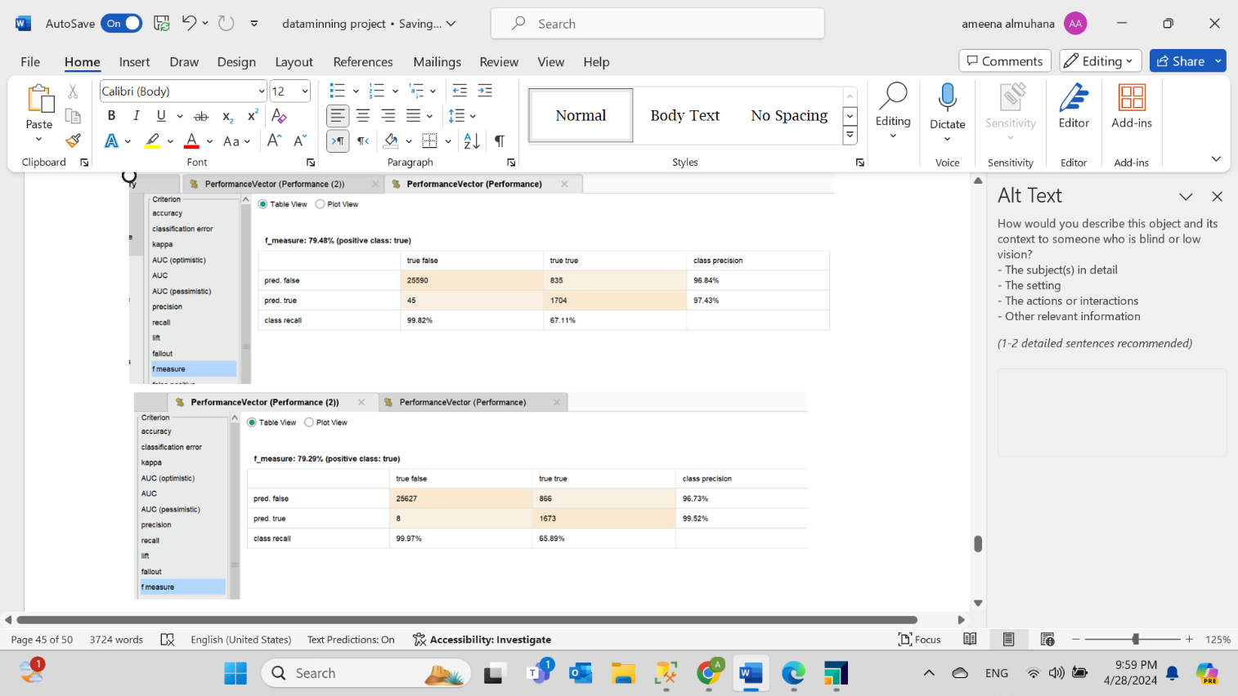

**Figure 92. The F-measure of the first model is 79.48% and F-measure of the second model is 79.29%.** The first model has more F-measure compared to the second model.

# **Task Six - Inferences, Recommendation and Reflection**

# Inferences

The accuracy of all models is above 96% but the second model (Random Forest) is the highest with 97.01%. Moreover, the confusion matrix shows the highest number of True Positives is in the First Model (Decision Tree) as 5675 and True Negatives in the Second Model (Random Forest) as 85444. The lowest number of False Positives is in the first ensemble model (Decision Tree) as 835 and False Negatives is in the Second Model (Random Forest) as 5. In addition, the Recall of all models is higher than 65%, however, The Recall of the ensemble first model is 67.11% which makes it the largest percentage. Furthermore, the Precision overall is higher than 97%, In contrast, The second model (Random Forest) has highest value of 99.91%. Finally, the F-measure is generally more than 79%, however, the first (Decision Tree) and second model (Random Forest) have the same valueof 80.08%.

Comparing all models, the Second Model (Random Forest) is the best for the business problem. Having the highest accuracy as 97.01%, True Negatives in the confusion matrix as 85444, Precision as 99.91%, F-measure as 80.08% and having the lowest False Negatives as 5.

This will impact the medical field, by predicting diabetes accurately to enhance patient health, taking early action to prevent diabetes-related complications, contributing to further research and innovation in diabetes cases and providing patients with the information they need.

# Recommendation

Due to time and resources constraints, it is recommended to include diverse datasets from multiple resources to get a more comprehensive diabetes risk assessment. In addition to using artificial intelligence tools to make predictive models easy to understand. Also, the predictive model must be continuously evaluated and updated for it to remain accurate and relevant in this dynamic world. Moreover, any patient or doctor needs to be informed to ensure the factors that lead to diabetes in this model are not high or else he or she will suffer from diabetes.

# Reflection

Working on this project was an enlightening experience that offered valuable knowledge of diabetes analysis. We created predictive models for estimating diabetes, which enabled us to dive deeper into the field of data mining in healthcare.

We have learned that the most important phase is the preparation of the selected dataset and making sure the data is cleaned and ready before building the models, otherwise if the data is unreliable the model will be unreliable as well. Moreover, we became experts in using Rapid Miner Studio and R Tool Studio software for producing models.

There were several problems we encountered in the project due to the size of our data set and the amount of space it consumed, which made using outlier detectors in both software programs impossible. To overcome this issue, we used another method to detect the outlier, a box plot which did not show any outliers, thus concluding that the operator was not working because there were no outliers.

Next time we will improve our work by learning different algorithms, exploring new operators and tools. Furthermore, we will collaborate with healthcare professionals to interview them directly and collect trustworthy details that may enhance our model’s predictability.

# **Extra challenge**

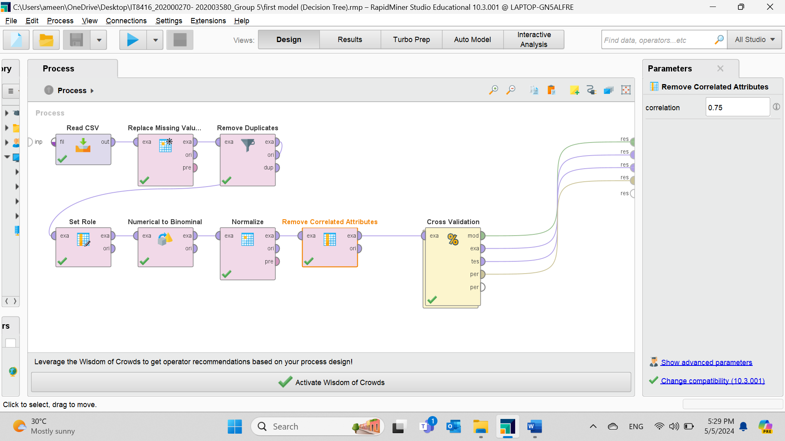

Using the Remove correlated attributes as another method of reduction like PCA as explained previously.

# **Log Files**

|  |  |  |  |  |
| --- | --- | --- | --- | --- |
| **Mentor : Sini Raj Pulari** | | | | |
| **Project Name:** | Diabetes prediction | | | |
| **Student 1 Name and Student ID with Role taken:** | | | | Sara albuainain - 202003580 -Data Mining Engineer |
| **Student 2 Name and Student ID with Role taken:** | | | | Amena Almuhana - 202000270 - Data Scientist |
| **Student 3 Name and Student ID with Role taken:** | | | | **-** |
| **Date** | **Week No** | **Task Name** | **Work done During the week** | **Issues Experienced if any** |
| 10/3/2024 | Four | Group discussion and planning | Reading the project and understanding it, Splitting the tasks, role and choosing a topic. | None |
| 17/3/2024 | Five | Task 1 and Task 2 | Writing task 1 and finding a dataset for our topic. | None |
| 24/3/2024 | Six | Task 3 | preparing the dataset by removing noisy data | None |
| 31/3/2024 | Seven | Task 3 | PCA | None |
| 6/4/2024 | Eight | Task 3 | Outlier reduction | None |
| 13/4/2024 | Nine | Task 3 | Visualization | None |
| 20/4/2024 | Ten | Task 3 | Completing task 3 and editing it | None |
| 28/4/2024 | eleven | Task 4 | Completing task 4 and editing it | None |
| 5/5/2024 | twelve | Task 5 & 6 | Completing task 5 and 6 and editing. | None |

# **GitHub Link**

# **YouTube Link**

<https://youtu.be/u_DW6P54CV0>

# **References**

Mustafa, M. (2023). Diabetes prediction dataset. Retrieved March 8, 2024, from Kaggle.com website: <https://www.kaggle.com/datasets/iammustafatz/diabetes-prediction-dataset?resource=download>

World Health Organization. (2023, April 5). *Diabetes*. <https://www.who.int/news-room/fact-sheets/detail/diabetes>